Web Based Appointment Scheduling System for Fake Rider Motorparts

______________

A Thesis Presented to
The Faculty of the College of Computing and Information Sciences
BOHOL ISLAND STATE UNIVERSITY
Balilihan Campus
Magsija, Balilihan. Bohol
______________
In Partial Fulfillment
of the Requirements for the Degree
Bachelor of Science in Information Technology

Erikson |  |  |  |  | J. | Apolona
Lilibeth |  |  |  |  | C. | Bacohod
Ashley Louise |  |  |  |  |  | Chiu

September 2026
Chapter 1
THE PROBLEM AND ITS SCOPE
INTRODUCTION
Rationale
Vehicle repair shops are service-oriented businesses that manage various activities such as customer appointments, repair services, customer information, and service updates. In today’s digital world, technology plays an important role in improving the way businesses manage their daily operations. Many service-oriented businesses now use web-based systems to organize customer information, manage appointments, monitor services, and communicate more effectively with their clients. These systems can reduce manual work, improve information accessibility, save time, and support more efficient service delivery. The use of digital platforms also allows service providers to handle customer requests in a more structured manner and maintain information that can be accessed when needed. As customers increasingly seek convenient and responsive services, businesses are encouraged to adopt technological solutions that can support both their operational activities and customer needs.
However, vehicle repair shops that rely on traditional and manual processes may encounter difficulties in managing appointments, customer records, and repair service information. Practices such as handwritten records, walk-in scheduling, and verbal confirmations can make it difficult to organize information, maintain accurate records, coordinate schedules, and provide timely service updates. Existing appointment scheduling and service management systems also vary in their features and may not fully address the needs of small repair shops, particularly in terms of appointment accessibility, centralized record management, repair monitoring, and customer communication. These concerns highlight the need for a more organized and accessible digital solution that can support appointment scheduling and repair service management.
In response to these needs, the researchers proposed the development of a Web-Based Appointment Scheduling System for Fake Rider Motorparts. The proposed system is designed to allow customers to schedule repair appointments online without requiring them to create an account, making the booking process more accessible and convenient. Customers can also monitor the progress of their repair services through a booking reference number. On the administrative side, the system will provide functions for managing appointment schedules, customer records, repair service status, and information about motorcycle parts and accessories through a centralized web-based platform. Through these features, the proposed system aims to provide a more organized, accessible, and efficient approach to appointment scheduling and repair service management. The system is intended to provide customers with a convenient means of accessing appointment and repair-related information while giving administrators a centralized platform for handling the shop’s service activities. By integrating these functions into a single web-based platform, the proposed system seeks to support a more systematic approach to managing the shop’s daily service operations.

Literature Background
The increasing adoption of web-based systems has influenced how service-oriented businesses manage appointments, customer information, and service operations. Digital platforms provide opportunities to organize business processes, improve information accessibility, and provide customers with more convenient ways to access services. In vehicle repair businesses, web-based appointment scheduling can help organize service requests, coordinate schedules, maintain customer records, and provide updates regarding repair services.
To provide a conceptual basis for understanding the acceptance and use of technology in this study, the Technology Acceptance Model (TAM) was adopted as the theoretical foundation. The model explains how users accept and use technology based on its perceived usefulness and ease of use (Davis, 1989). Perceived usefulness refers to how users believe a system can improve their tasks, while perceived ease of use refers to how easily users believe they can use the system. In this study, TAM provides a basis for understanding the acceptance of the proposed Web-Based Appointment Scheduling System by customers and administrators in managing appointments and repair services.
The Technology Acceptance Model (TAM) is relevant to the proposed study as it focuses on how users accept and use technology based on its perceived usefulness and ease of use. These factors are important in determining whether customers and administrators can effectively adopt and use the proposed Web-Based Appointment Scheduling System.
Technology Acceptance Model (TAM).
This theory explains how users accept and use technology based on its usefulness and ease of use. It supports the adoption of the proposed web-based appointment scheduling system for Fake Rider Motorparts by customers and administrators (Fred Davis, 1989).

Section 6 of Republic Act No. 8792. This act recognizes the legal validity of electronic documents, records, and digital transactions in the Philippines, supporting the use of electronic systems and online services in business and communication (Republic of the Philippines, 2000)
Section 11 of Republic Act No. 10173. This provision outlines the general principles for processing personal information, ensuring that data is collected for legitimate purposes and protected from unauthorized access. (Republic of the Philippines, 2012).

Expectancy Theory. This theory emphasizes that individuals are motivated to perform actions based on the expected outcomes and rewards they may receive. It explains how users are encouraged to use the system effectively when they believe that features such as booking, tracking, and notifications will help them achieve convenience, efficiency, and better service experience (Victor Vroom, 1964).

Web-Based Appointment Scheduling System for Fake Rider Motorparts
Characteristics and Features:

- Repair Service Booking and Information Input
- Repair Status Updates and Notification System
- Service Progress Tracking Timeline
- Repair Records and Transaction History
- Admin Dashboard for Repair and Service Management
- Public Repair Status Tracking Using Reference Number

A Proposed Technology Action Plan

Figure 1. Theoretical and Conceptual Framework
Through this framework, the proposed system aims to provide useful and easy-to-use functions for appointment scheduling, repair service monitoring, customer record management, and administrative operations. It provides a basis for considering the system’s usability and usefulness in supporting the needs of both customers and administrators.
Moreover, this study is likewise guided by the Expectancy Theory proposed by Victor Vroom (1964). The theory explains that people are motivated to perform an action when they expect that it will lead to a desired result. It focuses on how effort, performance, and expected outcomes influence a person’s motivation. In this study, the theory is relevant because customers and administrators may be encouraged to use the proposed system when they see that it can make appointment scheduling and repair service management easier and more organized.
The study, An Implementation and Evaluation of Web-Based Appointment System for Institutional Scheduling by Ampuan and Delena (2022), examined the development of a web-based appointment system intended to replace manual scheduling procedures with an online reservation platform. The study aimed to improve appointment organization and provide users with a more convenient scheduling process. Findings revealed that the system improved schedule organization, reduced waiting time, and enhanced the efficiency of service delivery. However, the study focused on institutional appointment scheduling and did not specifically address the scheduling and repair service requirements of vehicle repair shops.
In response to these limitations, the proposed Web-Based Appointment Scheduling System for Fake Rider Motorparts adapted the web-based appointment concept to motorcycle repair services. While Ampuan and Delena (2022) focused on institutional appointment scheduling, the proposed system allows customers to select repair services, preferred date and time slots, and mechanic preferences. It also provides booking references, repair status updates, notifications, centralized records, and schedule management. These features address the study's limitation by applying appointment scheduling to actual repair service operations. The system also replaces manual processes such as handwritten records, walk-in scheduling, phone calls, and verbal updates with a centralized web-based platform accessible through different devices.
The study, Project Clinik: A Cross-Platform Scheduling and Appointment Reservation System by Dela Fuente et al. (2023), examined the development of a cross-platform system designed to improve appointment scheduling and service accessibility. The study aimed to provide users with a more accessible and organized method of making appointments. Findings revealed that centralized appointment management improved scheduling efficiency and accessibility while reducing the administrative burden associated with manual appointment processing. However, the study was developed for healthcare services and focused mainly on appointment reservation rather than repair service management.
These findings were relevant to the proposed study as they demonstrated how centralized appointment management can improve scheduling and accessibility. While the previous study focused on healthcare services, the proposed system applies similar appointment scheduling principles to motorcycle repair services. The proposed system further addresses the operational needs of a repair shop by integrating appointment scheduling with repair status monitoring, customer record management, and administrative functions.
The study, Digital Tracking Systems in Logistics Operations: Improving Efficiency and Visibility by Helo and Thai (2024), examined the use of digital tracking systems to improve efficiency and visibility in logistics operations. The study focused on how digital technologies can provide access to information and improve the monitoring of ongoing operations. Findings revealed that digital tracking systems can improve operational efficiency and visibility by providing more accessible information throughout the service process. However, the study focused on logistics operations and digital tracking rather than appointment scheduling and repair service management.
These findings were relevant to the proposed study as they demonstrated the importance of providing accessible and timely information during service processes. While the previous study focused on logistics tracking, the proposed system applies the concept of digital monitoring to motorcycle repair services. The proposed system allows customers to monitor the progress of their repair services through a booking reference number while administrators can update repair status through a centralized platform.
The study, PARADAJuan: A Web-Based Parking Lot Management System Designed and Developed Using Multi-Paradigm Programming Languages by Luciano et al. (2023), examined the development of a web-based parking lot management system for organizing parking-related operations and information. The study aimed to provide a centralized digital platform for managing parking activities and related records. Findings revealed that the developed system provided a web-based approach for managing parking spaces and operational information. However, the study focused on parking lot management and did not address appointment scheduling or repair service management.
These findings were relevant to the proposed study as they demonstrated how a centralized web-based platform can be used to organize operational information. While the previous study focused on parking management, the proposed system applies centralized information management to motorcycle repair services. The proposed system manages customer records, appointments, repair status, and information about motorcycle parts and accessories in one platform to support more organized repair shop operations.
The study, Information Technology Capability and Service Performance in Logistics Industries by Nour (2022), examined the relationship between information technology capability and service performance in logistics industries. The study focused on the role of information technology in supporting business operations and improving service performance. Findings revealed that information technology capabilities can contribute to better service performance by supporting business processes and information management. However, the study focused on logistics industries and did not specifically address appointment scheduling or repair service management in vehicle repair businesses.
These findings were relevant to the proposed study as they highlighted the role of information technology in improving service operations and performance. While the previous study focused on logistics, the proposed system applies the use of information technology to motorcycle repair services. The proposed system provides digital functions for appointment scheduling, repair progress monitoring, customer record management, and administrative operations to support more efficient service management.
The study, An Effective Garage Management System Web Application for Customer Service by Patidar et al. (2021), examined the development of a web-based garage management system designed to improve customer service and organize garage operations. The study focused on applying web technology to manage vehicle service-related activities and customer information. Findings revealed that the use of a web-based application helped organize garage operations and provided a centralized approach to managing service-related information. However, the study focused on broader garage management and did not specifically emphasize online appointment scheduling and public repair status monitoring.
These findings were relevant to the proposed study as they demonstrated the usefulness of web-based technology in managing vehicle repair and garage operations. The previous study is closely related to the proposed research because both apply web-based technology to a vehicle repair environment. However, the proposed system focuses more specifically on appointment scheduling and adds repair progress monitoring through a booking reference number, together with customer record management and administrative functions.
The study, Online Courier and Service Management System with Text Blast and QR Code Integration by Regla and Dadiz (2022), examined the development of an online system for managing courier and service-related activities and improving communication between service providers and customers. The study incorporated digital features for managing service transactions and providing customer updates. Findings revealed that the system supported service coordination and communication by providing customers with information about their transactions. However, the study focused on courier and service management and incorporated text blast and QR-code features that were not specifically intended for vehicle repair services.
These findings were relevant to the proposed study as they emphasized the importance of providing customers with timely information during a service process. While the previous study focused on courier services, the proposed system applies service monitoring to motorcycle repair operations. The proposed system allows customers to monitor repair progress using a booking reference number and enables administrators to update repair status and manage appointment and service information through the system.
The study, QR-Code-Based Online Appointment Scheduling System for Service Management by Varshney and Gupta (2021), examined the use of online appointment scheduling with QR-code-based verification to improve the management of service appointments. The study aimed to provide a more organized and convenient appointment process while reducing difficulties associated with manual scheduling. Findings revealed that digital appointment scheduling and verification improved appointment management and provided greater convenience for users. However, the study relied on QR-code-based verification and did not focus on the specific appointment and repair monitoring requirements of a motorcycle repair shop.
These findings were relevant to the proposed study as they demonstrated the usefulness of digital appointment scheduling in improving the management of service appointments. While the previous study used QR-code-based verification, the proposed system provides a simpler booking process suited to the needs of its intended users. Customers can schedule appointments without creating an account and use a booking reference number to monitor their repair progress, while administrators can manage appointments, customer records, and repair information through the system.
Furthermore, Republic Act No. 8792, also known as the Electronic Commerce Act of 2000, recognizes the legal validity of electronic documents, electronic transactions, and digital records in the Philippines. This law encourages the use of (ICT) to improve efficiency and support the digital transformation of both public and private organizations. In relation to the proposed study, it supports the implementation of a web-based appointment scheduling system where customers can submit appointment requests electronically and repair shop personnel can efficiently manage service schedules through a digital platform (Republic Act No. 8792, 2000).
“Information shall not be denied legal effect, validity or enforceability solely on the grounds that it is in the data message purporting to give rise to such legal effect, or that it is merely referred to in that electronic data message (Republic of the Philippines, 2000).”

Furthermore, according to Republic Act No. 10173, also known as the Data Privacy Act of 2012, under Section 11, it is stated that:
“The processing of personal information shall be allowed, subject to compliance with the requirements of this Act and other laws allowing disclosure of information to the public and adherence to the principles of transparency, legitimate purpose and proportionality (Republic of the Philippines, 2012).”

This provision establishes the principles for processing personal information, ensuring that customer data is collected, used, and stored responsibly. In relation to the proposed study, the system collects customer information, such as names, contact numbers, and appointment details, to facilitate repair service scheduling. Therefore, appropriate data protection measures must be implemented to safeguard user information and ensure compliance with the Data Privacy Act of 2012.
Additionally, while the reviewed studies demonstrate that web-based appointment scheduling systems improve operational efficiency, customer service, and service management, most of these studies were developed for larger repair shops, institutional settings, or other service-oriented businesses. Only a few studies focus on the specific needs of small motorcycle repair shops that still rely on manual appointment scheduling and record-keeping. Moreover, no existing study has specifically examined the operational challenges of Fake Rider Motorparts, where handwritten logbooks, walk-in scheduling, and verbal confirmations remain the primary methods of managing appointments. This study addresses this gap by designing and developing a Web-Based Appointment Scheduling System tailored to the operational needs of Fake Rider Motorparts, providing a centralized platform that improves appointment scheduling, customer record management, and repair service coordination.
Furthermore, the proposed system provides an opportunity to make repair service information more accessible to customers without requiring direct communication with shop personnel for every inquiry. Customers can use their booking reference number to check the current status of their repair, allowing them to obtain service updates at their convenience. The system also provides an administrative platform where authorized personnel can update service information and maintain organized records of ongoing and completed appointments. Through these functions, the study seeks to provide a practical digital solution that is appropriate for the day-to-day operations of a motorcycle repair business.

THE PROBLEM
Statement of the Problem
This study aimed to design and develop a Web-Based Appointment Scheduling System for Fake Rider Motorparts to provide a more efficient, organized, and centralized platform for managing customer appointments, repair service records, and scheduling operations.
Specifically, the study sought to answer the following questions:
1. What is the current process of managing appointment scheduling, customer records, and service operations at Fake Rider Motorparts?
2. What challenges are encountered in the current manual process of Fake Rider Motorparts?
3. How will the proposed Web-Based Appointment Scheduling System be designed in terms of:
A. System Rules;
B. Context Diagram;
C. Event List;
D. Process Specification;
E. Program Hierarchy;
F. Database Design;
G. Data/Test Cases;
H. Technical Requirements;
I. Cost-Benefit Analysis; and
J. Interface Design?
4. What technology action plan should be implemented to ensure the successful deployment and maintenance of the system?
Scope and Limitations
This study focused on the development of a Web-Based Appointment Scheduling System for Fake Rider Motorparts to improve appointment booking, customer record management, and service organization. The system allows customers to book repair appointments online, view available motor parts and accessories, and receive updates regarding their scheduled services. It also enables shop staff to manage appointments, track repair progress, and organize customer and service information through a centralized platform.
The system is accessible through a web browser on different devices, making it convenient for both customers and administrators. Staff members can manage schedules, monitor repair statuses, and update customer records in real time. The system also ensures organized appointment handling through automated scheduling features that help prevent booking conflicts and improve workflow efficiency.
The system includes basic notification features that inform customers about appointment updates and service status changes. It also allows customers to check parts and accessories availability, helping them make informed decisions before booking a service.
However, the system is limited to appointment scheduling and basic service record management. While it allows customers to view available parts and accessories, it does not include full inventory management functions such as automatic stock updating or purchase order generation. The system also does not support online payment processing or advanced analytics for repair shop operations. It is designed specifically for Fake Rider Motorparts and may not fully apply to other repair shop settings. Additionally, the system requires a stable internet connection to function properly, and technical issues with the platform or server may affect accessibility and performance. It also does not handle the physical repair process or follow-ups beyond scheduled appointments.
Significance of the Study
The study aimed to design and develop a Web-Based Appointment Scheduling System for Fake Rider Motorparts. This initiative is designed to benefit the following:
Customers. The system allows customers to conveniently book appointments online, check the availability of motor parts and accessories, and receive timely notifications. This reduces waiting time, prevents double bookings, and ensures a smoother and more organized repair experience.
Shop Staff. The system provides staff with a centralized platform to manage appointments, track repair progress, and organize customer and service information. This reduces errors caused by manual record-keeping, streamlines workflow, and allows staff to focus more on providing quality service.
Fake Rider Motorparts. The study benefits the shop by improving operational efficiency, enhancing customer satisfaction, and providing an organized system for managing daily operations. By reducing manual work and preventing mistakes, the shop can serve more customers effectively and maintain high service standards.
Future Researchers and Developers. The study provides a model for developing web-based appointment systems in small service businesses. It demonstrates how digital scheduling combined with basic parts visibility can improve workflow and customer experience, serving as a reference for similar projects in other repair shops or service-oriented establishments.

RESEARCH METHODOLOGY
Research Design
The study employed a developmental research design, which focuses on the application of systematic methods in designing, developing, and evaluating a system to address existing operational challenges. The study aims to evaluate the system's effectiveness in improving appointment scheduling, customer record management, repair service monitoring, and motor parts inventory viewing.
Research Environment and Participants
The study was conducted at Fake Rider Motorparts, located in Bool, Tagbilaran City, Bohol which serves as the primary research environment. It is a local service center that provides repair services to customers in the community, where transactions, customer records, and service operations are currently managed manually.
The participants of the study includes the two (1) shop owner, five (6) staff or technicians, and six (5) random customers who avail of the repair services. These individuals were directly involved in the shop’s operations and provide relevant information needed for the development of the proposed Web-Based Service Management System. Their participation provided valuable insights into the current operational processes and helps determine the system requirements for the proposed web-based appointment scheduling system, their perspectives helped identify areas for improvement through the proposed system.
Data Gathering Instrument
The researchers secured permission to conduct data gathering activities at Fake Rider Motorparts. The study utilized interviews and direct observation to collect relevant information about the current appointment scheduling process, repair service management, and operational challenges of the shop. These research instruments helped the researchers identify system requirements and gain a better understanding of the existing processes that require improvement.
Interview and Discussion
The researchers conducted interviews with the shop owner, staff, and selected customers of Fake Rider Motorparts to obtain information about the existing appointment scheduling process and the challenges encountered in managing repair services. The interviews explore current scheduling practices, communication between customers and staff, common issues associated with manual appointment handling, and the participants' recommendations for improving service management. The information obtained is used to identify the system requirements for the proposed Web-Based Appointment Scheduling System.
Documentation Review
The researchers reviewed available documents from Fake Rider Motorparts, including appointment records, customer information, repair service records, and records of motorcycle parts and accessories. This process helped identify the necessary data fields, as well as the information required for the input and output design of the proposed Web-Based Appointment Scheduling System. Additionally, related studies on web-based appointment scheduling and repair service management systems were examined to identify potential features that could improve the system's functionality, efficiency, and usability. The review also provided a clearer understanding of how appointments, customer records, repair services, and parts availability were handled within the shop.
Research Procedure
The researchers used the Agile Model of the Software Development Life Cycle (SDLC) for the development of the Web-Based Appointment Scheduling System for Fake Rider Motorparts. The Agile Model supports continuous development and improvement of the proposed system based on user feedback. The development process will consist of the following phases:
Phase I: Requirements Gathering and Analysis
This phase involves gathering requirements through interviews and observations of the current appointment scheduling process at Fake Rider Motorparts. The researchers identify issues such as manual appointment recording, scheduling conflicts, difficulty in managing customer information, and delays in service coordination. These findings serve as the basis for determining the system requirements and developing the proposed Web-Based Appointment Scheduling System. This ensures that the proposed system is aligned with the shop’s workflow.
Phase II: Design the Requirements
This phase involves designing the system based on the requirements gathered from the previous phase. The researchers define the system architecture, database structure, user interface, and key components, including the appointment booking process, appointment management, customer records, service management, parts and accessories management, and schedule blocking. The design also considers the customer booking process, which allows customers to schedule appointments without creating an account or logging in. The system design provides the basis for developing an organized and user-friendly system for Fake Rider Motorparts.
Phase III: Coding
This phase involves coding the system based on the approved design using the Agile Software Development Life Cycle. The researchers develop the main functions of the system, including online appointment booking, booking status management, customer records, service and parts management, notifications, and report generation. The system is developed through iterative cycles, allowing the researchers to identify and correct issues and improve the system based on feedback from the shop owner and staff.
Phase IV: Testing
This phase involves testing the system to ensure that all components function correctly. Each feature, including appointment booking, booking status updates, customer records, service management, parts and accessories, notifications, and reports, is checked for accuracy, functionality, and reliability. Identified errors and issues are resolved to ensure that the system meets the identified requirements and is ready for deployment. Unit testing and system testing are conducted to verify that each module performs as expected, while User Acceptance Testing (UAT) is conducted with the shop owner, staff, and selected customers to evaluate the system's usability and performance.
Phase V: Deployment
This phase involves the deployment of the proposed Web-Based Appointment Scheduling System in the actual operational environment of Fake Rider Motorparts. The system is set up for actual use, and the administrator account and system database are configured to support appointment scheduling and repair service management. Necessary adjustments are made to ensure that the system functions properly within the shop's existing workflow. System performance is monitored during the initial use to identify possible issues and improvements, while assistance is provided to the shop owner and staff to ensure proper use of the system.
Phase VI: Feedback
This phase involves gathering feedback from the shop owner, staff, and selected customers after the system is deployed. The participants provide their experiences, suggestions, and concerns regarding the system's usability, functionality, and performance. The collected feedback is used to evaluate the effectiveness of the system and identify areas for improvement. The results are analyzed to guide future updates and enhancements and to ensure that the system continues to meet the needs of Fake Rider Motorparts and its customers.
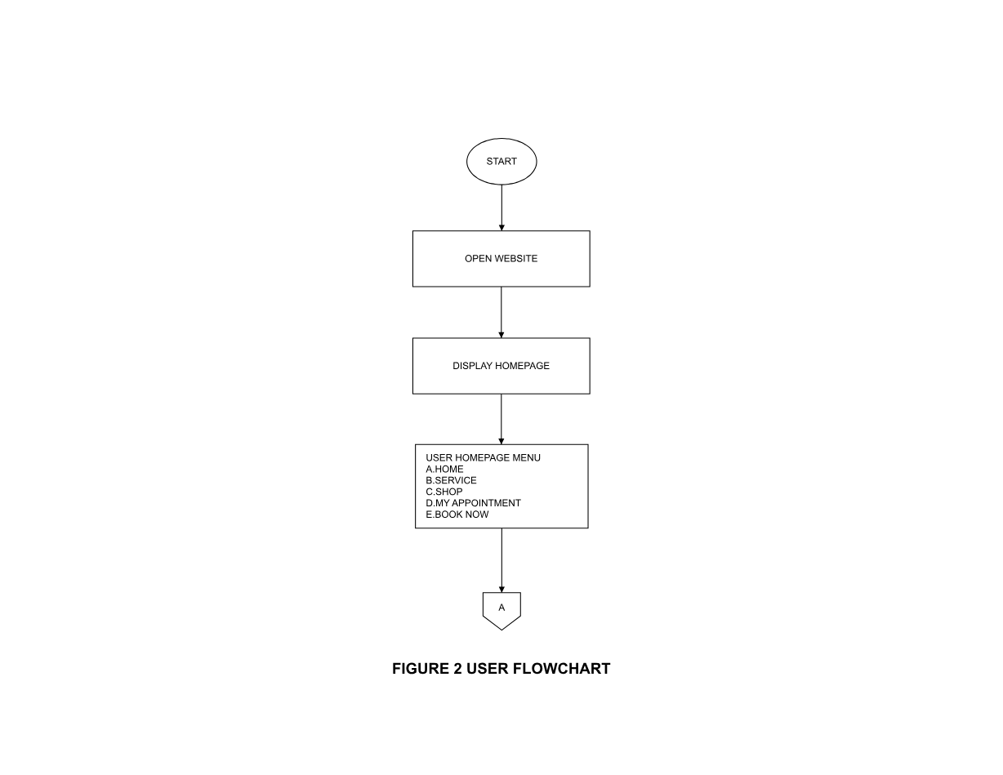
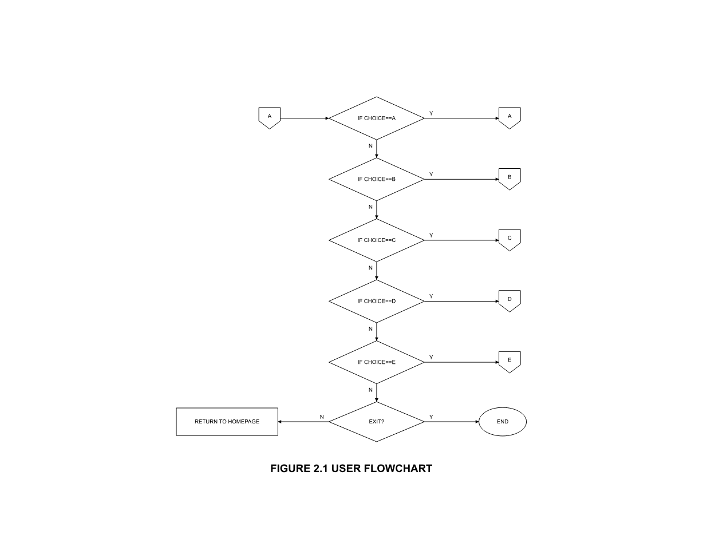
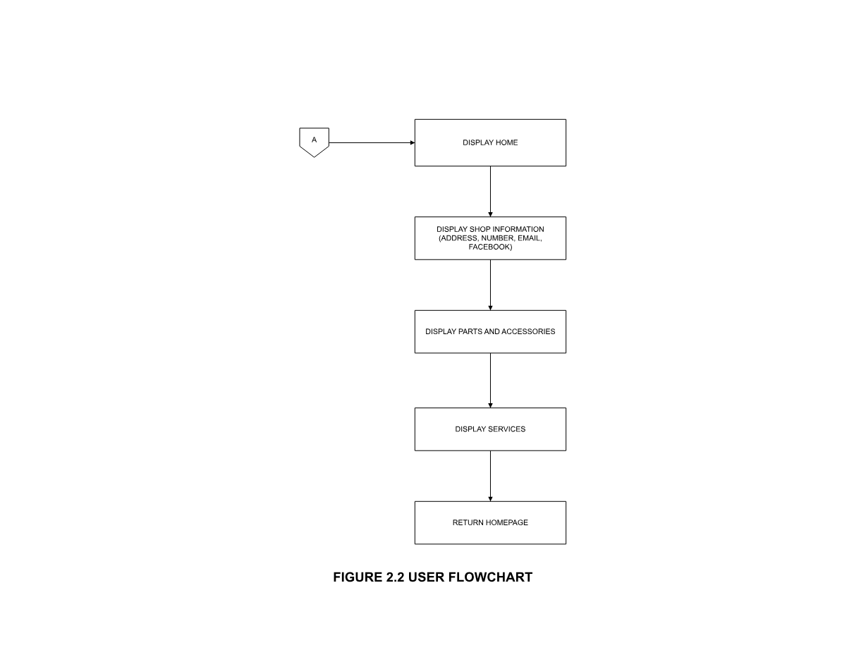
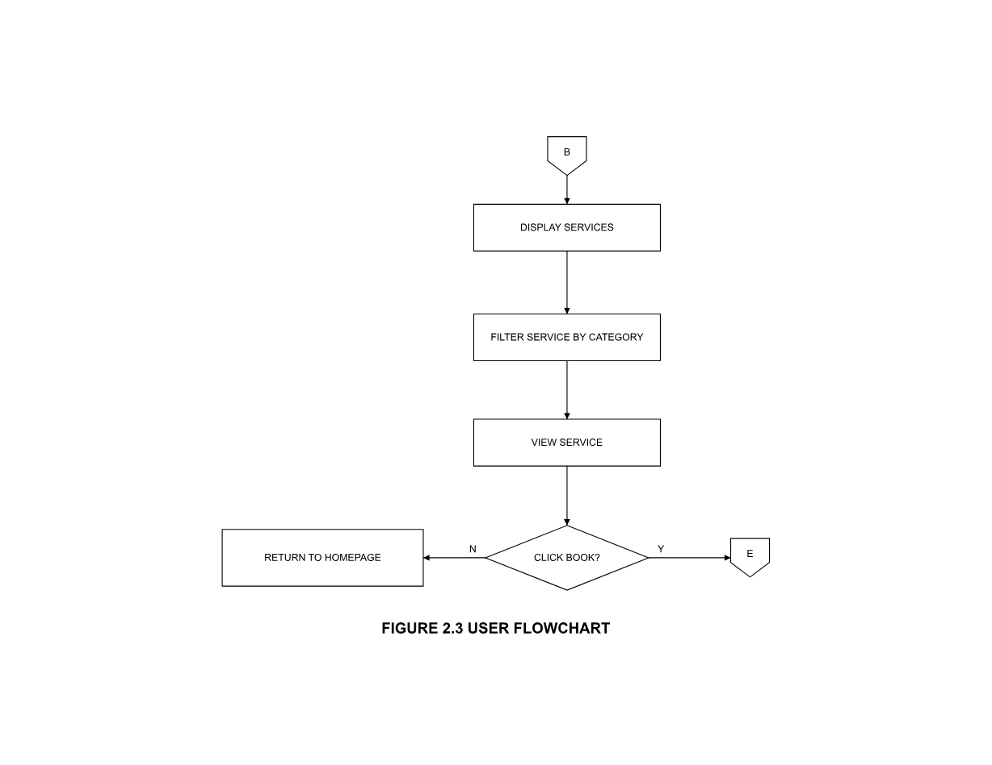
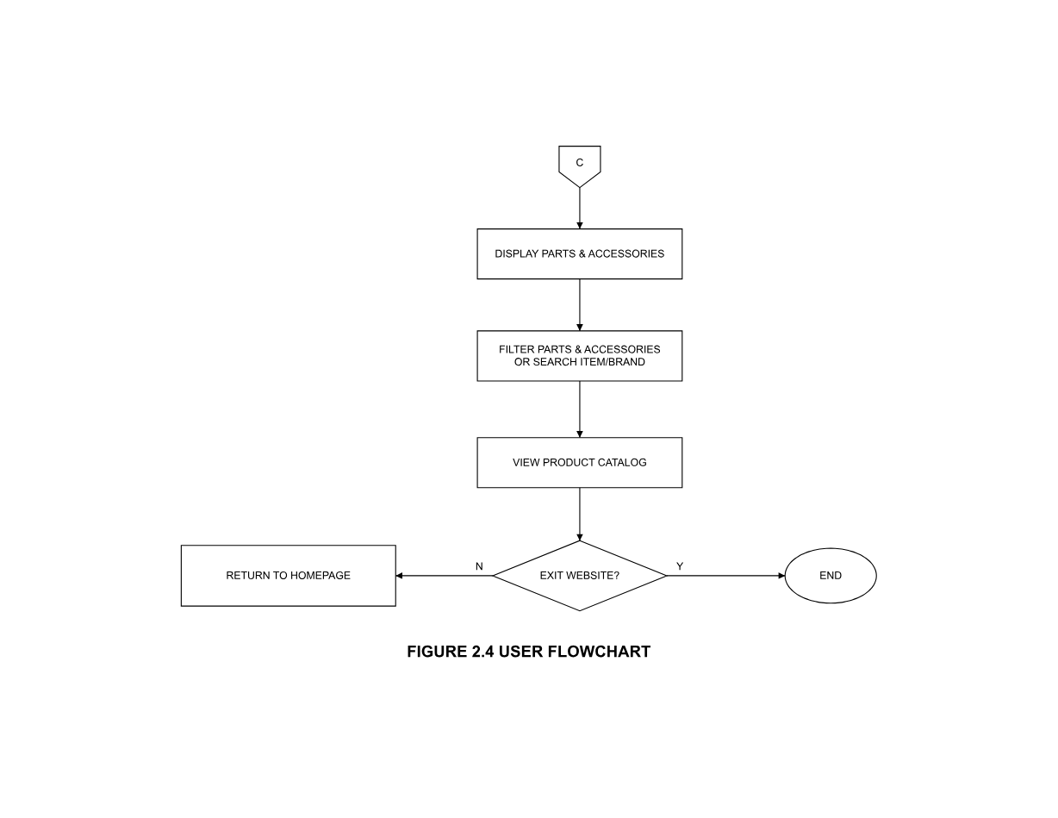
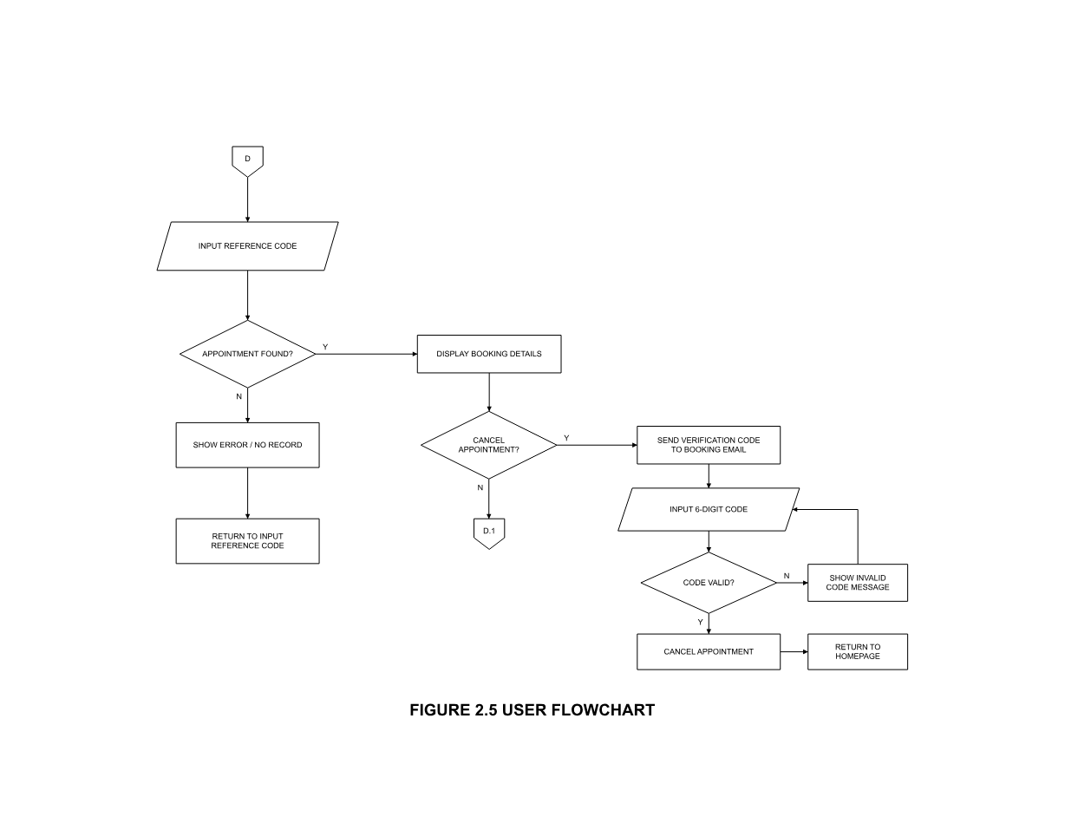
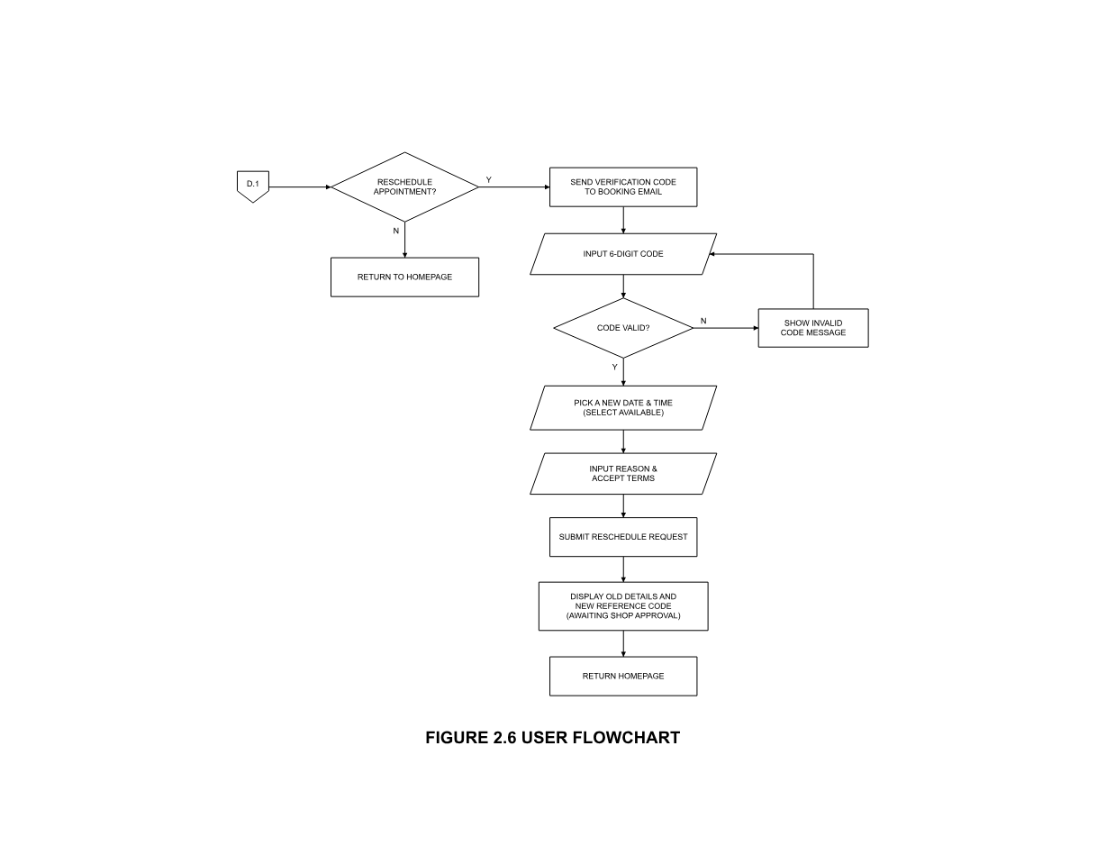
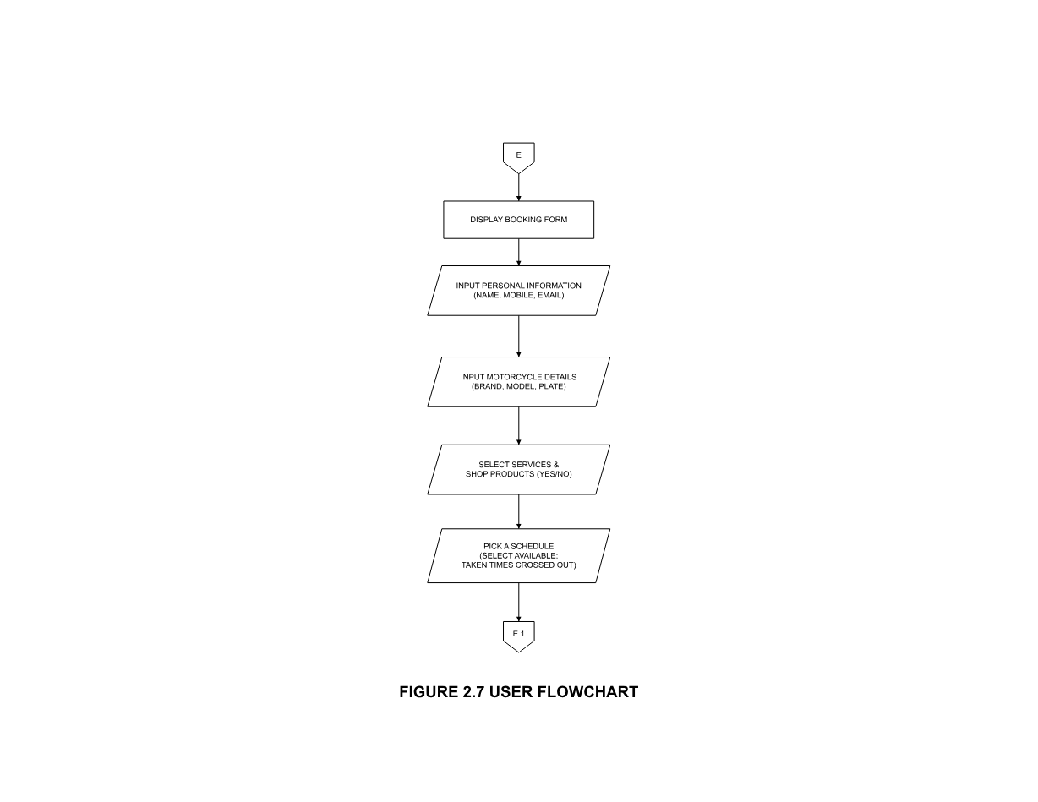
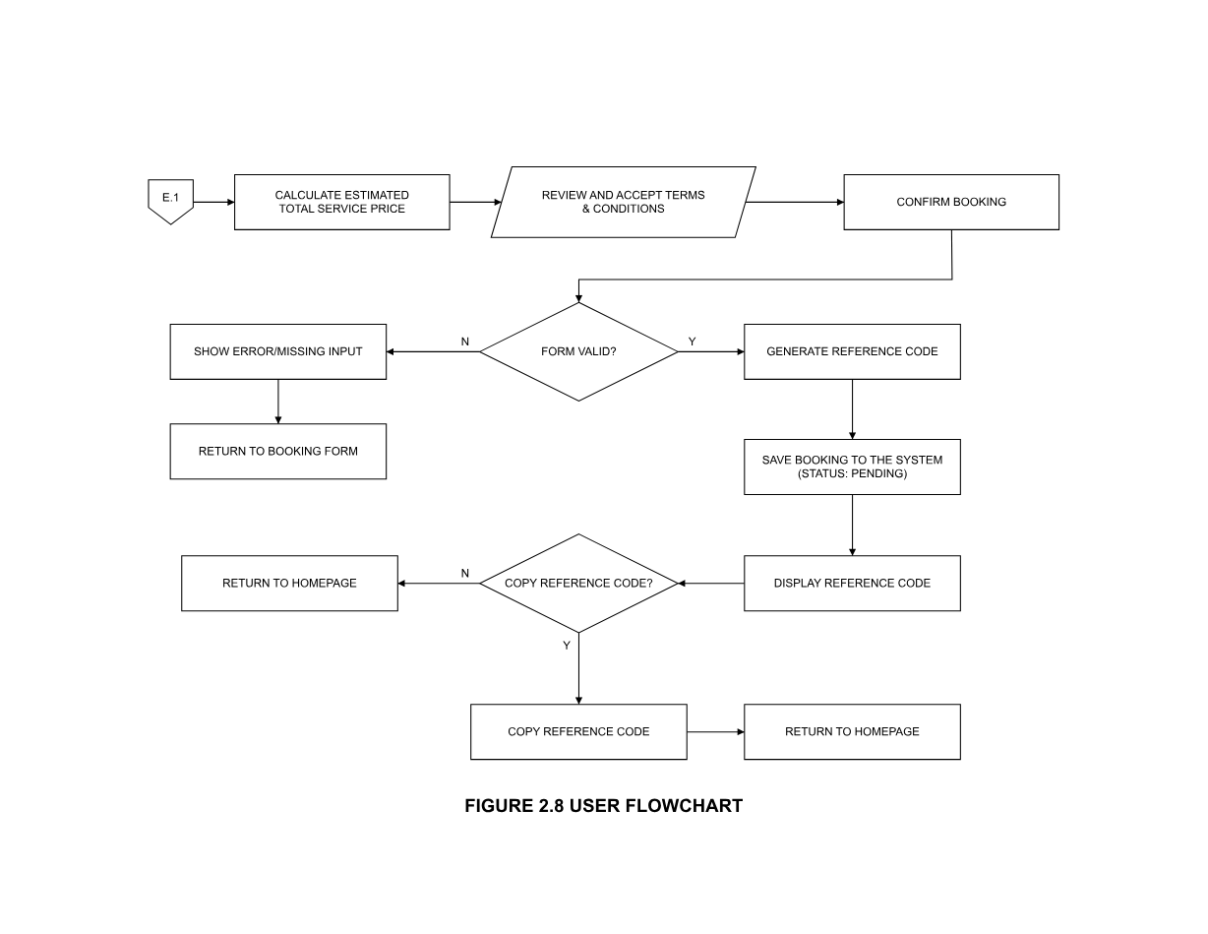
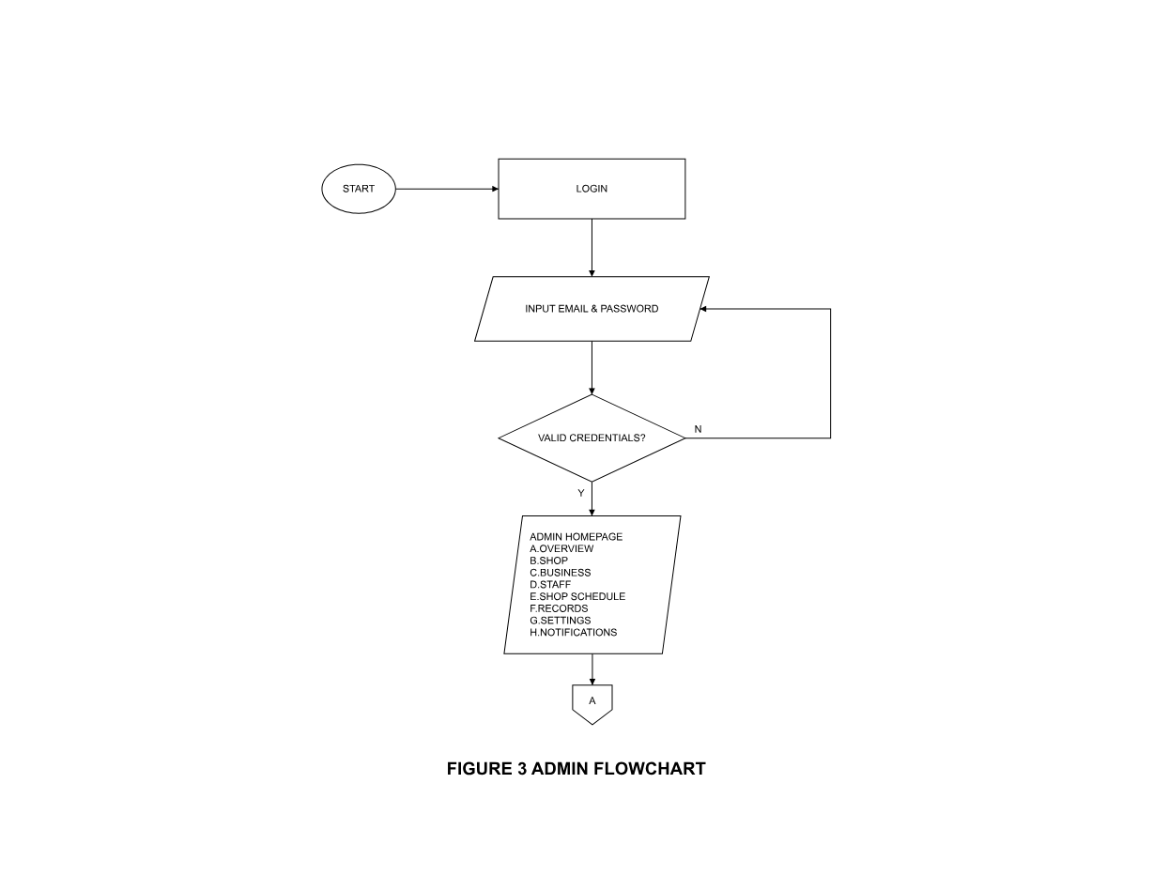
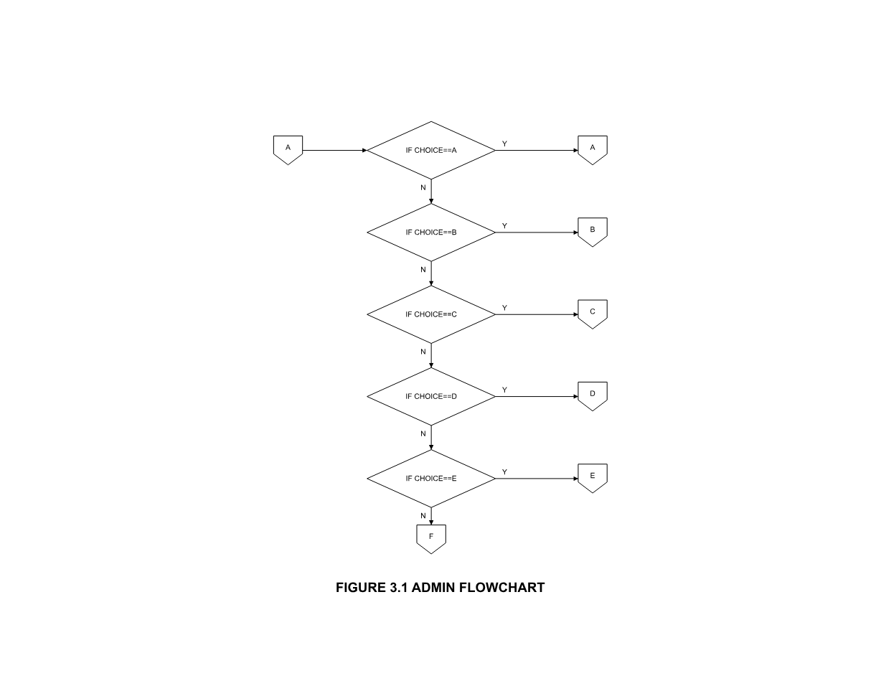
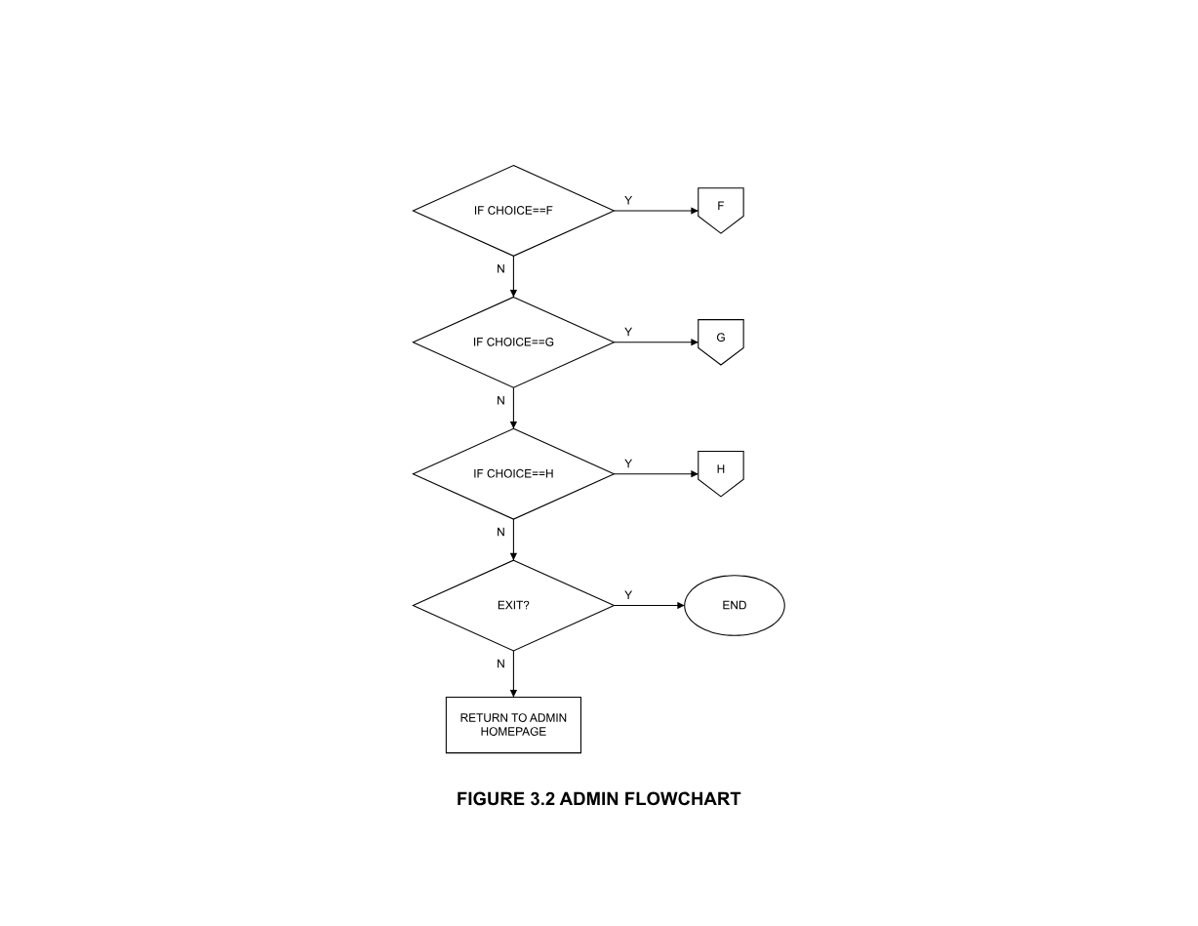
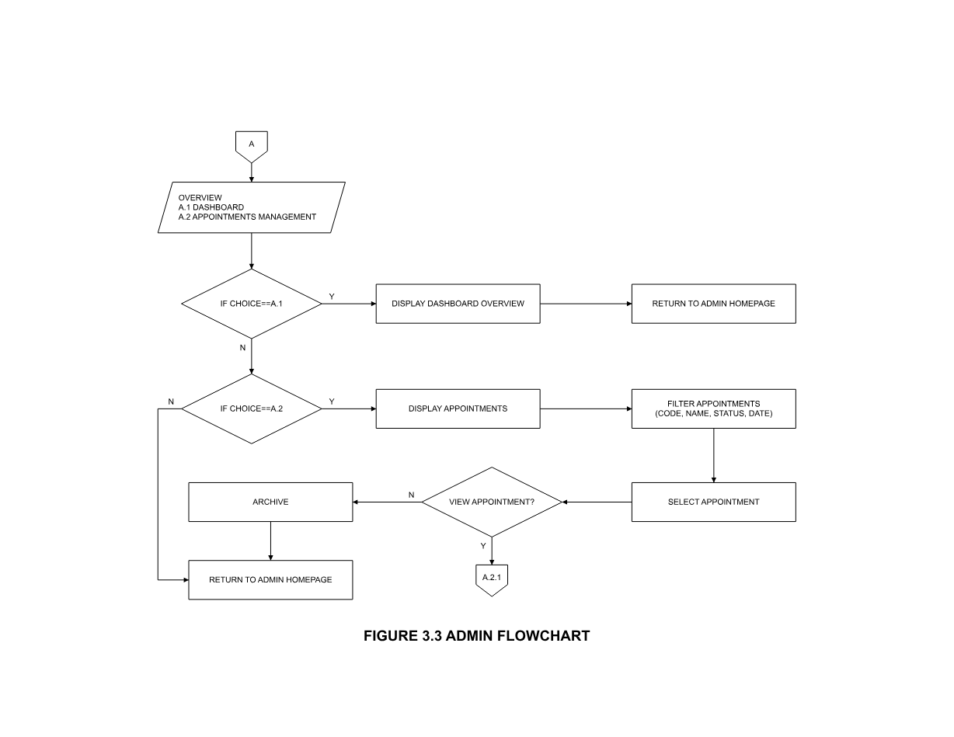
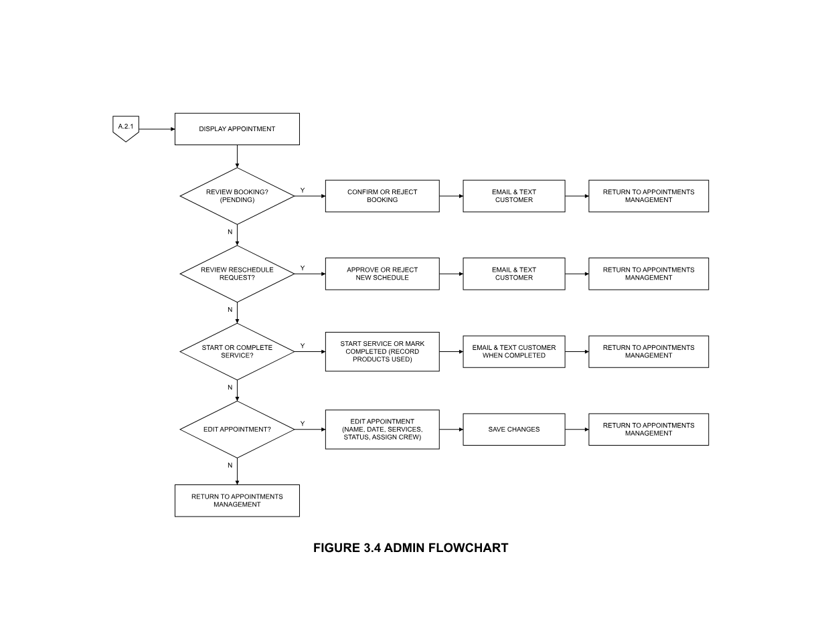
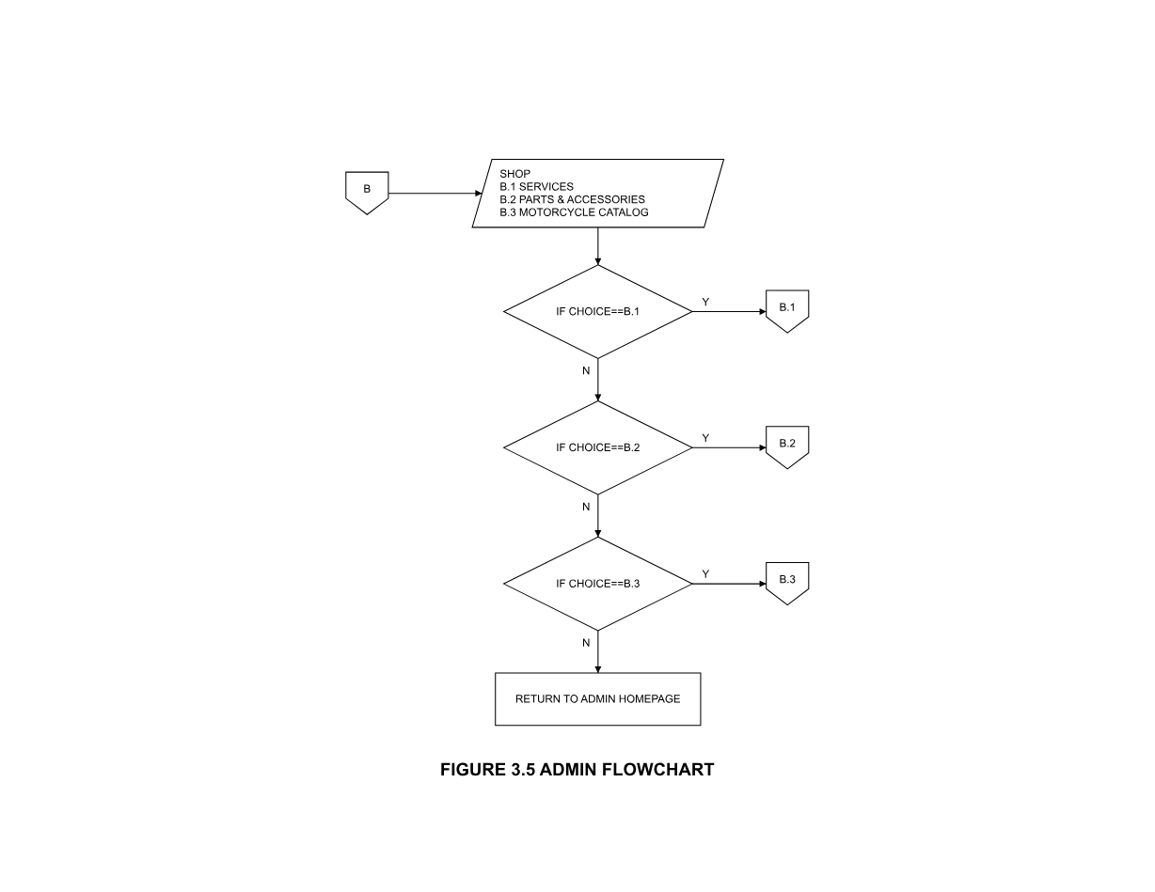
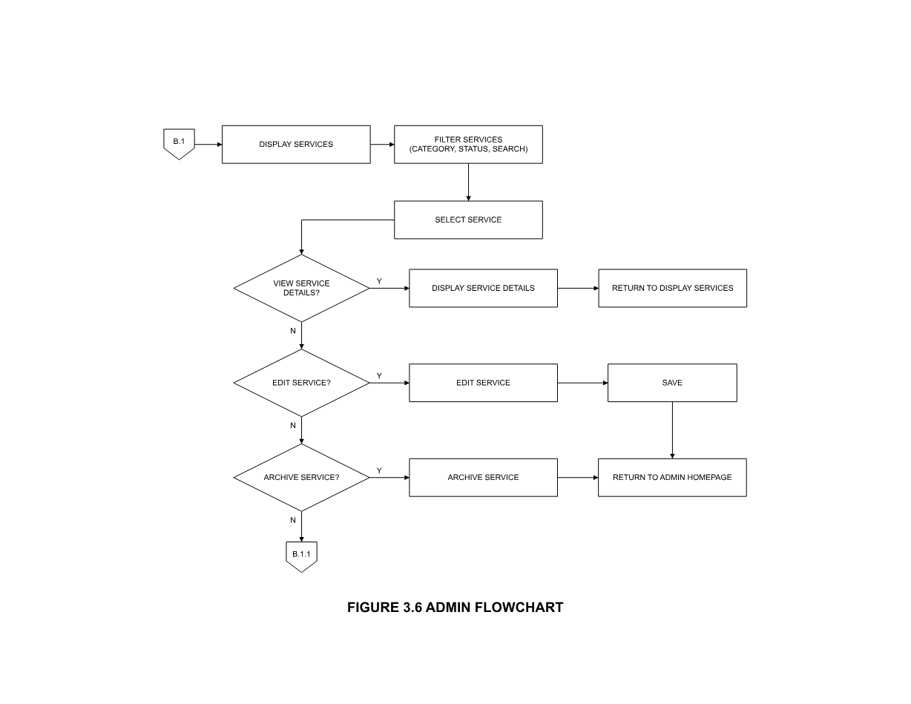
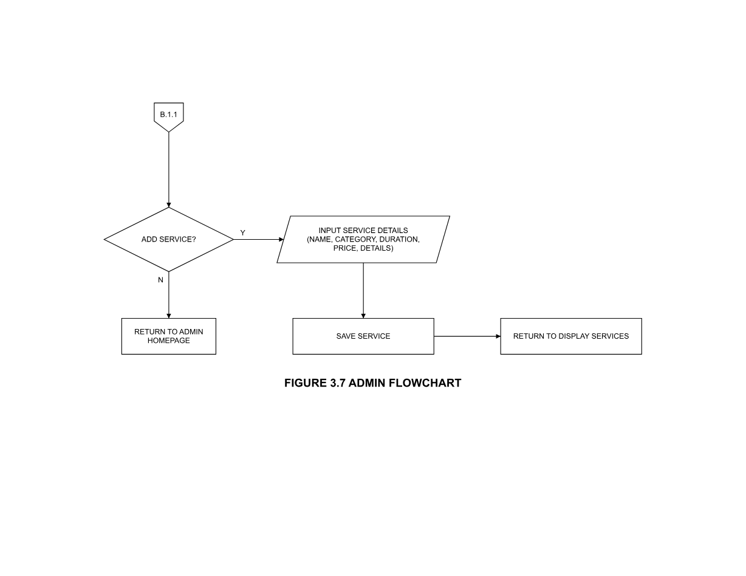
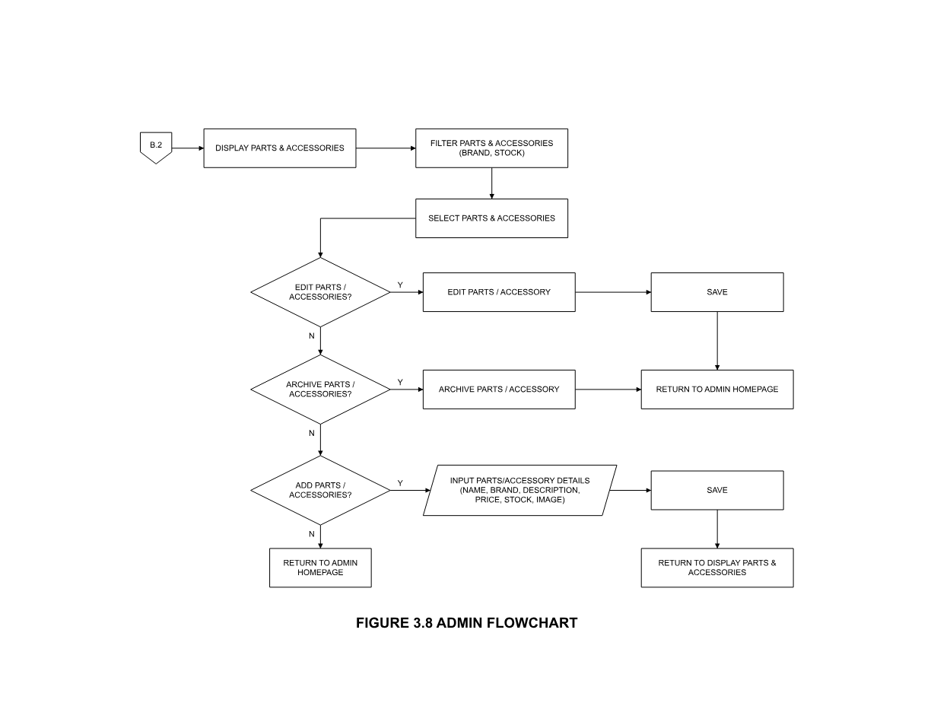
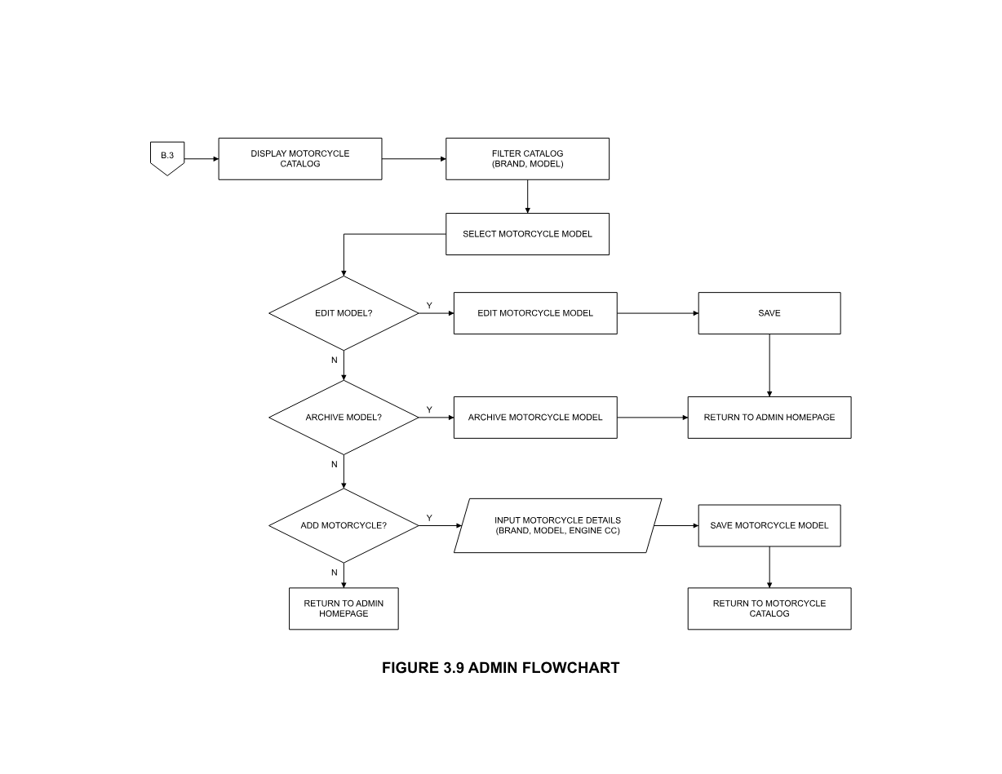
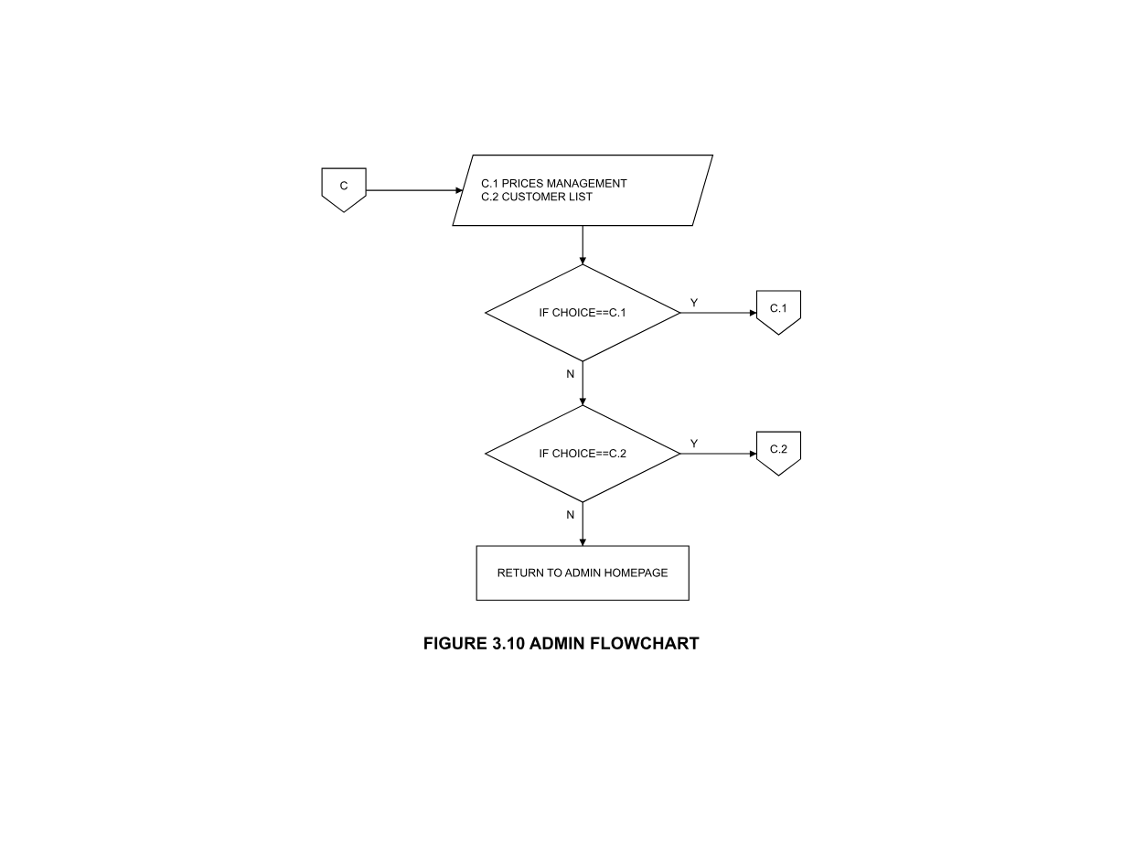
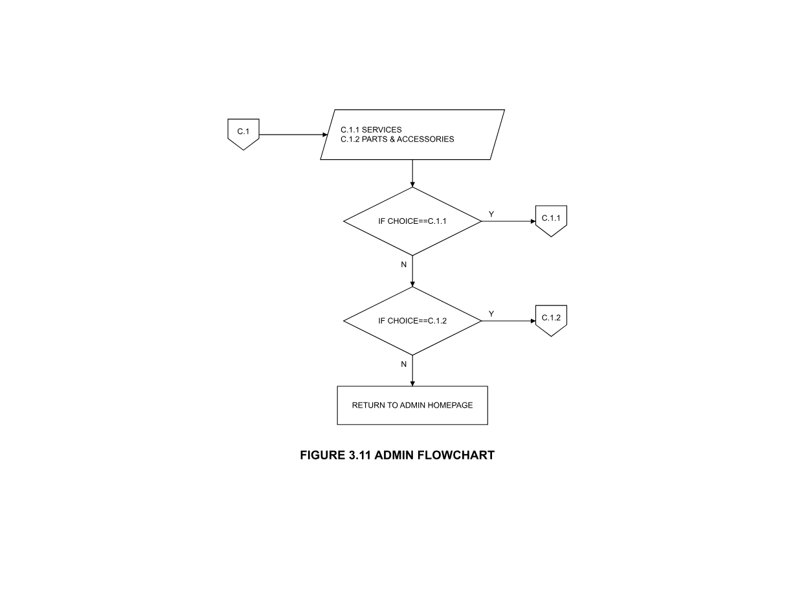
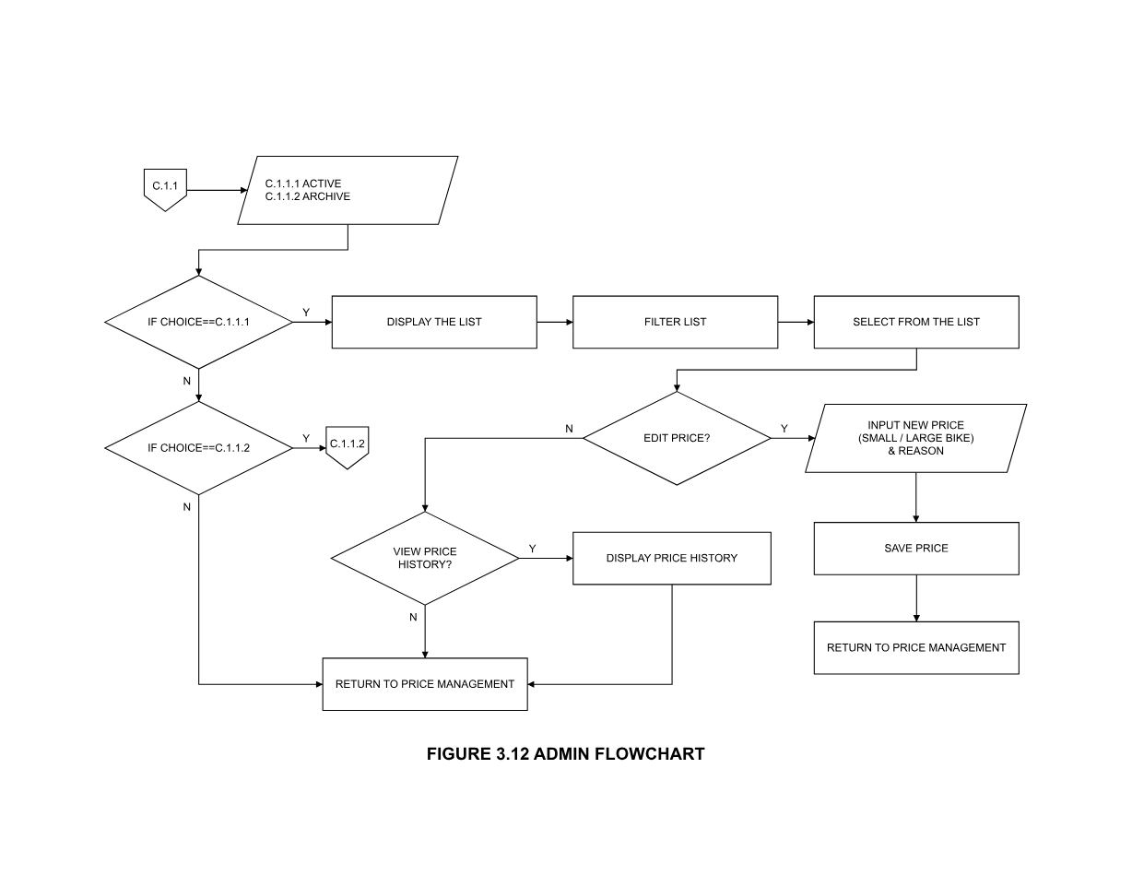
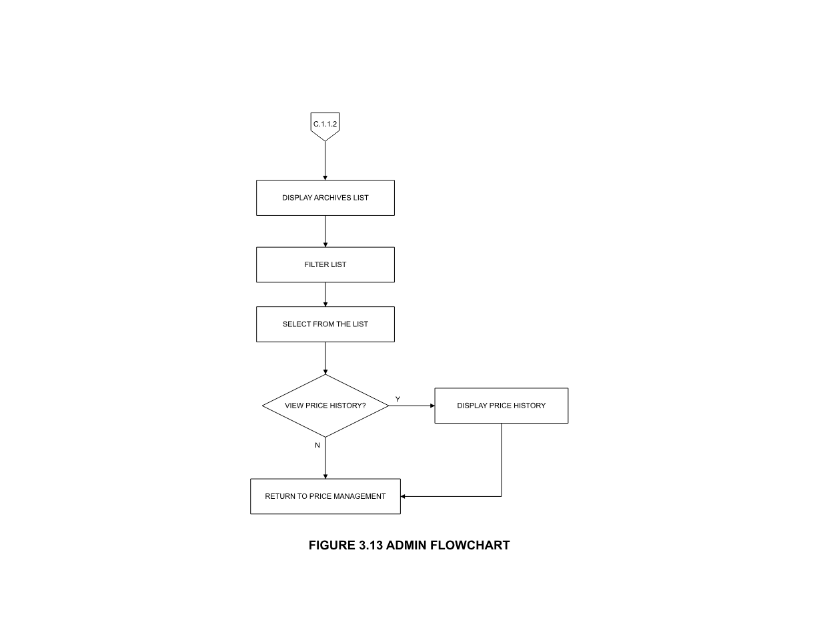
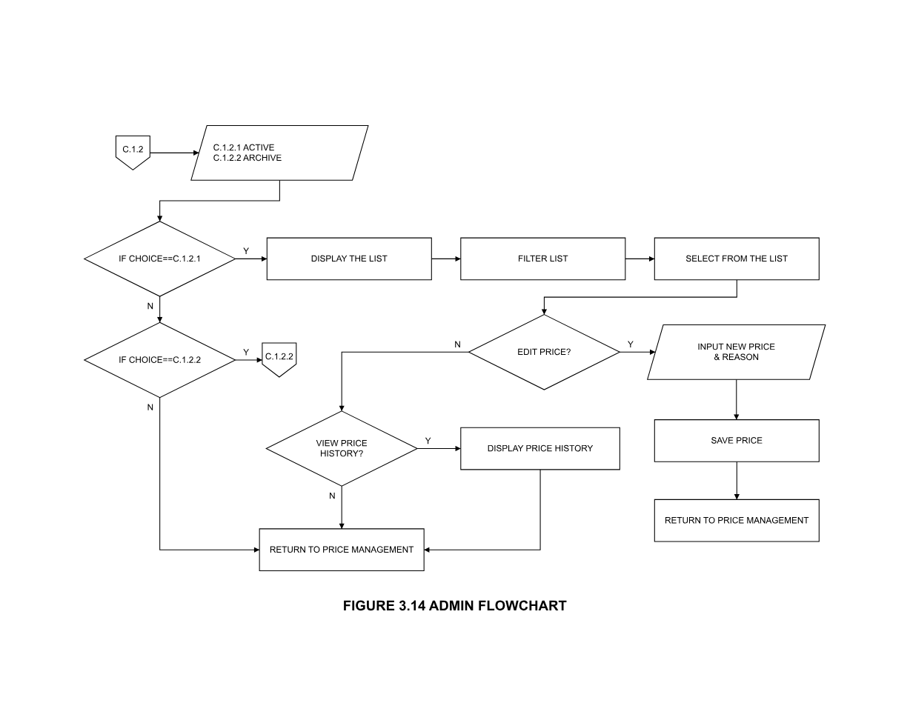
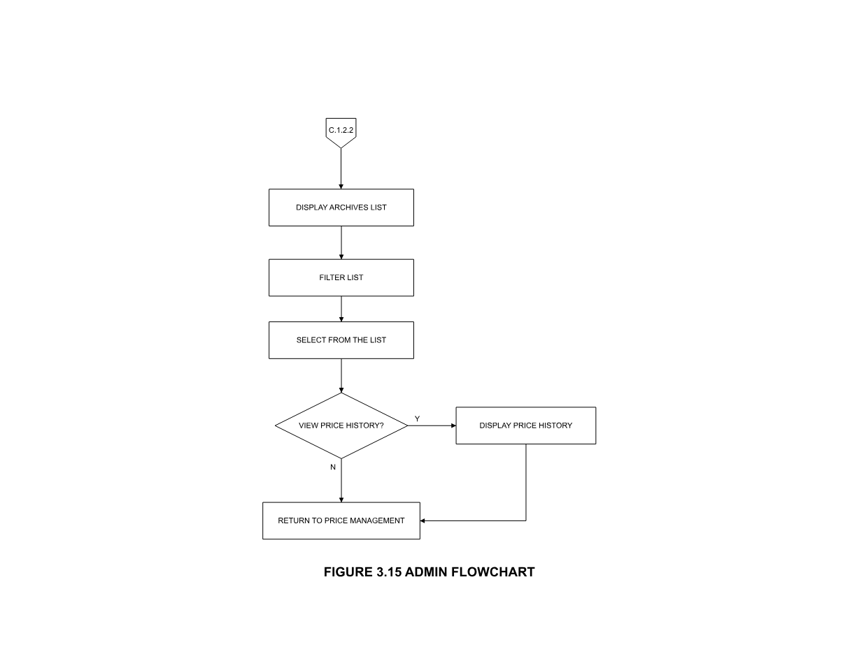
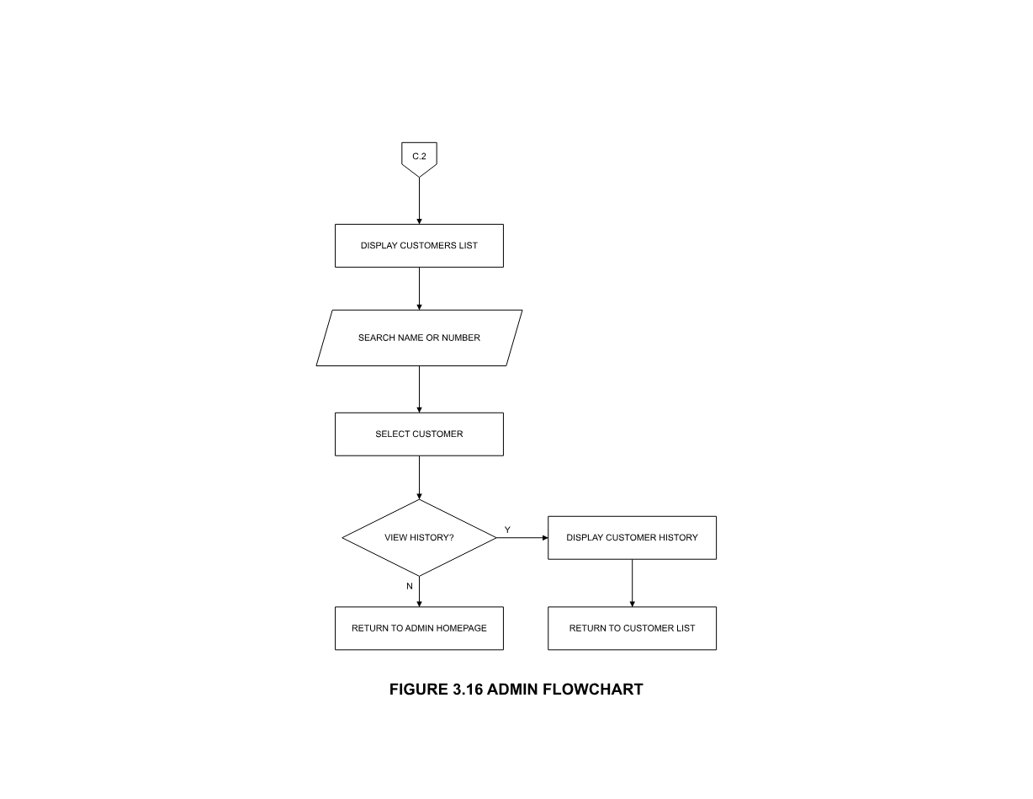
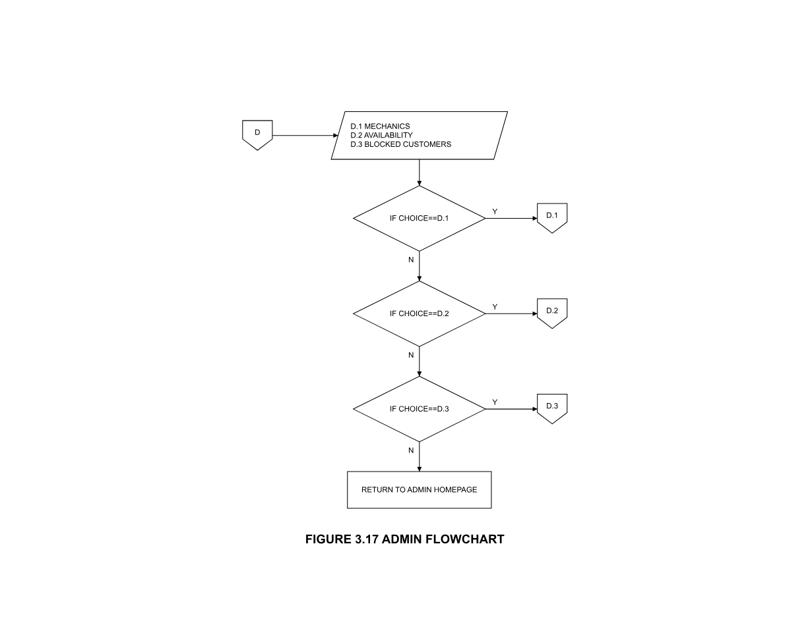
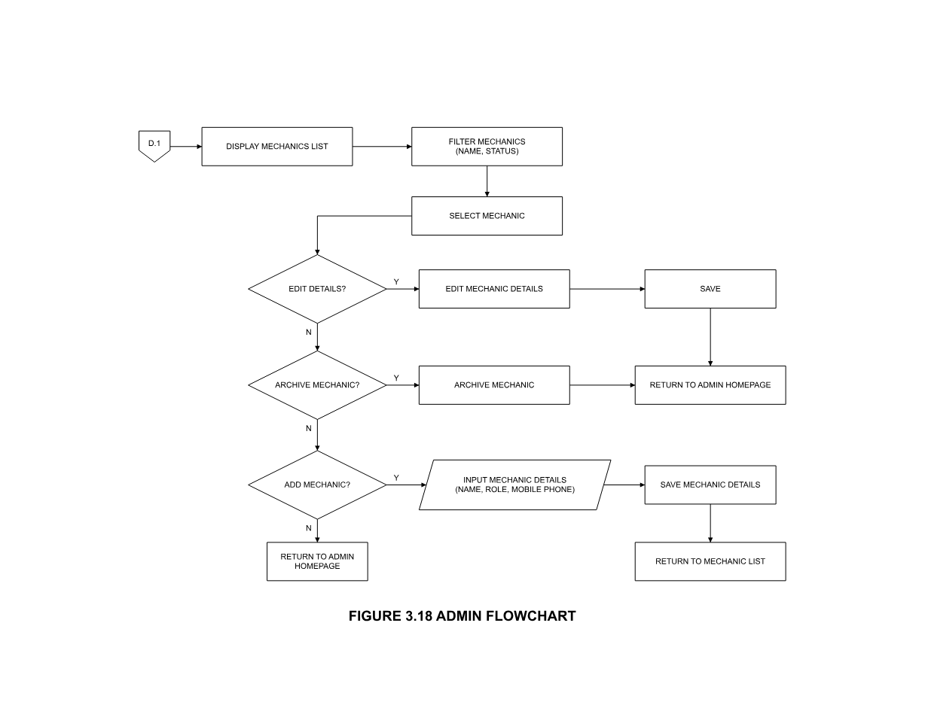
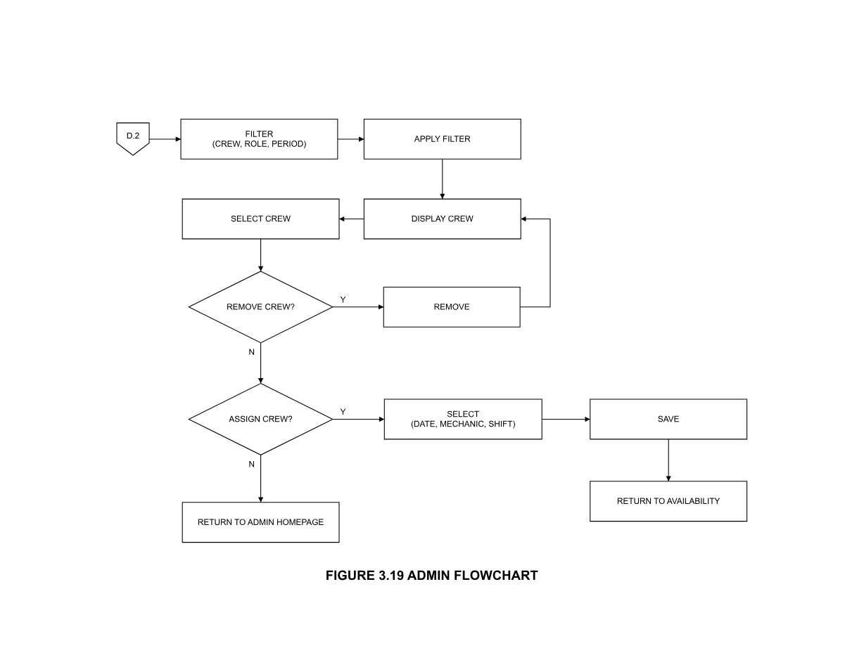
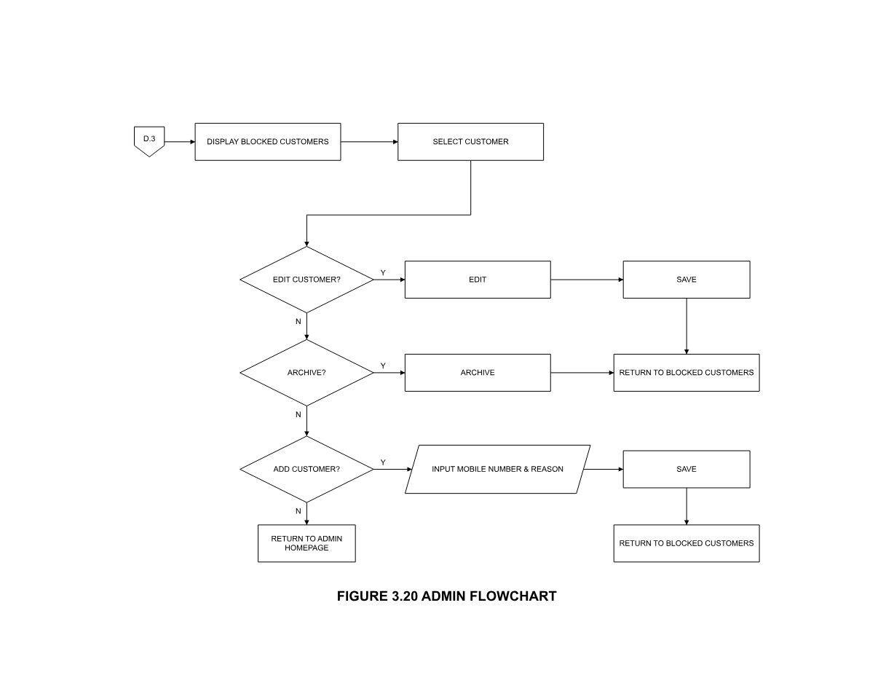
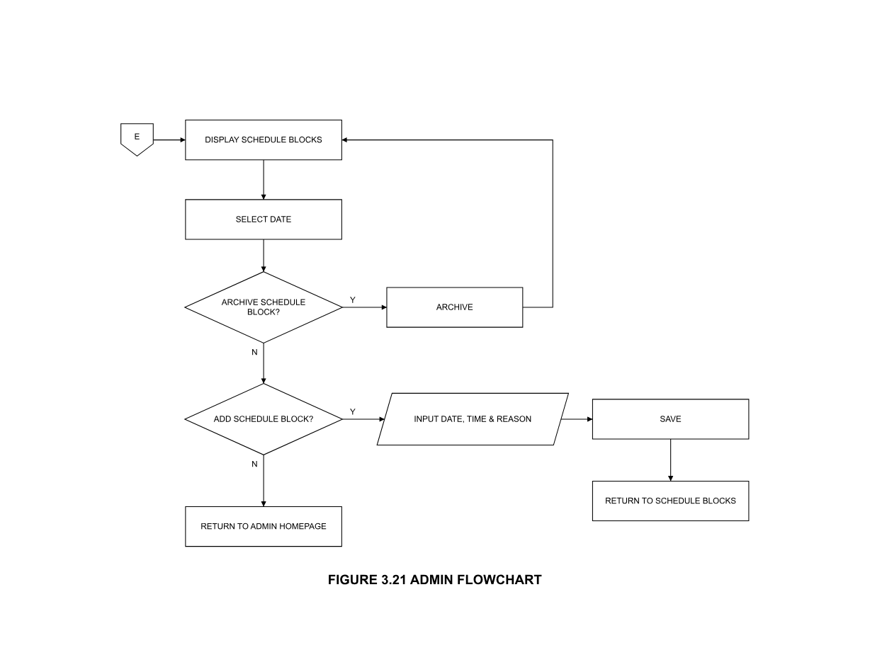
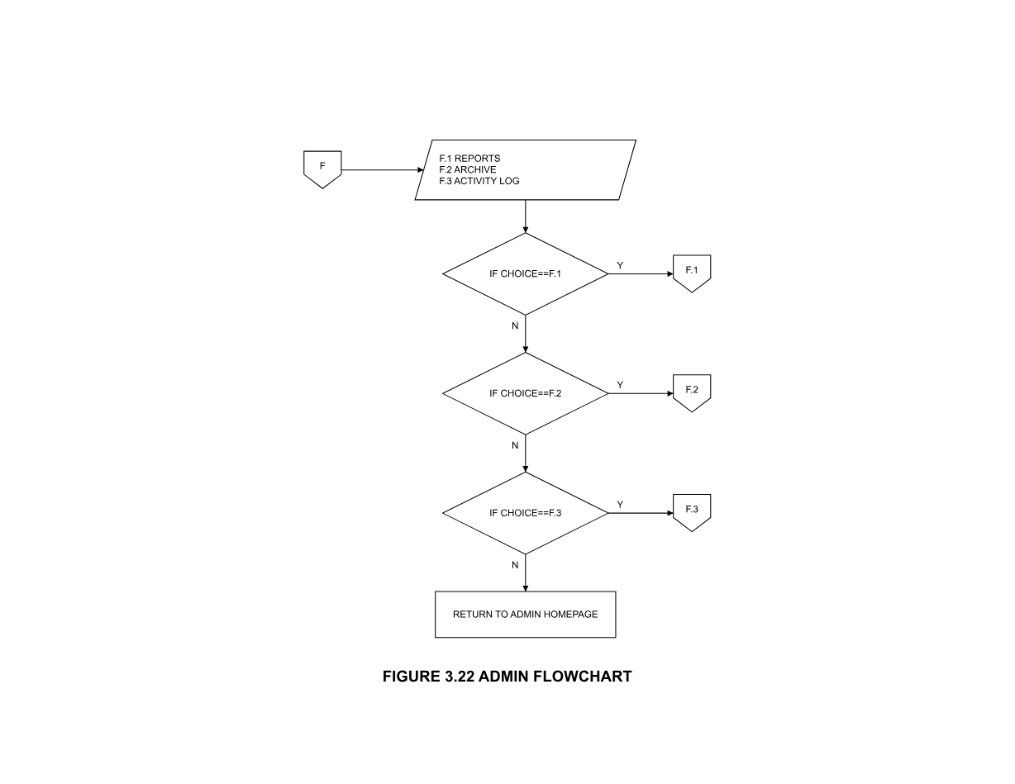
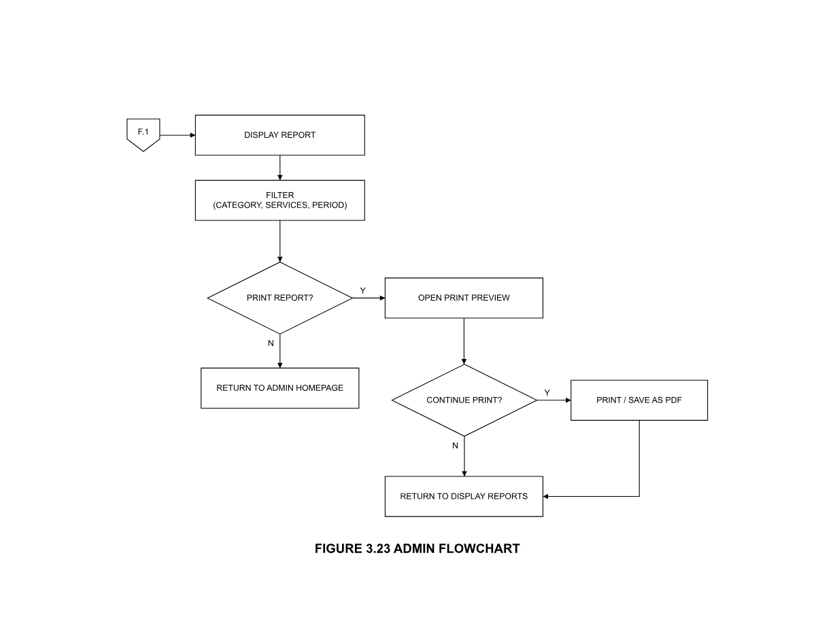
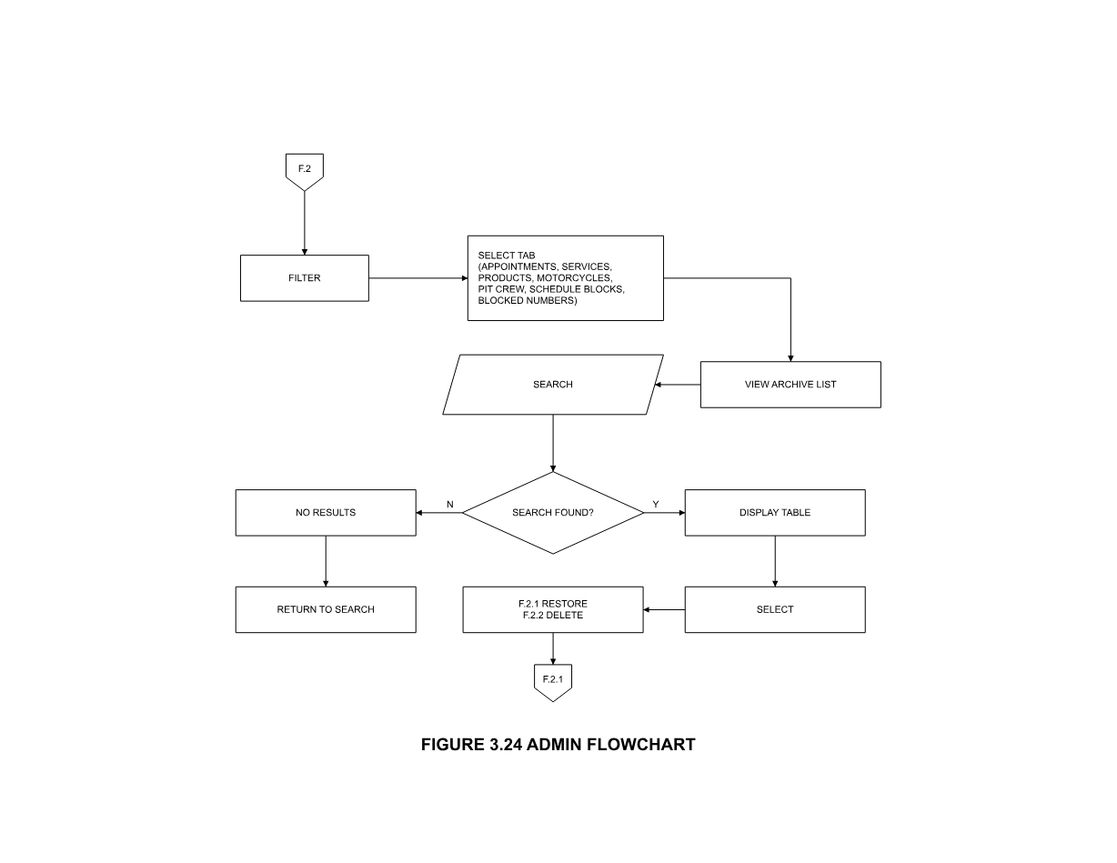
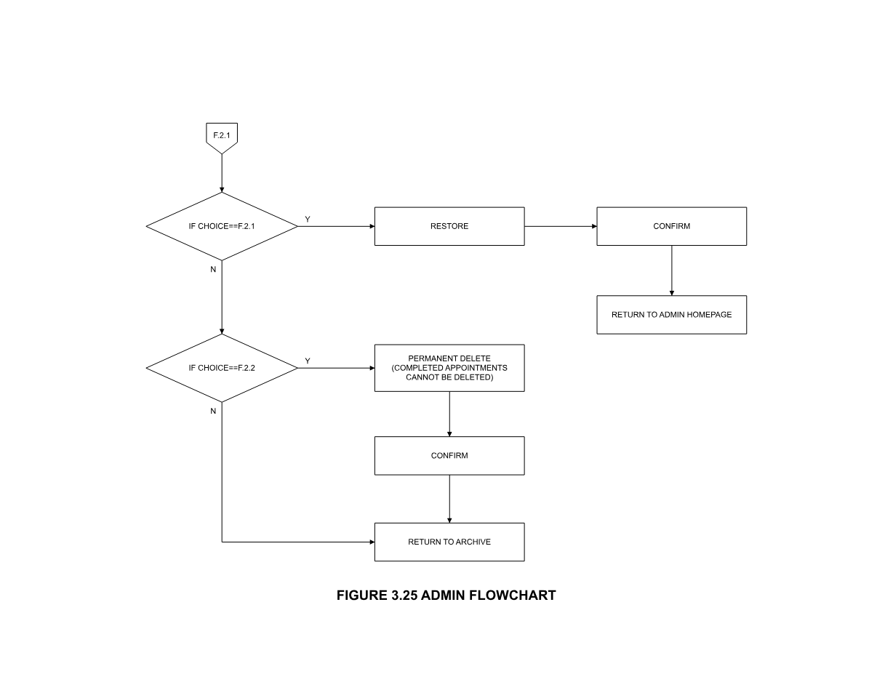
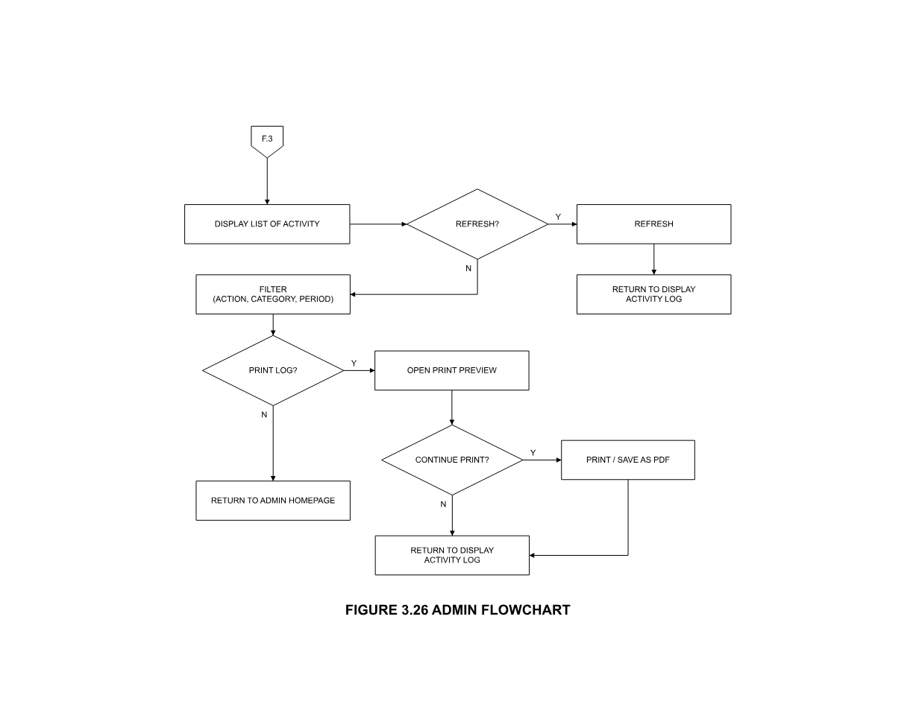
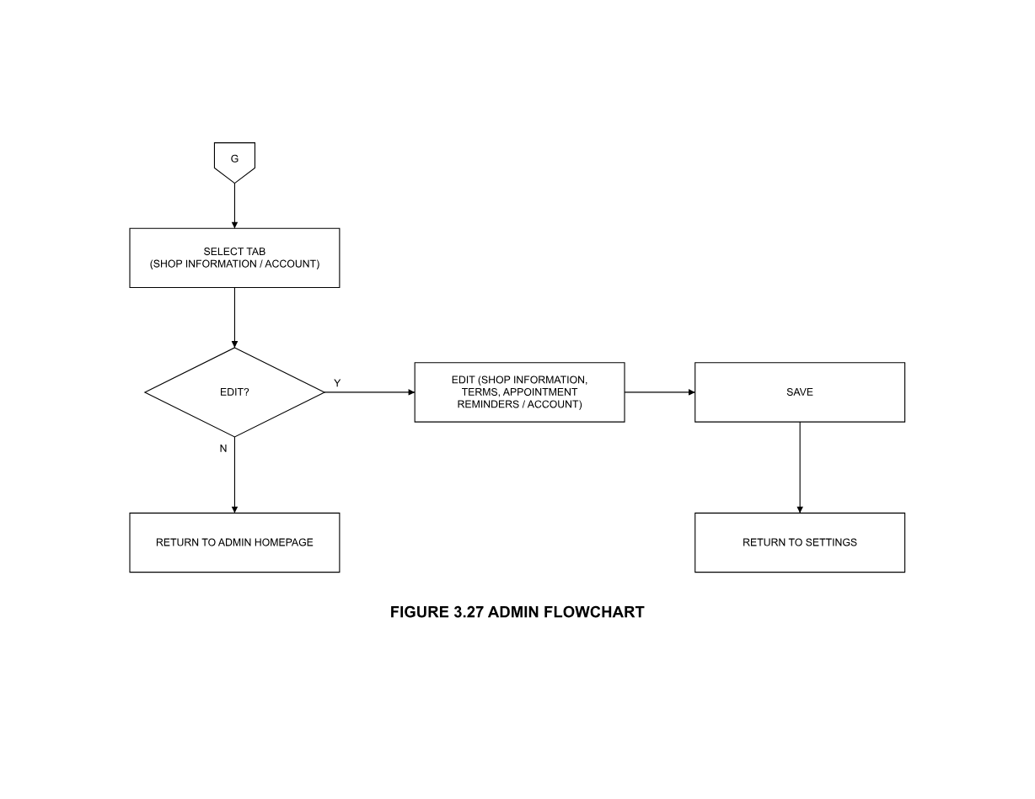
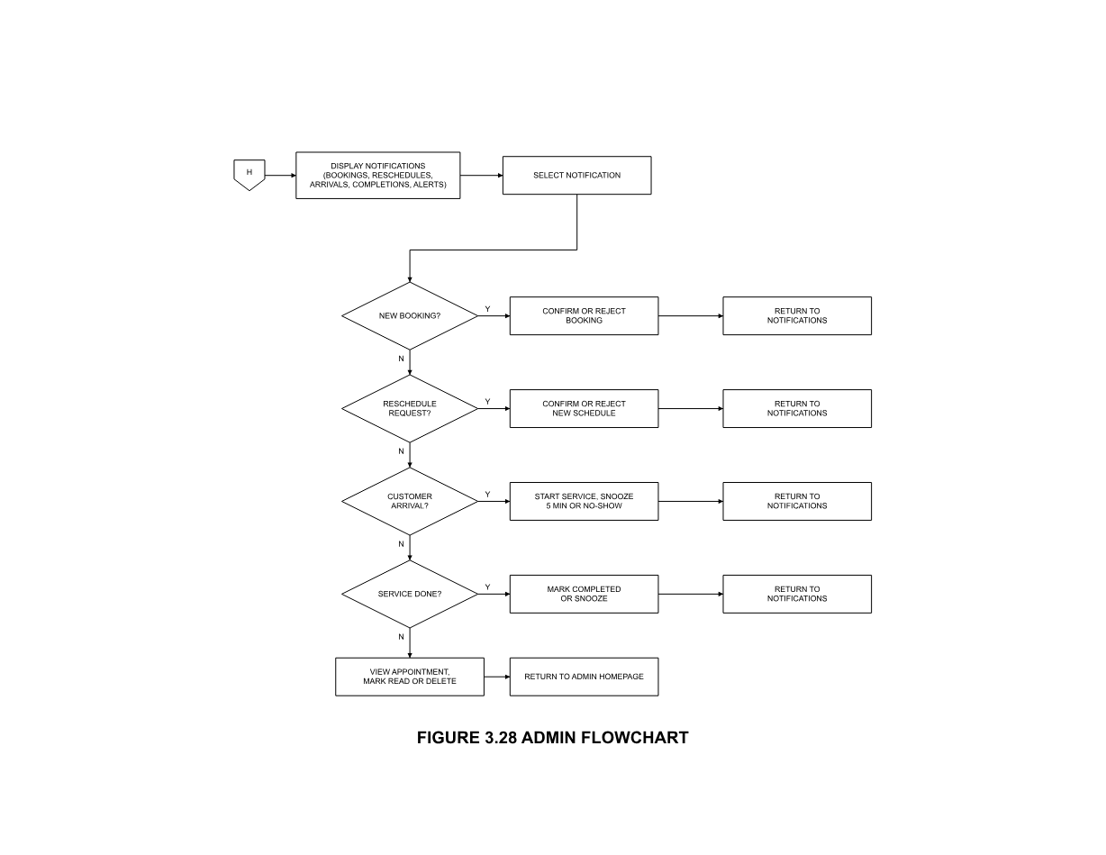
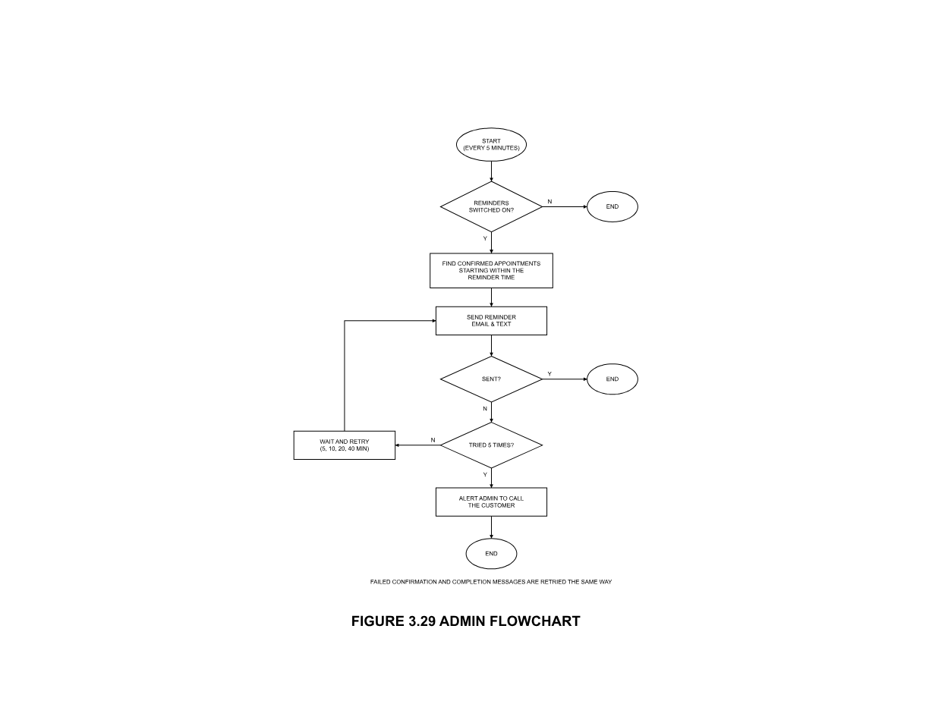

DEFINITION OF TERMS
The following terms are operationally defined based on how they are used in this study:
Appointment Scheduling – The process of managing customer appointments for motorcycle repair services by assigning available dates and times through the proposed system.
Customer Records – The stored information of customers and their appointment history used in managing repair service transactions.
Manual Process – The existing method of managing appointments and service information through handwritten records, walk-in scheduling, and verbal confirmations.
Repair Service – The motorcycle repair and maintenance services offered by Fake Rider Motorparts that customers can schedule through the proposed system.
Service Operations – The activities involved in managing appointments, customer information, repair services, and service status at the repair shop.
Technology Action Plan – The planned activities for the deployment, use, maintenance, and continued operation of the proposed system.
Web-Based Appointment Scheduling System – The proposed system developed for Fake Rider Motorparts to manage customer appointments, customer records, and repair service information through a web browser.

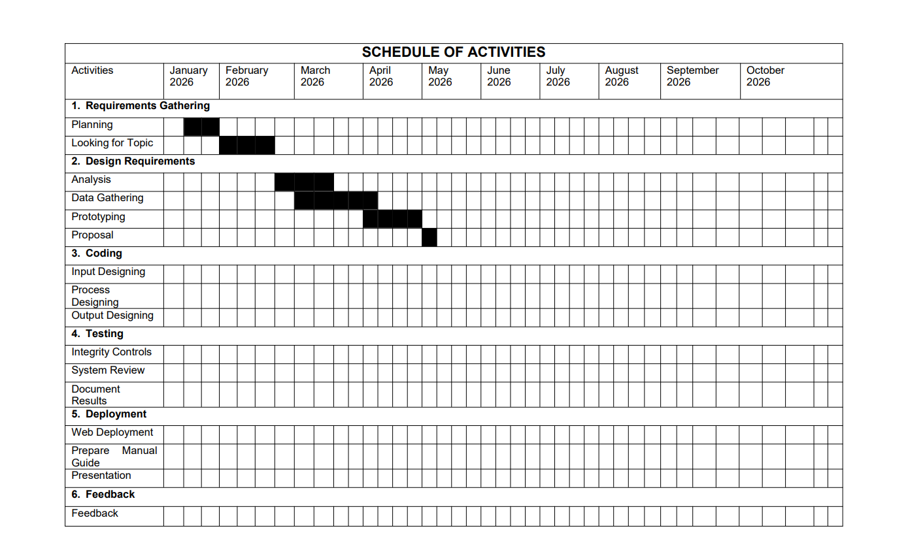

Figure 2. Gantt Char

CHAPTER 2
PRESENTATION OF THE PRESENT AND PROPOSED SYSTEM
- PRESENT SYSTEM
System Narrative
Fake Rider Motorparts is a local motorcycle repair shop that provides repair and maintenance services to customers in the community. At present, the shop manages appointment scheduling, customer records, and repair services through manual procedures. Customers usually visit the shop personally or contact the staff through phone calls to inquire about services and schedule appointments. Appointment details, customer information, and repair records are recorded manually in logbooks, while repair updates are communicated through phone calls or verbal conversations. The availability of motorcycle parts and accessories is also checked manually by the staff when requested by customers.
Despite the functionality of the current process, several challenges are encountered in managing appointments and repair services. Since bookings and customer information are recorded manually, scheduling conflicts, misplaced records, and incomplete information may occur. Staff members also spend additional time checking previous records, organizing appointments, and coordinating repair services. These procedures can affect the efficiency of daily operations, particularly when several customers and repair services are being handled at the same time.
The existing process also affects communication between the shop and its customers. Customers need to contact or visit the shop to schedule an appointment, inquire about repair progress, or check the availability of motorcycle parts and accessories. This may result in delays in receiving service information and may require customers to make unnecessary visits to the shop. As the number of customers increases, these limitations make it more difficult to maintain organized records and efficiently coordinate appointments and repair services.
To address these challenges, the proposed Web-Based Appointment Scheduling System for Fake Rider Motorparts will provide a centralized platform for managing appointments, customer records, and repair services. Customers will be able to schedule appointments online without creating an account or logging in, while the administrator will manage appointments, customer information, repair status, and other system records through the administrator account. The system will also provide notifications regarding appointment approval, repair progress, and service updates to improve communication between the shop and its customers.
Constraints
The current appointment scheduling and repair service process of Fake Rider Motorparts has several limitations due to its use of manual procedures. Appointment details, customer information, repair records, and service updates are recorded and managed manually through logbooks, personal visits, and phone calls. This makes the process more time-consuming and may result in scheduling conflicts, incomplete records, and difficulty in retrieving previous information.
The lack of an organized appointment and service monitoring process also affects communication between the shop and its customers. Customers need to contact or visit the shop to schedule appointments, ask about repair progress, or check the availability of motorcycle parts and accessories. Staff members also spend additional time checking records, managing schedules, responding to inquiries, and providing service updates.
As the number of customers and repair transactions increases, manually managing appointments and service records becomes more difficult. The absence of a centralized platform also limits the ability of the shop to organize customer information, monitor repair services, and provide timely appointment updates. These limitations can affect the efficiency of daily operations and the service provided to customers.
To address these constraints, the proposed Web-Based Appointment Scheduling System will provide a centralized platform for managing appointments, customer records, repair services, notifications, and motorcycle parts and accessories information. Customers will be able to book appointments without creating an account or logging in, while the administrator will manage the system through the administrator account. The proposed system aims to reduce manual work, improve record organization, minimize scheduling conflicts, and make appointment and service information easier to access.

Walk-in Appointment
Shop Staff
Manual Appointment Scheduling and Records Management
Customer
Customer Information and Repair Details
Appointment Confirmation and Repair Status Updates
Appointment Schedule and Repair Records

Figure X. Context Diagram of Present System
Event List
- Manual Walk-In Appointment Scheduling
- Manual Recording and Management of Customer and Repair Records
- Manual Monitoring of Repair Services
- Manual Customer Notification and Repair Status Updates
Event List Diagram
Customer
Walk-in appointment and recording of details
Appointment recorded in logbook

Figure X. Manual Walk-In Appointment Scheduling
Shop Staff
Recording customer information and repair details logbook
Customer and repair details stored in logbook/files

Figure X. Manual Recording and Management of Customer and Repair
Shop Staff
Manual monitoring of repair progress and service schedule
Updated repair status
Records

Figure X. Manual Monitoring of Repair
Shop Staff
Providing appointment confirmation and repair status through personal visit or phone call
Customer receives service updates

Figure X. Manual Customer Notification and Repair Status Updates
B. PROPOSED SYSTEM
System Rules
The proposed Web-Based Appointment Scheduling System for Fake Rider Motorparts shall provide a centralized platform for managing customer appointments, repair service records, service updates, and motorcycle parts and accessories. The system shall support customers in scheduling repair appointments and accessing relevant service information, while allowing the administrator to manage appointments, customer records, repair services, and other system information. By integrating these functions into a single platform, the system shall help improve the organization and efficiency of appointment and repair service management.
The proposed Web-Based Appointment Scheduling System for Fake Rider Motorparts shall provide a centralized platform for managing customer appointments, repair service records, service updates, and information about motorcycle parts and accessories. The system shall support customers in scheduling repair appointments and accessing relevant service information, while allowing the administrator to manage appointments, customer records, repair services, and other system information. By integrating these functions into a single platform, the system shall help improve the organization and efficiency of appointment and repair service management.
The system shall allow customers to access the appointment scheduling services without creating an account or logging in. Customers shall provide the necessary information when submitting an appointment request, including their name, contact number, motorcycle information, preferred service, appointment date, and available time slot. The system shall retrieve existing appointments and schedule blocks for the selected date and display the available time slots and on-duty mechanics. Customers shall be able to select a specific mechanic or choose no mechanic preference before submitting the appointment request.
The system shall validate the information provided by the customer before accepting an appointment request. If the required information is complete and valid, the system shall save the appointment record, set its status to Pending, generate a unique booking reference number, and display the reference number to the customer. The booking reference number shall be used by customers to look up their appointment details and status without creating an account or logging in.
The system shall allow customers to look up their appointment by entering the assigned booking reference number. The system shall display the appointment details and current status when a matching record is found. Customers shall be allowed to cancel an appointment only when its status is Pending. Once a cancellation is confirmed, the system shall update the appointment status to Cancelled and record the cancellation activity.
The administrator shall be required to log in using the designated administrator account before accessing the administrative functions of the system. The system shall validate the administrator’s login credentials before granting access to the administrator dashboard. Customers shall not be required to create an account or log in when using the customer-side functions.
The administrator shall manage appointment requests by viewing appointment details, searching or filtering appointments, and updating appointment statuses. The administrator shall be able to view customer information, motorcycle details, selected services, appointment schedules, and other relevant information associated with each appointment. Any changes to appointment records shall be recorded by the system to maintain an organized history of activities.
The system shall allow the administrator to manage the services and motorcycle parts and accessories displayed in the system. The administrator shall be able to add, edit, and archive service or product records, including their names, descriptions, prices, categories, and images. The information maintained by the administrator shall be displayed to customers through the shop section of the system, allowing them to browse available services and parts and accessories.
The system shall allow the administrator to manage service and product prices within the system. When a price is updated, the system shall save the new price and record the corresponding price change in the price history. The recorded price history shall allow the administrator to review previous price changes for a selected service or product.
The administrator shall be able to manage mechanic information and duty schedules within the system. The administrator shall be able to add, edit, or remove mechanic records and assign duty schedules based on their availability. The system shall use the assigned duty schedules when displaying available mechanics during the appointment booking process.
The administrator shall be able to create and manage schedule blocks for dates or time periods when appointments cannot be accepted. The administrator shall provide the applicable date, time range or full-day setting, and reason for the blocked schedule. The system shall prevent blocked dates or time periods from being presented as available appointment schedules to customers.
The system shall maintain customer information, appointment records, repair service records, and service history in a centralized database. The administrator shall be able to view customer records and retrieve their appointment history based on the information stored in the system. This shall allow the administrator to access previous appointment and service information when needed.
The system shall allow the administrator to update the repair status of an appointment as the service progresses. Customers shall be able to view the status of their repair service without requiring an account. This feature shall allow customers to check whether their repair service is pending, ongoing, or completed and reduce the need for repeated inquiries through phone calls or personal visits.
The system shall provide notifications for important appointment and service updates. The system shall notify the administrator when a new appointment is submitted and shall provide customers with relevant updates regarding their appointment status and repair service. Notifications shall be associated with the corresponding appointment to help improve communication between Fake Rider Motorparts and its customers.
The system shall provide reports based on appointment, revenue, and service information for a selected date range. The administrator shall be able to select the report type and date range, view the generated results, and export the reports in the available file formats. These reports shall support the administrator in monitoring appointments, services, and business-related information.
The system shall allow customers to browse the available services and motorcycle parts and accessories through the shop section. The system shall display active and non-archived records based on the selected category. Customers shall be able to view the available information before deciding to schedule a repair appointment. The system shall not include inventory management or automatic stock monitoring for motorcycle parts and accessories.
The system shall provide an archive function for service, product, and appointment records that are no longer actively used. The administrator shall be able to archive selected records without permanently deleting their information. Archived records shall be stored separately and may be retrieved by the administrator when needed. The administrator shall also be able to restore archived records to make them active again or permanently delete them when necessary.
The system shall maintain records of relevant activities performed within the system, including appointment submissions, cancellations, record updates, and other administrative actions. These activity records shall provide a history of system transactions and support proper monitoring and record management.

Login Credentials
Manage Appointments
Manage Customer Records
Manage Parts & Services
Update Repair/
Appointments Status
View Export Reports
Manage Notification
Browse Shop Information
Browse Services
Browse Parts & Accessories
Appointment Request
Personal Information
Input Code

Appointment Request
Customer Records
Booking Details
Parts & Service Information
Reports
Notifications
Web-Based Appointment Scheduling System for Fake Rider Motorparts
Customer
Administrator

Shop Information
Services
Parts & Accessories
Appointment Details
Appointment Status
Display Booking

Figure X: Context Diagram of the Proposed System
Event List
- Administrator Login
- Appointment Request
- Appointment Approval and Scheduling
- Repair Status Update
- Customer Record Management
- Service Information Management
- Parts and Accessories Viewing
Event List Diagram
Administrator
Login Authentication
Admin Dashboard

Figure X: Administrator Login
Customer
Submit Appointment Request
Appointment Request Saved

Figure X: Appointment Request
Administrator
Approve Appointment Schedule
Appointment Schedule Updated

Figure X: Appointment and Approval and Scheduling
Administrator
Update Repair Status
Repair Status Updated

Figure X: Repair Status Update
Administrator
Manage Customer Records
Customer Records Updated

Figure X: Customer Record Management
Administrator
Manage Service Information
Service Information Updated

Figure X: Service Information Management
Customer
View Parts and Accessories
Available Parts Displayed

Figure X: Parts and Accessories Viewing
Process Specification
1. Browsing the Shop (Services and Parts Catalog)
Begin
Open Homepage
Select Shop Section
Choose Category
Services
Parts and Accessories
Retrieve active, non-archived records for the selected category
If records are found
Display records as browsable cards
Else
Display "No Items Found"
End If
End
2. Booking an Appointment
Begin
Open Appointment Booking
Enter motorcycle brand, model, year, and plate number
Select service
Enter customer name, phone number, and notes
Select preferred date
Retrieve existing appointments and schedule blocks for the selected date
Display available time slots and on-duty mechanics
Select time slot
Choose mechanic preference
Specific Mechanic
No Preference
Select Submit Booking
Validate required booking information
If booking information is valid
Save appointment record
Set Status to Pending
Generate booking reference number
Record booking activity
Display booking reference to customer
Else
Display validation errors
End If
End
3. Looking Up and Cancelling an Appointment
Begin
Open Booking Lookup
Enter booking reference code
Select Search
Retrieve matching appointment record
If matching record is found
Display appointment status and details
If appointment status is Pending
Select Cancel Appointment
Confirm cancellation
Update Status to Cancelled
Record cancellation activity
Display "Appointment Cancelled"
End If
Else
Display "No Appointment Found"
End If
End
4. Admin Login and Authentication
Begin
Display Admin Login Page
Enter Email
Enter Password
Select Log In
Validate admin credentials
If credentials are valid
Create admin session
Display Admin Dashboard
Else
Display "Invalid Email or Password"
End If
End
5. Managing Appointments
Begin
Open Appointment Management
Enter search keyword, or select status or date filter
Retrieve filtered appointment list
Select appointment
Choose action
View Details
Update Status
If View Details is selected
Display customer, motorcycle, service, and schedule information
Else If Update Status is selected
Select new status
Update appointment record
Record activity
Display "Status Updated"
End If
End
6. Managing Shop Services and Parts/Accessories
Begin
Open Shop Management
Choose category
Services
Products and Accessories
Choose action
Add
Edit
Archive
Enter or update name, description, price, category, and image
Validate required information
If information is valid
Save record
Record activity
Display "Saved Successfully"
Else
Display validation errors
End If
End
7. Managing Prices
Begin
Open Price Management
Select service or product
Enter new price
Select Save
Validate new price
If price is valid
Update price field
Log change to price history
Record activity
Display "Price Updated"
Else
Display validation errors
End If
Select View Price History
Retrieve logged price changes for the selected item
Display price change history
End
8. Managing Mechanics and Duty Schedule
Begin
Open Mechanic and Duty Schedule
Choose action
Add Mechanic
Edit Mechanic
Remove Mechanic
Assign Duty Schedule
Enter mechanic name and contact information, or select duty dates
Validate required information
If information is valid
Save mechanic record or duty schedule
Record activity
Display "Saved Successfully"
Else
Display validation errors
End If
End
9. Managing Schedule Blocks
Begin
Open Schedule Blocks
Choose action
Add Blocked Date
Remove Blocked Date
Enter date, time range or full-day flag, and reason
Select Save
Validate required information
If information is valid
Save or remove schedule-block record
Record activity
Display updated blocked dates on the public booking calendar
Else
Display validation errors
End If
End
10. Viewing Customer Records
Begin
Open Customer Records
Retrieve unique customers derived from appointment history
Display customer directory
Select customer
Retrieve booking history for the selected customer
Display customer booking history
End
11. Generating and Exporting Reports
Begin
Open Reports
Select date range and report type
Retrieve appointment, revenue, and service data for the selected period
Display KPI summaries and charts
Select Export
Choose format
CSV
PDF
Compile report file
Download exported report
End
12. Viewing Real-Time Notifications
Begin
System listens for newly inserted appointment records
If a new appointment record is detected
Raise alert on notification bell
Display alert details
End If
Select notification
Display related appointment
End
13. Managing the Archive
Begin
Open Archive
Retrieve archived service, product, and appointment records
Display archive list
Select record
Choose action
Restore
Permanently Delete
If Restore is selected
Update record status to active
Record activity
Display "Record Restored"
Else If Permanently Delete is selected
Confirm deletion
Remove record from database
Record activity
Display "Record Permanently Deleted"
End If
End

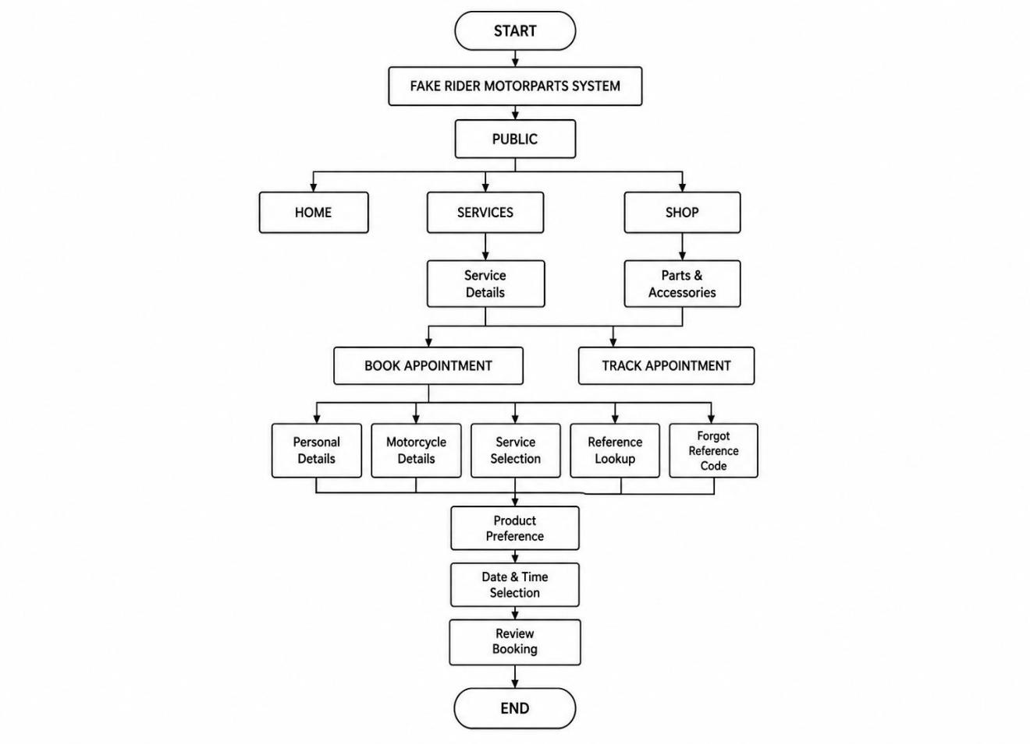

FIGURE X. PROGRAM HIERARCHY(PUBLIC)

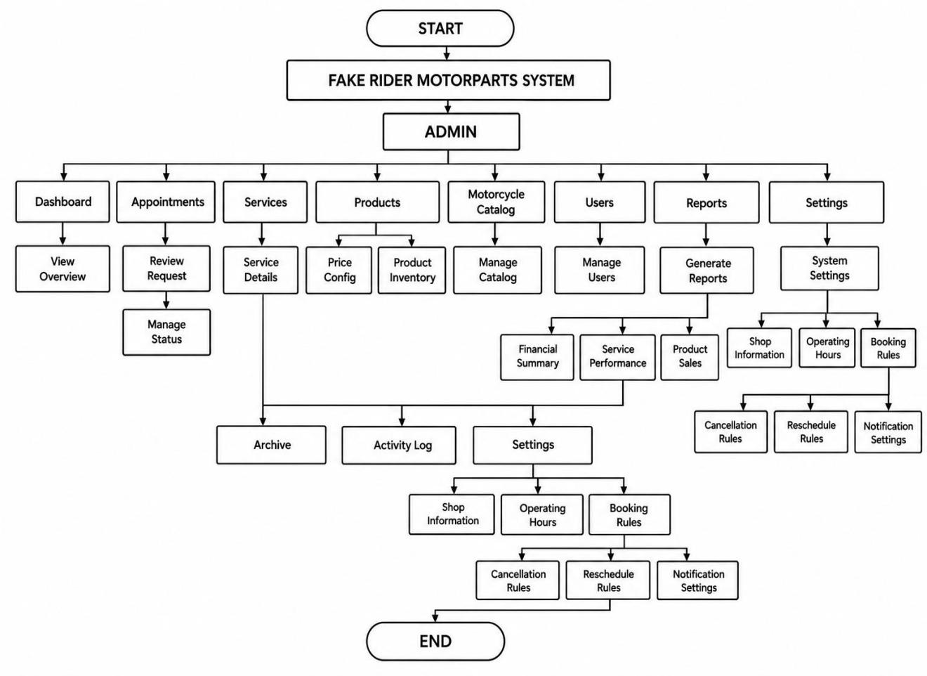

FIGURE X. PROGRAM HIERARCHY(ADMIN)

Database Design
The following tables are duplicated from the design of the whole system. It states the information that the system used.
Table 1. Users: This table stores admin account information used to access the management panel and manage system functions.
Field Name | Data Type | Description
id | int | Primary key for the admin user.
full_name | varchar | Admin's display name.
email | varchar | Login email address.
password | varchar | Stored password value.
role | text | Access role for the account.
created_at | timestamptz | When the account was created.
Table 2. Customers: This table stores customer information from appointment bookings and their booking history.
Field Name | Data Type | Description
id | int | Primary key for the customer record.
full_name | varchar | Customer's full name.
phone_number | varchar | Customer's contact number.
created_at | timestamptz | When the customer record was first created.
Table 3. Mechanics: This table stores information about the shop's mechanics for duty schedules and appointment assignments.
Field Name | Data Type | Description
id | int | Primary key for the mechanic record.
full_name | varchar | Mechanic's full name.
contact_number | varchar | Mechanic's contact number.
status | text | Employment status: active or inactive.
created_at | timestamptz | When the mechanic record was created  defaults to now.
Table 4. duty_schedules: This table stores assigned duty schedules for mechanics to determine their availability for appointments.
Field Name | Data Type | Description
id | int | Primary key for the duty schedule record.
duty_date | date | Date the mechanic is scheduled on duty.
created_at | timestamptz | When the duty schedule record was created.
Table 5. Services: Contains information about the repair services offered by the shop, displayed in the services catalog and used in appointment booking.
Field Name | Data Type | Description
id | int | Primary key for the service.
name | text | Service name.
description | text | Service description.
price | numeric | Service price.
status | text | Record status: active or archived.
created_at | timestamptz | When the service record was created.
updated_at | timestamptz | Last update timestamp.
Table 6. Products: Contains information about the parts and accessories offered by the shop, displayed in the parts and accessories catalog.
Field Name | Data Type | Description
id | int | Primary key for the product.
name | text | Product name.
description | text | Product description.
price | numeric | Product price.
status | text | Record status: active or archived.
created_at | timestamptz | When the product record was created.
updated_at | timestamptz | Last update timestamp.
Table 7. price_history: Contains a log of price changes made to services and products, used to display price change history to the admin.
Field Name | Data Type | Description
id | int | Primary key for the price history record.
item_type | text | Type of item changed: service or product.
item_id | int | ID of the affected service or product  (references services.id or products.id  depending on item_type).
old_price | numeric | Price before the change.
new_price | numeric | Price after the change.
changed_at | timestamptz | When the price change was logged.
Table 8. Appointments: Contains information about customer appointment bookings, including motorcycle details, selected service, schedule, and booking status.
Field Name | Data Type | Description
id | int | Primary key for the appointment.
reference_number | Varchar | Unique booking reference number shown  to the customer.
customer_id | Fk int –  customers.id | References customers.id.
motorcycle_brand | text | Brand of the customer's motorcycle.
motorcycle_model | text | Model of the customer's motorcycle.
motorcycle_year | int | Year of the customer's motorcycle.
plate_number | text | Plate number of the customer's motorcycle.
service_id | Fk int –  services.id | References services.id.
mechanic_id | Fk int –  mechanics.id | References mechanics.id
appointment_date | date | Selected appointment date.
time_slot | time | Selected appointment time slot.
notes | text | Additional customer notes.
status | text | Booking status: pending, confirmed,  completed, or cancelled.
created_at | timestamptz | When the appointment was booked.
updated_at | timestamptz | Last update timestamp.
Table 9. schedule_blocks: Contains dates or time ranges blocked by the admin, used to restrict availability on the public booking calendar.
Field Name | Data Type | Description
id | int | Primary key for the schedule block record.
block_date | date | Blocked date.
start_time | time | Start of the blocked time range.
end_time | time | End of the blocked time range.
full_day | time | Whether the entire day is blocked.
created_by | Fk int - users.id | References users.id.
created_at | timestamptz | When the schedule block was created.
Table 10. Notifications: Contains real-time notification records generated when a new appointment is booked, used to alert the admin through the notification bell.
Field Name | Data Type | Description
id | int | Primary key for the notification.
appointment_id | Fk int –  appointments.id | References appointments.id.
message | text | Notification message content.
is_read | bool | Whether the notification has been viewed.
created_at | timestamptz | When the notification was generated.
Table 11. activity_logs: Contains information about the activities performed by admin users within the system. It is used to monitor user actions and support accountability.
Field Name | Data Type | Description
id | int | Primary key for the log entry.
user_id | Fk int –  users.id | References users.id (nullable).
action | varchar | Action type (e.g. create, update, delete,  login).
module | varchar | Application module where the action  occurred.
description | text | Human-readable details of the activity.
created_at | timestamptz | Log creation timestamp.
Table 12. Archives Contains archived service, product, and appointment records removed from active use, used to support restoring or permanently deleting records.
Field Name | Data Type | Description
id | int | Primary key for the archive record.
original_id | int | ID of the original record before archiving.
entity_type | text | Type of archived record: service, product, or appointment.
archived_at | timestamptz | When the record was archived.

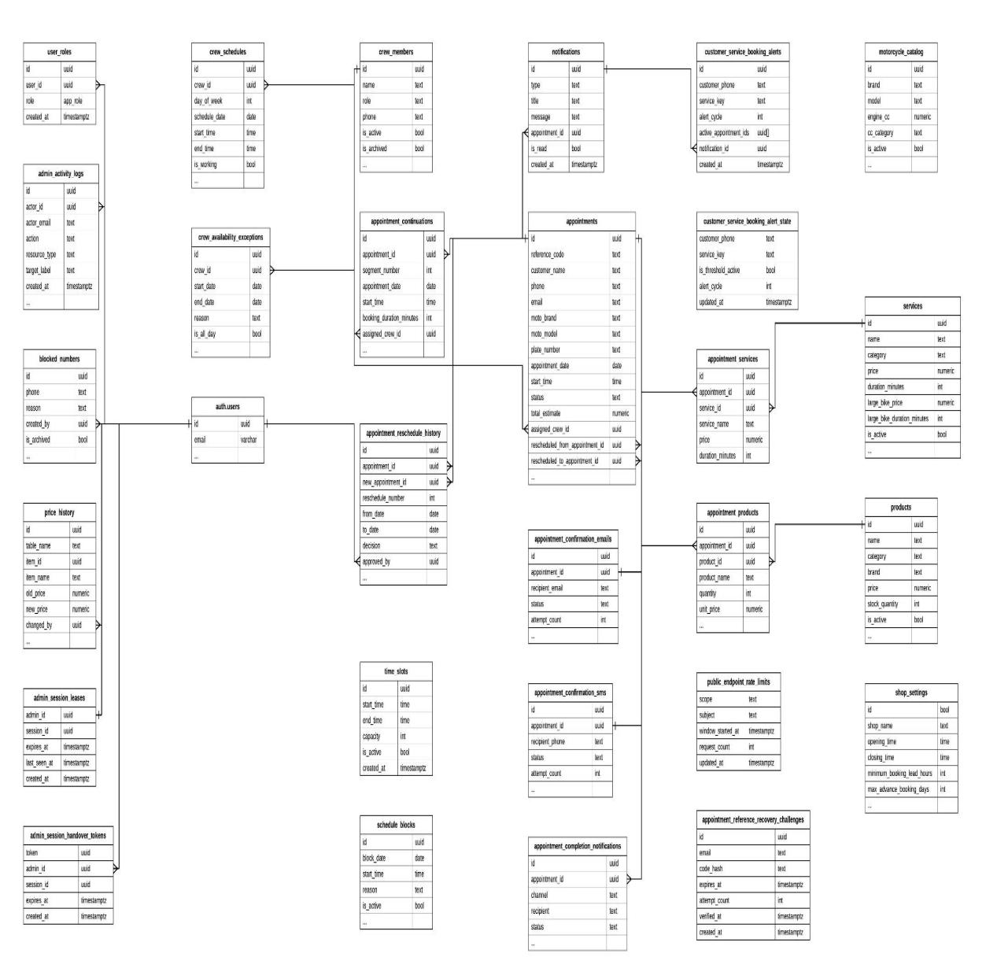

FIGURE X: Database Schema

Test Data/Cases
Test Case 1: Incomplete Customer and Motorcycle Details
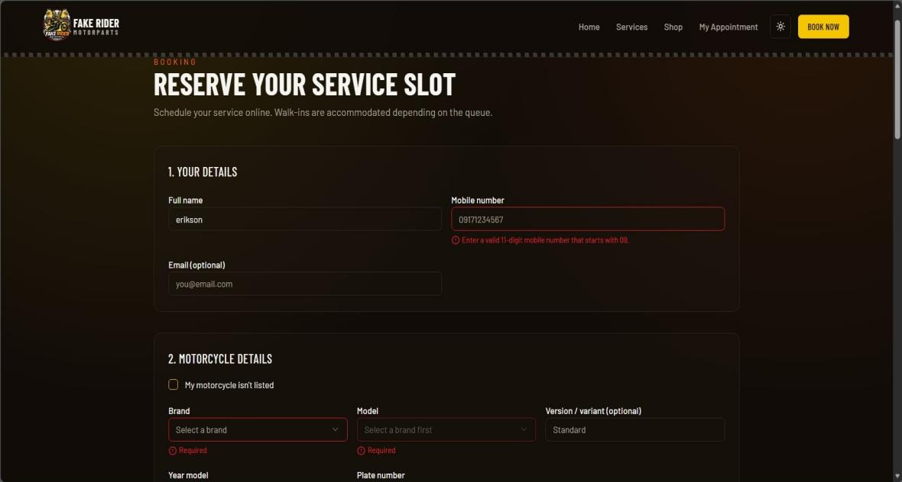
Preview 1: Invalid Customer and Motorcycle Details
Input: Full name entered as erikson
Mobile number entered as 09171234567
Email left blank
Brand not selected
Model not selected
Version/variant entered as Standard
Year model and Plate number not entered
PROCESS: System validates the required customer and motorcycle details.
OUTPUT: Enter a valid 11-digit mobile number that starts with 09. Brand and Model are required.

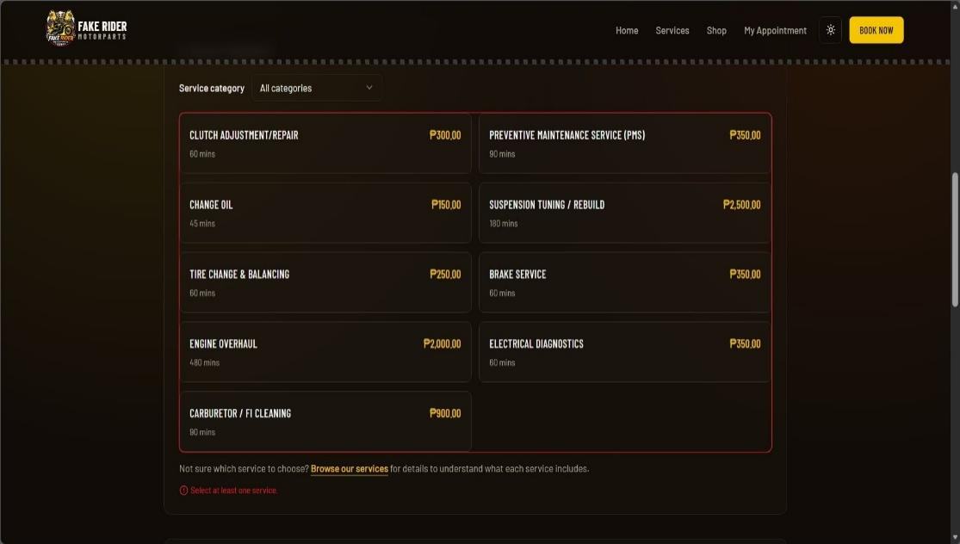
Test Case 2: Missing Service Selection

Preview 2: No Service Selected

Input: No service selected
PROCESS: System checks if at least one service is selected before continuing.
OUTPUT: Select at least one service.

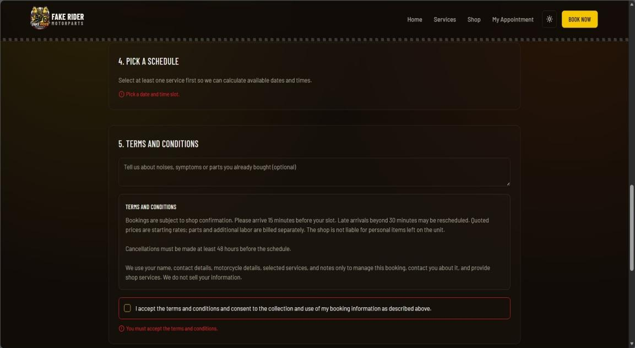
Test Case 3: Missing Schedule

Preview 3: Missing Date and Time Slot
INPUT: No date selected
No time slot selected
PROCESS: System checks if the required schedule details are provided before moving to the next step.
OUTPUT: Pick a date and time slot.

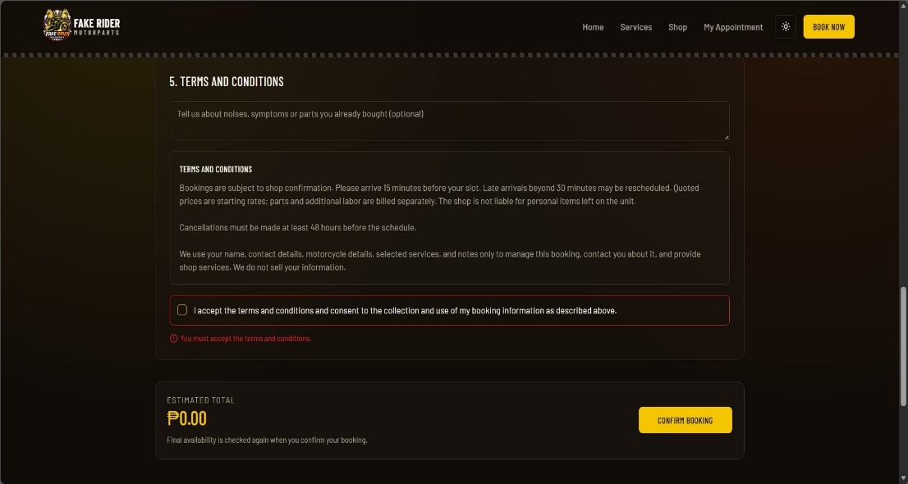
Test Case 4: Terms and Conditions Validation

Preview 4: Terms and Conditions Not Accepted

Input: Terms and Conditions not accepted
PROCESS: System checks if the customer accepts the terms and conditions before confirming the booking.
OUTPUT: You must accept the terms and conditions.

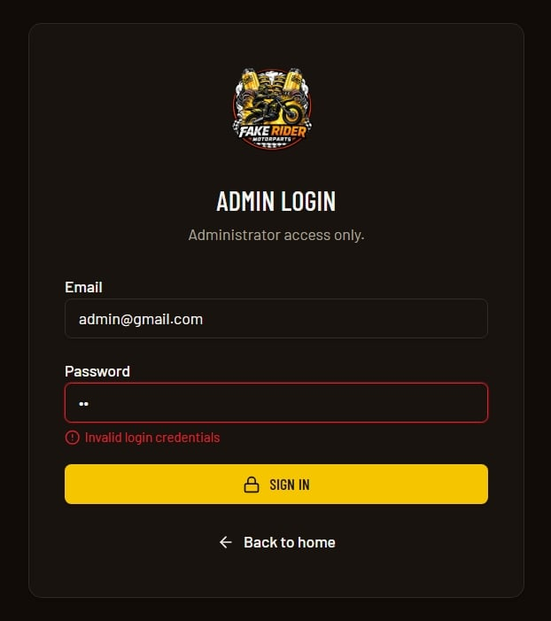
Test Case 5: Admin Log In

Preview 5: Invalid Login

Input: Email: admin@gmail.com
Password: Invalid password
PROCESS: System validates the administrator’s login credentials.
OUTPUT: Invalid login credentials.

Test Case 6: Empty Service Fields
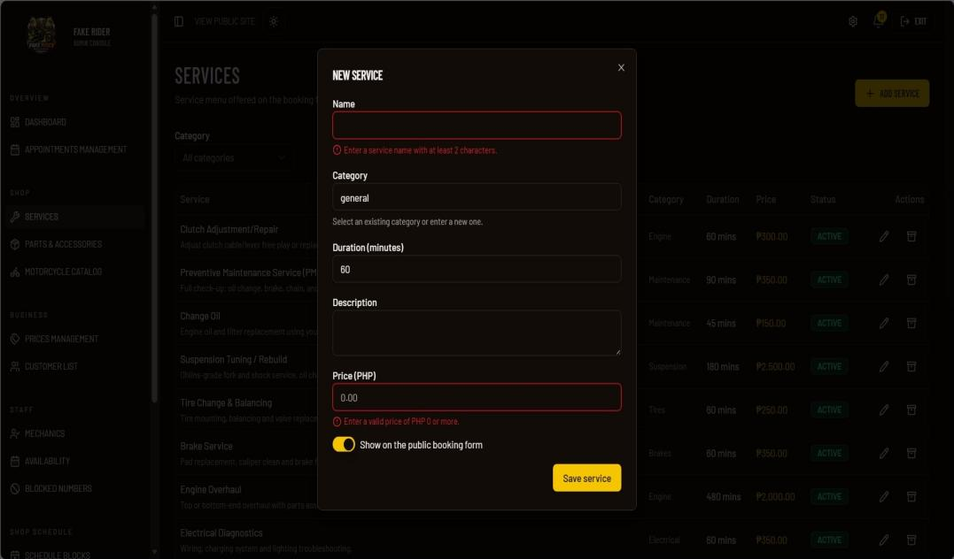
Preview 6: Empty Service Fields
Input: No service name entered
No description entered
PROCESS: System validates that the required service fields are not empty.
OUTPUT: Displays validation errors for the required fields.

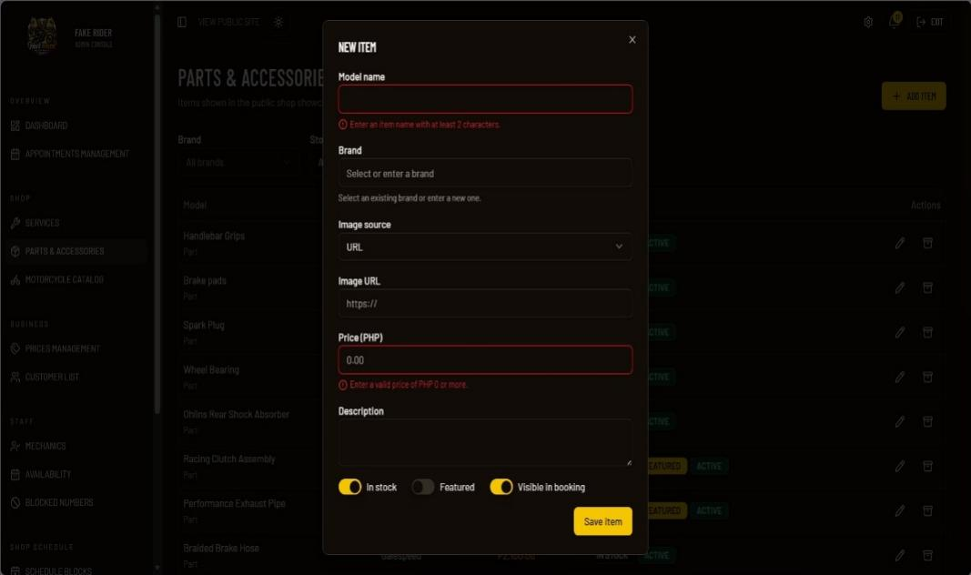
Test Case 7: Invalid Parts and Accessories Information

Preview 7: Empty Item Fields
Input: No model name entered
No brand selected
Invalid price entered
PROCESS: System validates the required parts and accessories information before saving.
OUTPUT: Displays validation errors under incomplete or invalid fields.

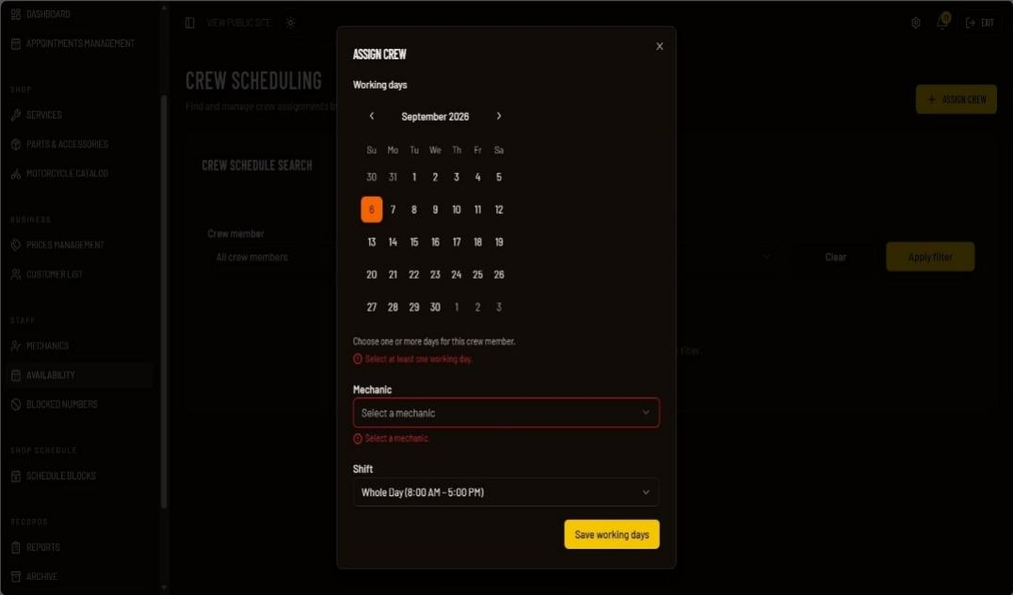
Test Case 8: Incomplete Crew Scheduling

Preview 8: Empty Crew Scheduling Fields
Input: No working day selected
No mechanic selected
PROCESS: System validates that the required crew scheduling information is provided before saving.
OUTPUT: Select at least one working day and select a mechanic.

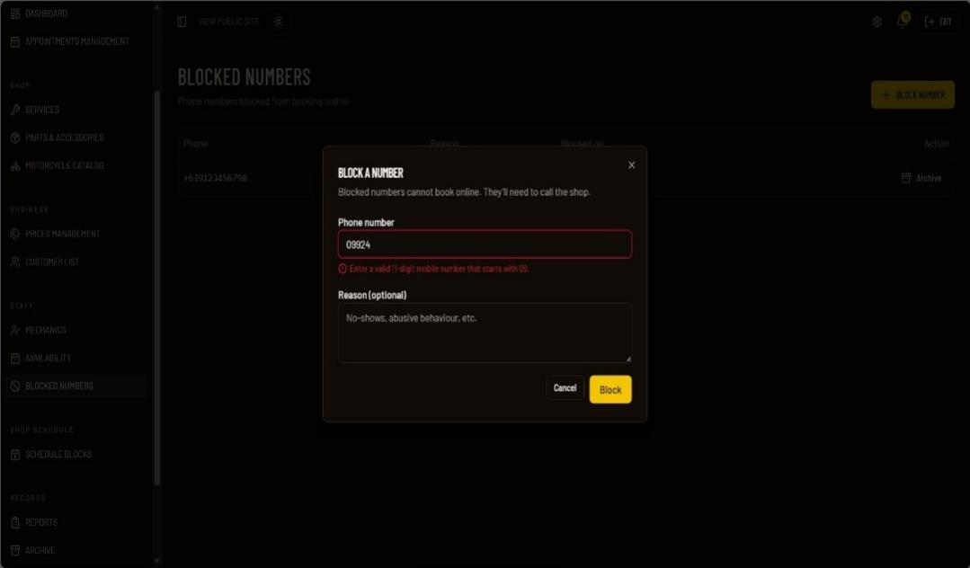
Test Case 9: Invalid Blocked Number

Preview 9: Invalid Blocked Number
Input: Invalid phone number entered
Reason entered
PROCESS: System validates the entered phone number before allowing the administrator to block the number.
OUTPUT: Enter a valid 11-digit mobile number that starts with 09.

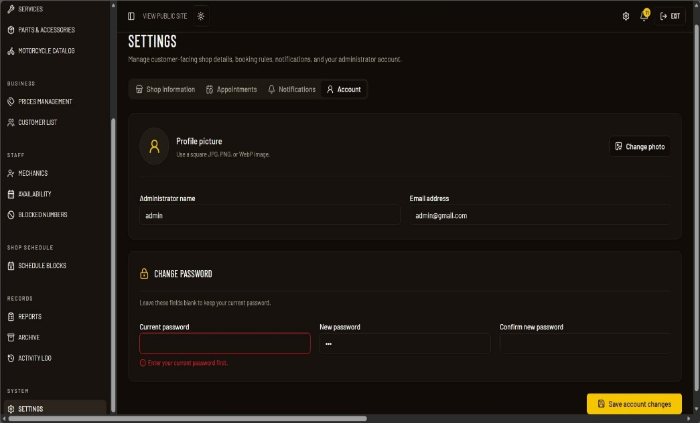
Test Case 10: Password Settings

Preview 10: Password Settings
Input: Current password not entered
PROCESS: System validates the current password before changing the password.
OUTPUT: Enter your current password.

Revision of the System
First Revision
• Redesign the User Interface (UI)
• Add report export to PDF
Second Revision
• Add Archive Functionality
• Add Price Management
Third Revision
• Improve the Report Format

Technical Requirements
Hardware, software, and peopleware are three essential requirements needed for the implementation of the Web-Based Appointment Scheduling System for Chan Repair Shop. These components must work together effectively to ensure the system’s stability, efficiency, and long-term usability for managing appointments, repair services, customer records, and shop operations.

Hardware Specification
Hardware refers to the physical components of the computer system and mobile devices used to develop and operate the Web-Based Appointment Scheduling System for Fake Rider Motorparts. It includes all input, output, processing, and storage devices that support system functionality and performance.
Since the proposed system is a web-based system designed for accessibility and convenience, devices such as computers, laptops, tablets, or mobile devices may be used to access and manage system operations, including appointment booking, repair service management, customer records, and service information. The system is accessible through a web browser on different devices, allowing customers and administrators to use the system conveniently. All hardware components must be compatible, reliable, and capable of supporting web-based system access to ensure smooth and efficient performance.

Random Access Memory (RAM)
Processor
• Minimum requirement: Intel Core i3 or equivalent or higher
Random Access Memory (RAM)
• Minimum requirement: 4GB RAM
Storage (SSD)
• At least 128GB SSD
User Devices
•Smartphone
• laptop
• desktop
Input Devices
• Keyboard
• Mouse
Connectivity
• Stable internet connection

Software Requirements
Software refers to the set of instructions and applications that enable the computer and mobile devices to access and operate the Web-Based Appointment Scheduling System for Fake Rider Motorparts. Since the proposed system is web-based, it can be accessed through a modern web browser without requiring users to install a separate application.

Operating System
The operating system serves as the platform that manages hardware resources and allows the web browser to run properly. Since the system is web-based, it may be accessed through computers, laptops, tablets, and mobile devices using an operating system that supports a modern web browser.

Application Program
Web Browser: The proposed system requires a web browser to access its features and functions. Customers can use the browser to schedule repair appointments, view available repair services and motorcycle parts and accessories, and receive updates regarding their scheduled services. The administrator can use the browser to manage appointments, monitor repair progress, and organize customer and service information.
Database: The proposed system uses a centralized database to store and manage customer information, appointment records, repair service records, and service history. It allows the administrator to retrieve and manage records when needed.

Peopleware
Peopleware refers to the individuals who use and manage the Web-Based Appointment Scheduling System for Fake Rider Motorparts. The main users are the Administrator and Customers. The administrator manages appointments, customer records, repair services, repair progress, and other system information, while customers use the system to schedule repair appointments and access relevant service information.
The administrator is required to log in using the designated administrator account before accessing the administrative functions of the system. Customers can use the customer-side functions without creating an account or logging in.

Cost Benefit Analysis
The cost-benefit analysis presents the comparison between the current manual appointment scheduling and repair service management process and the proposed Web-Based Appointment Scheduling System for Fake Rider Motorparts. The analysis helps determine whether the proposed system is practical, efficient, and beneficial to the repair shop. The current system relies on manual appointment recording, logbooks, personal visits, phone calls, and manual checking of customer and repair records.

Table X. Present System Annual Operating Cost
ITEM | QTY | UNIT
Logbook/Record Book | Actual Quantity | Piece
Ballpen | Actual Quantity | Piece
Mobile Data Load | 12 | Months
Total Present Manual Operating Cost= 18,000+Stationary costs

Table X. Proposed System Annual Operating Cost
ITEM | QTY | UNIT
Domain Name | 0 | Year
Web Hosting/Server | 12 | Months
Mobile Data/Internet | 12 | Months
Database (Supabase Free Plan) | 12 | Months
Emaip Notification Service (Resend) | 12 | Months
SMS Notification Service | Actual Usage | SMS
Total Proposed Annual Operating Cost=18,000+Annual SMS charges

Benefits
The proposed Web-Based Appointment Scheduling System for Fake Rider Motorparts provides a more organized and efficient approach to managing motorcycle repair appointments and services. Instead of relying mainly on handwritten records, walk-in scheduling, phone calls, and verbal communication, the system provides a centralized web-based platform for appointment scheduling, customer records, repair service management, and service updates.
Customers can submit appointment requests online without creating an account or logging in. They can provide their motorcycle information, select a service, choose an available date and time slot, and select a mechanic preference. The system generates a unique booking reference number that customers can use to view their appointment details and status.
For administrators, the system provides functions for managing appointments, customer records, services, parts and accessories, mechanics, duty schedules, schedule blocks, repair status, notifications, reports, and archived records. These centralized functions help reduce manual work and improve the organization of daily repair shop operations.

Tangible Benefits
The proposed system provides measurable benefits by reducing the amount of manual work required for appointment scheduling and record management. Customer information, appointment records, repair service information, and service history are maintained in a centralized database, allowing administrators to retrieve information more efficiently.
The system also helps reduce scheduling conflicts by checking existing appointments and schedule blocks before displaying available time slots. This allows customers to select available schedules while helping administrators organize appointments more efficiently.
Furthermore, the system provides reports based on appointment, revenue, and service information. Administrators can select a date range, view the generated results, and export reports in available formats such as CSV and PDF. These features can reduce the time required to manually compile business-related information.
The system also provides an archive function for service, product, and appointment records. Archived records can be restored or permanently deleted when necessary, helping maintain organized records without immediately removing information from the system.

Intangible Benefits
The proposed system provides intangible benefits by improving the overall customer experience and service quality of Fake Rider Motorparts. Customers can conveniently schedule appointments online, check their appointment status using their booking reference number, and receive updates regarding their appointments and repair services. This reduces the need for repeated phone calls or personal visits to inquire about service progress.
The system also promotes better communication between customers and shop personnel through appointment and service notifications. Administrators receive notifications for new appointments, while customers receive relevant updates regarding their appointment status and repair service.
Another benefit is improved organization and accessibility of information. Since customer records, appointments, repair services, and service history are maintained in a centralized database, administrators can retrieve previous customer and appointment information when needed.
Overall, the proposed system is expected to improve the efficiency and organization of Fake Rider Motorparts appointment and repair service operations while providing customers with a more convenient and accessible way to schedule and monitor their services. The system addresses the limitations of the existing manual process by reducing manual work, improving record organization, minimizing scheduling conflicts, and making appointment and service information easier to access.

Interface Design
The screen layout of the Fake Rider Motorparts Web-Based Appointment Scheduling System is designed to be simple, clear, and user-friendly, allowing customers to easily access motorcycle services, parts, appointment booking, and appointment tracking without creating an account.
Object ID: Customer Home Page
Object Description: Main landing page where customers can view the shop information and access the system's primary features.
- GENERAL DESCRIPTION
This page serves as the main entry point of the system, providing customers with access to the services, shop, appointment booking, and appointment tracking features without creating an account.
- SCREEN LAYOUT
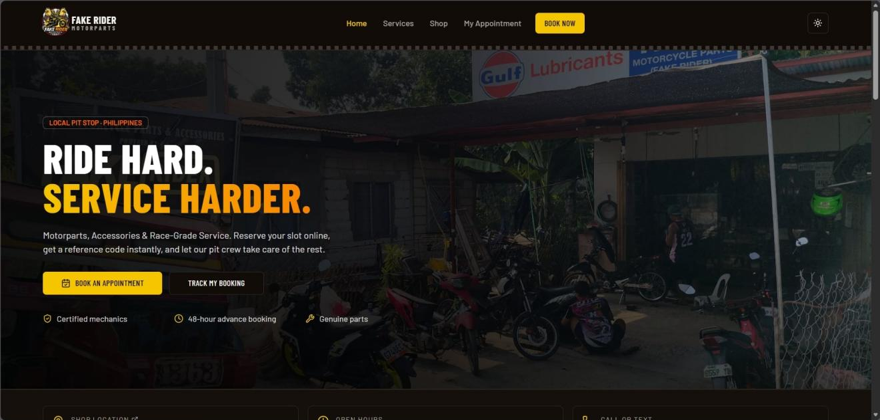
Preview 11: Customer Home Page

Object ID: Services Page
Object Description: Page where customers can view and browse the available motorcycle services.
A. GENERAL DESCRIPTION
This page allows customers to view the different motorcycle maintenance and repair services offered by Fake Rider Motorparts without creating an account.
B. SCREEN LAYOUT
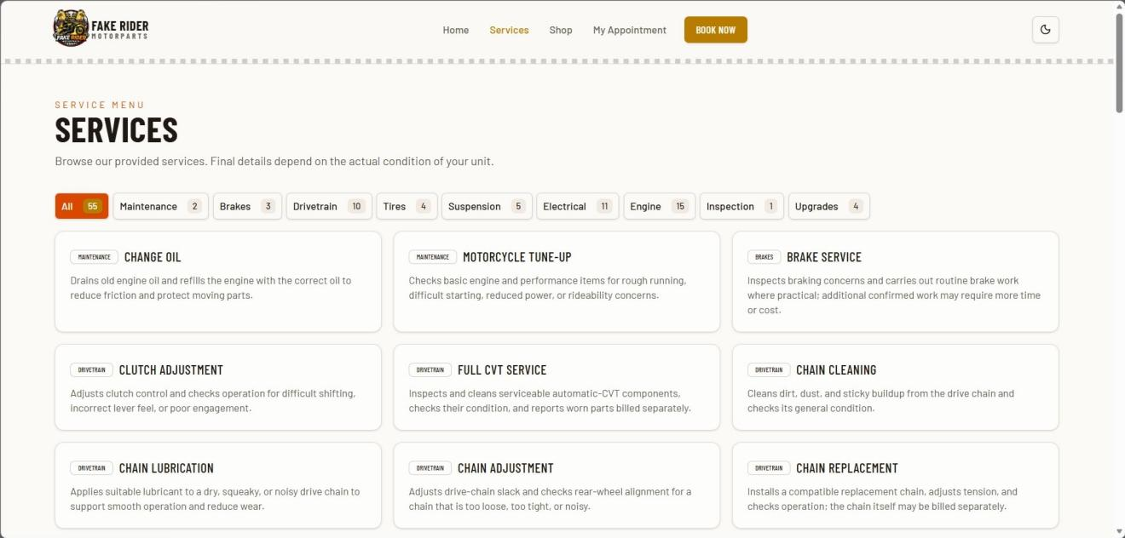

Preview 12: Services Page

Object ID: Appointment Booking Page
Object Description: Page where customers provide the required information and reserve a service appointment.
A. GENERAL DESCRIPTION
This page allows customers to enter their personal and motorcycle details, select a service, and schedule an available appointment slot without creating an account.
B. SCREEN LAYOUT
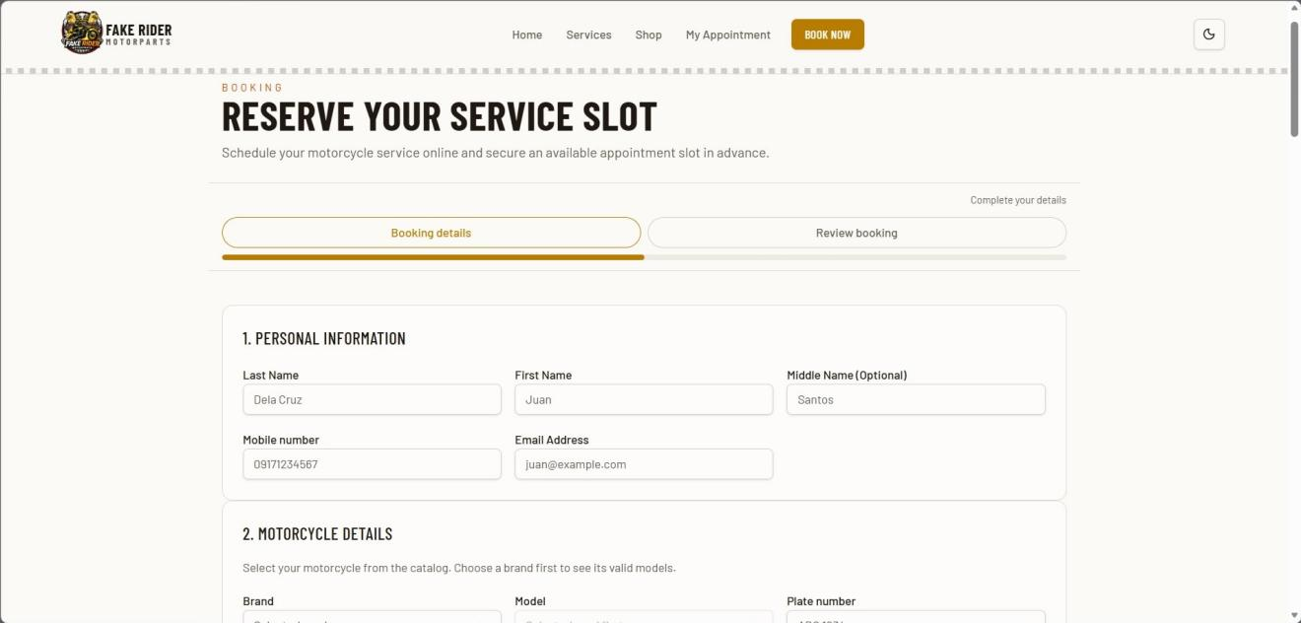
Preview 13: Appointment Booking Page

Object ID: Parts and Accessories Page
Object Description: Page where customers can browse available motorcycle parts and accessories.
A. GENERAL DESCRIPTION
This page allows customers to view available parts and accessories, including their product information, prices, and availability without creating an account.
B.SCREEN LAYOUT
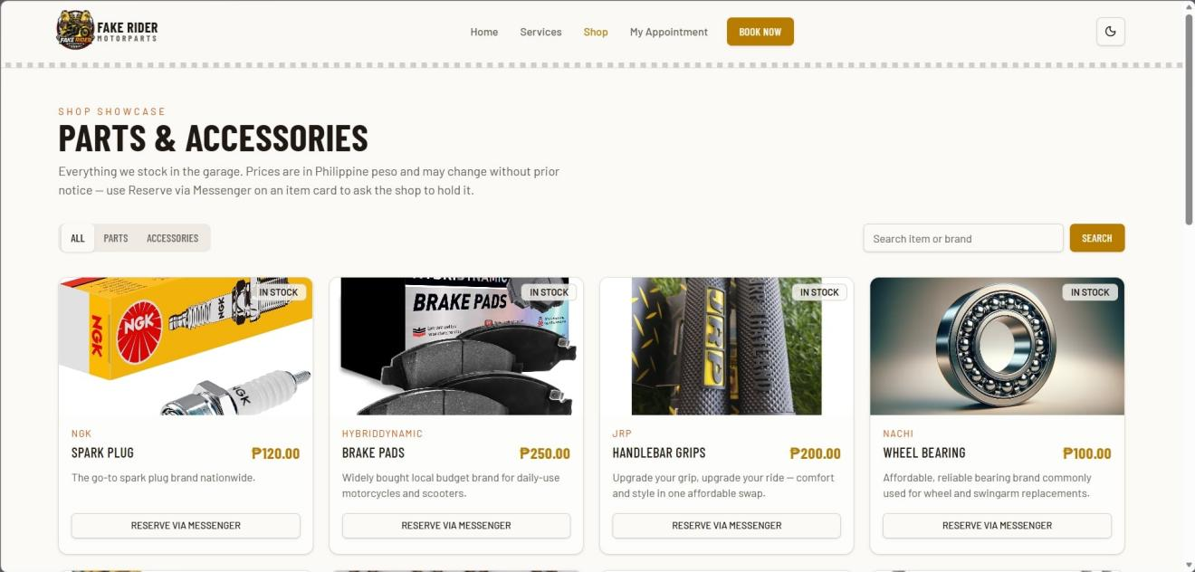
Preview 14: Parts and Accessories Page

Object ID: My Appointment Page
Object Description: Page where customers can track their appointment using their reference code.
A. GENERAL DESCRIPTION
This page allows customers to enter their booking reference code and retrieve their appointment information without creating an account.
B. SCREEN LAYOUT
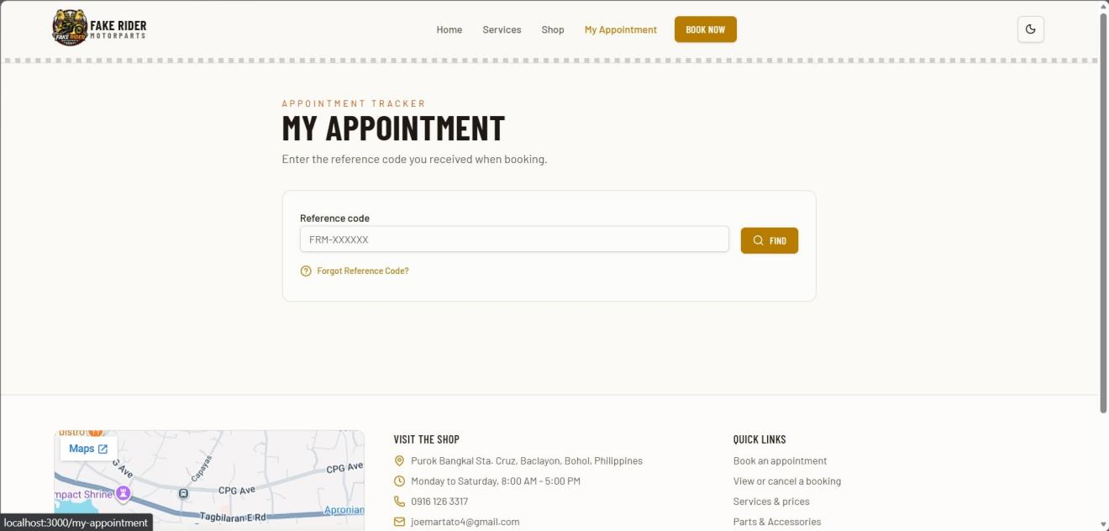
Preview 15: My Appointment Page

Object ID: Admin Dashboard
Object Description: Main dashboard displaying appointment statistics, appointment overview, appointment status, and other shop activities.
A. GENERAL DESCRIPTION
This page serves as the main dashboard for the administrator. It provides an overview of the shop's appointments, pending approvals, customers, completed revenue, and appointment status.
B. SCREEN LAYOUT
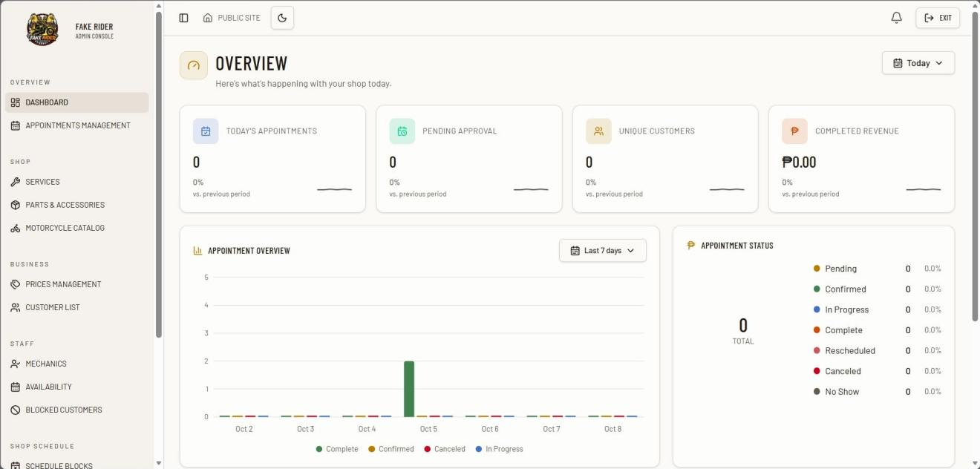
Preview 16: Admin Dashboard

Object ID: Appointments Management
Object Description: Manages customer appointments, including confirmation, rescheduling, and appointment status.
A. GENERAL DESCRIPTION
This page allows the administrator to view, manage, confirm, reschedule, and monitor customer appointments.
B. SCREEN LAYOUT
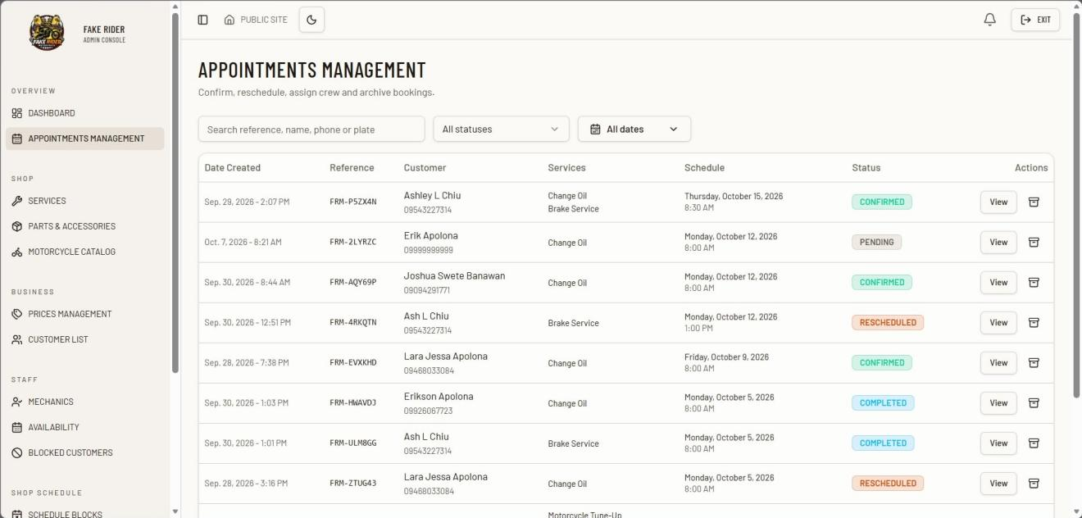
Preview 17: Appointments Management

Object ID: Services
Object Description: Manages the motorcycle services offered by the shop.
A. GENERAL DESCRIPTION
This page allows the administrator to manage available services, including their categories and active status.
B. SCREEN LAYOUT
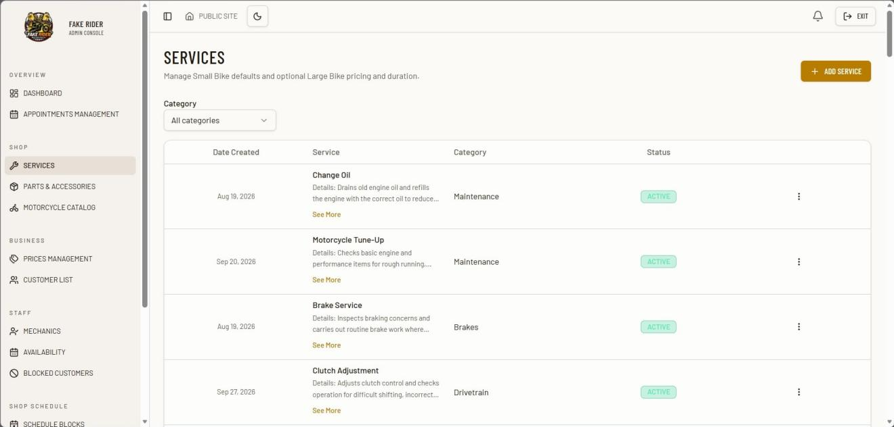
Preview 18: Services

Object ID: Parts & Accessories
Object Description: Manages the parts and accessories available in the shop.
A. GENERAL DESCRIPTION
This page allows the administrator to manage parts and accessories, including their brand, price, stock quantity, status, and featured items.
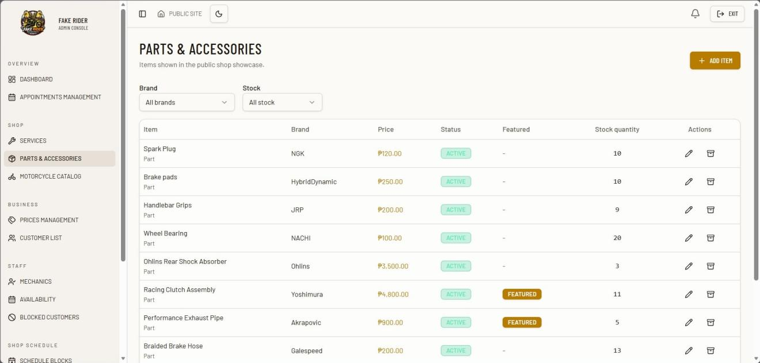
B. SCREEN LAYOUT

Preview 19: Parts & Accessories

Object ID: Motorcycle Catalog
Object Description: Manages the motorcycle brands and models available in the system.
A. GENERAL DESCRIPTION
This page allows the administrator to manage motorcycle brands and models used in the booking form.
B. SCREEN LAYOUT
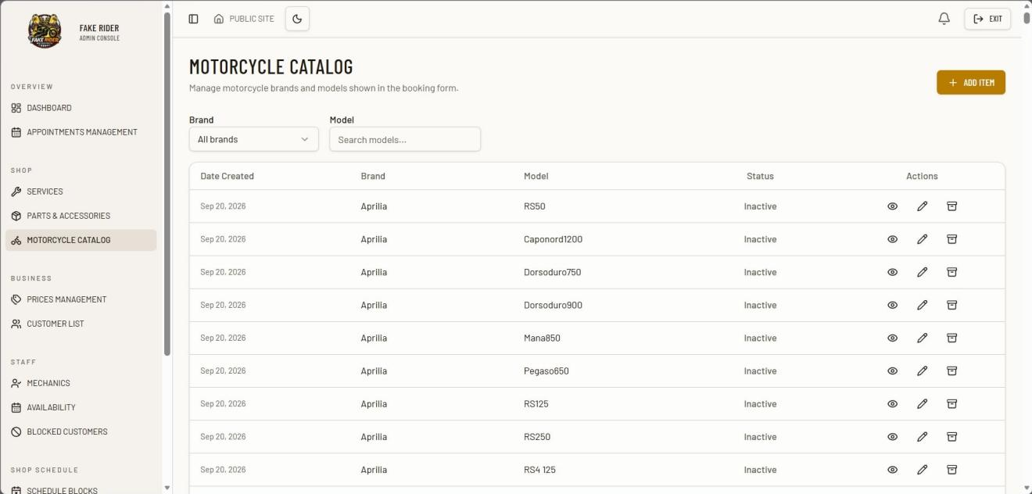
Preview 20: Motorcycle Catalog

Object ID: Prices Management
Object Description: Manages the pricing of services and parts & accessories.
A. GENERAL DESCRIPTION
This page allows the administrator to view and manage the prices of services and parts & accessories.
B. SCREEN LAYOUT
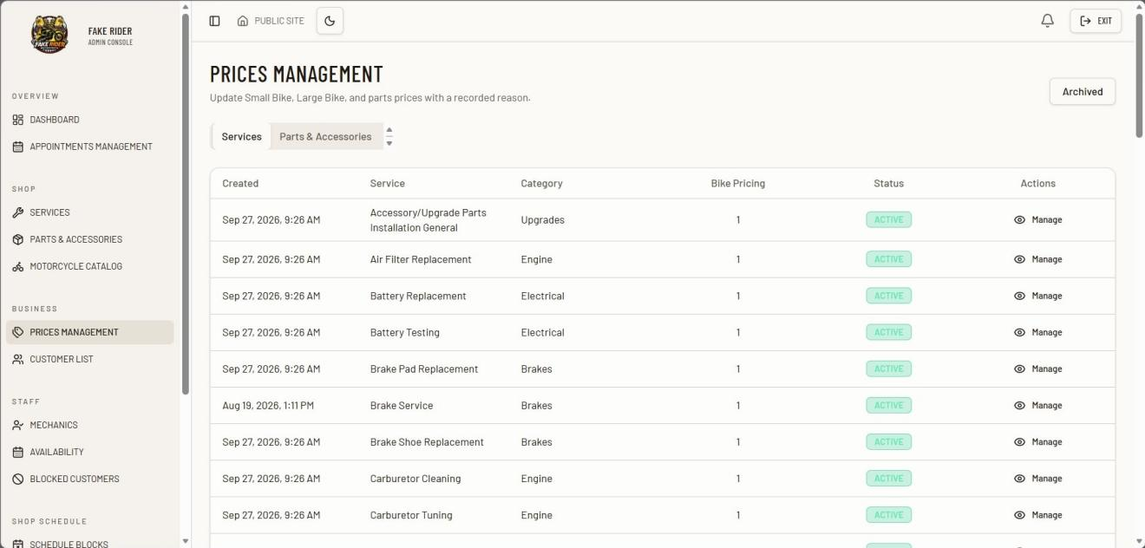
Preview 21: Prices Management

Object ID: Customer List
Object Description: Customer List page for viewing customers who have booked with the shop.
A. GENERAL DESCRIPTION
This page allows the administrator to view and manage customer records. It displays customer names, contact numbers, motorcycle units, number of bookings, completed spending, and the date of their last booking.
B. SCREEN LAYOUT
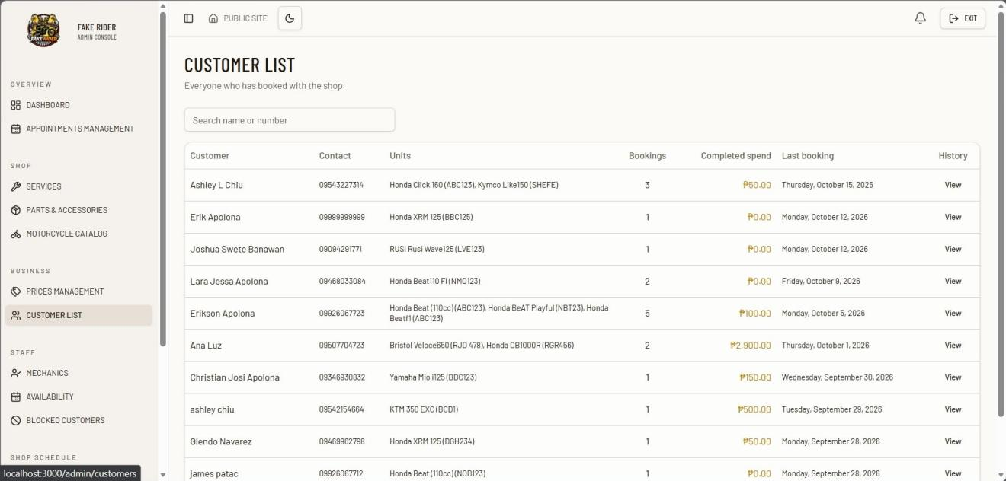
Preview 22: Customer List

Object ID: Mechanics
Object Description: Mechanics page for managing the shop’s mechanics and their current work status.
A. GENERAL DESCRIPTION
This page allows the administrator to view and manage registered mechanics. It displays each mechanic’s name, role, phone number, and current status. The administrator can search for mechanics, filter them by status, add a new mechanic, and edit or remove existing mechanic records.
B. SCREEN LAYOUT
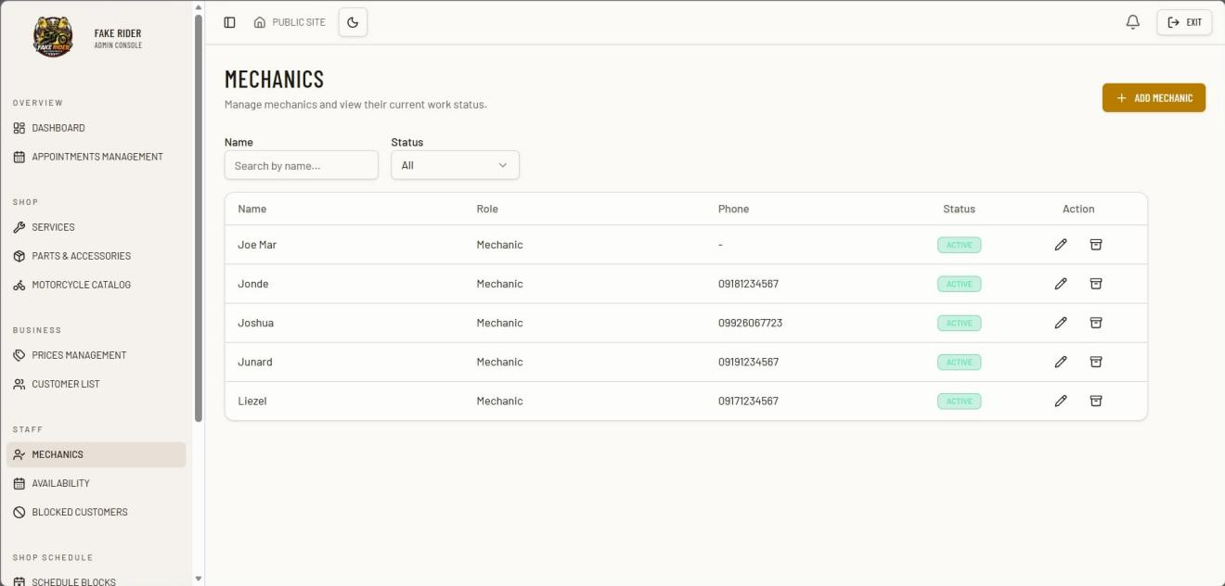
Preview 23: Crew Scheduling

Object ID: Schedule Blocks
Object Description: Schedule Blocks page for closing whole days or custom time ranges when the shop is unavailable.
A. GENERAL DESCRIPTION
This page allows the administrator to create and manage schedule blocks for holidays, events, maintenance, and other periods when the shop is unavailable.
B. SCREEN LAYOUT
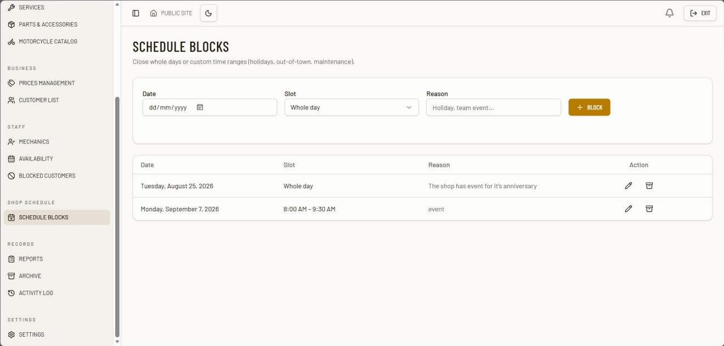

Preview 24: Schedule Blocks

Object ID: Reports
Object Description: Reports page for viewing booking volume and service activity for a selected period.
A. GENERAL DESCRIPTION
This page provides the administrator with a summary of booking and service activity. It displays total bookings, completed jobs, revenue from completed jobs, and booking status groups based on the selected reporting period and filters.
B. SCREEN LAYOUT
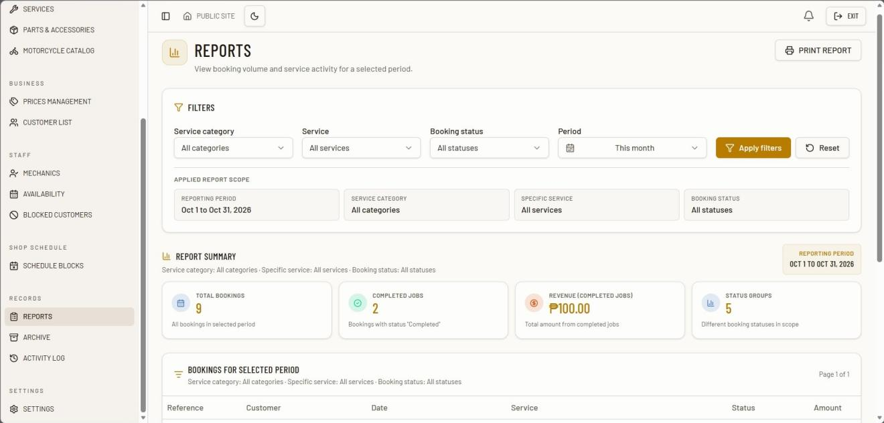

Preview 25: Reports

Object ID: Archive
Object Description: Archive page for viewing and managing archived records.
A. GENERAL DESCRIPTION
This page allows the administrator to view archived appointments, services, products, motorcycles, pit crew records, schedule blocks, and blocked numbers. Archived records can be restored or permanently deleted.
B. SCREEN LAYOUT
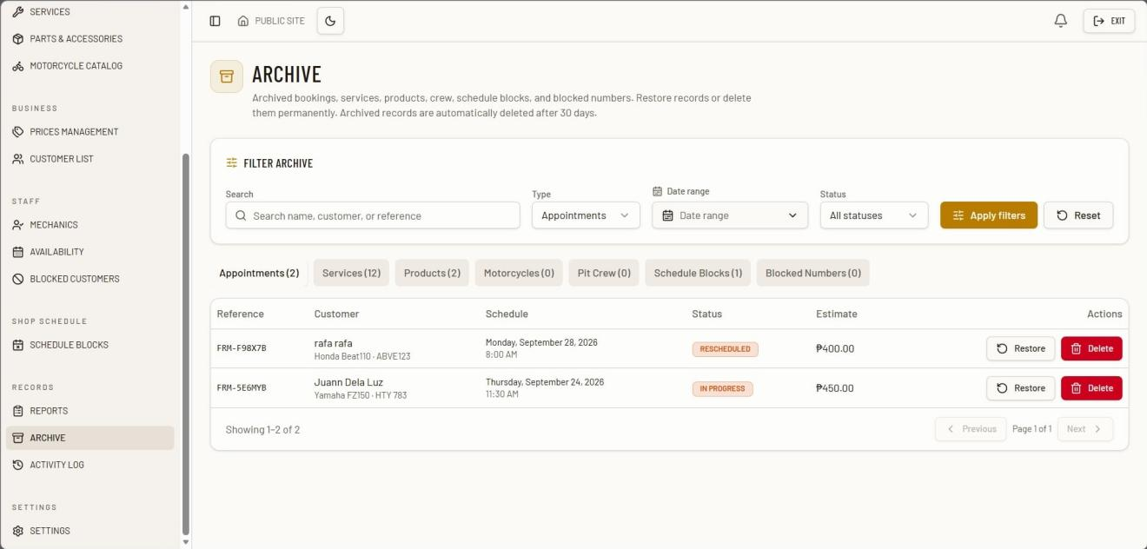

Preview 26: Archive

Object ID: Activity Log
Object Description: Activity Log page for monitoring administrator actions and sign-in events.
A. GENERAL DESCRIPTION
This page allows the administrator to review recorded system activities, including sign-in and sign-out events and other administrative actions. It displays the activity date and time, user, action, category, record ID, IP address, and changed fields.
B. SCREEN LAYOUT
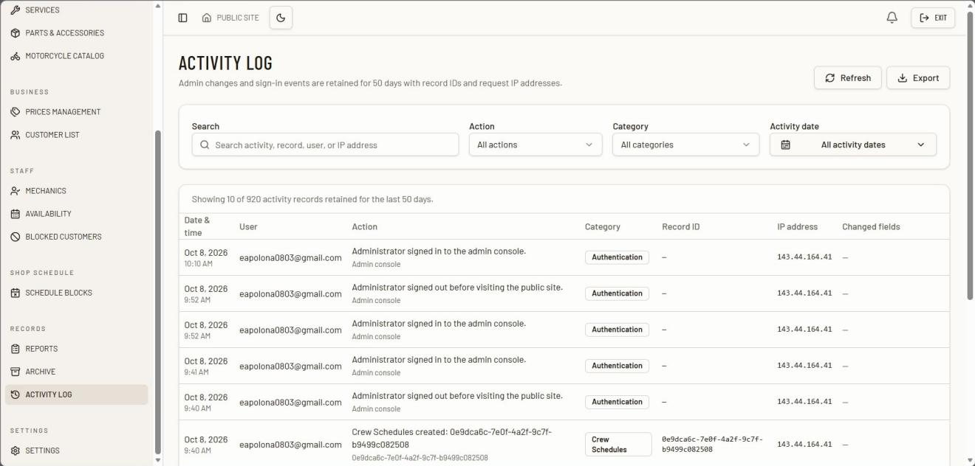
Preview 27: Activity Log

Object ID: Settings
Object Description: Settings page for managing customer-facing shop details and the administrator account.
A. GENERAL DESCRIPTION
This page allows the administrator to manage the shop’s contact information, contact number, shop address, and booking terms and conditions.
B. SCREEN LAYOUT
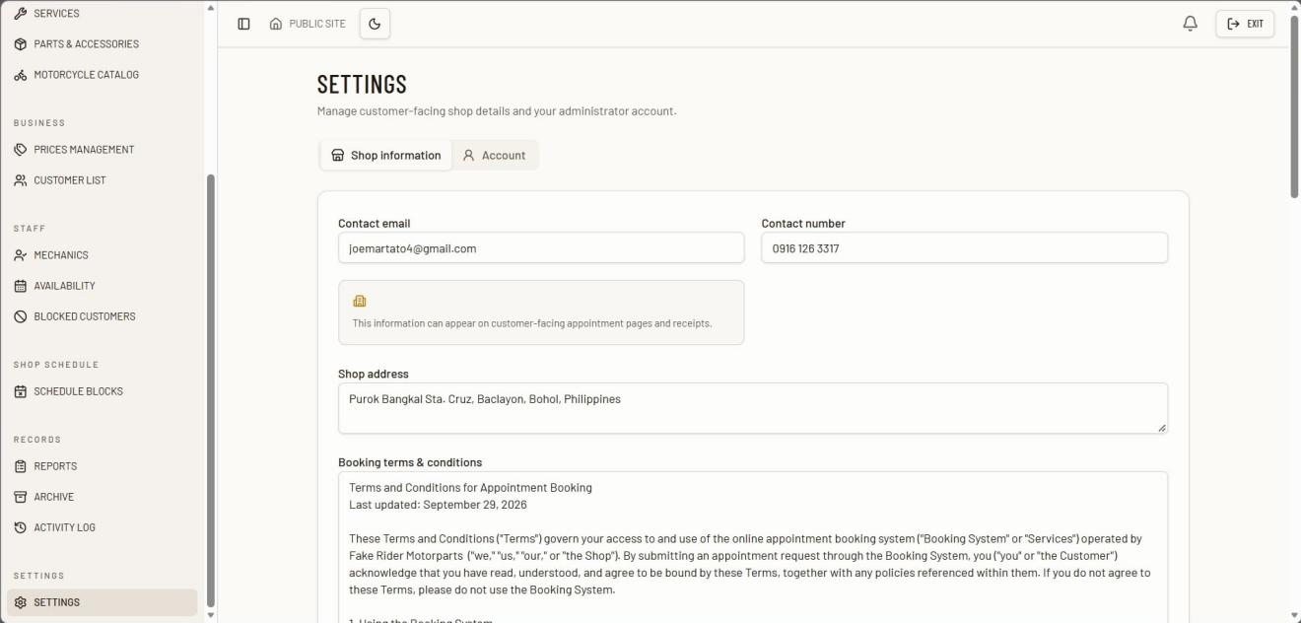
Preview 28: Settings

Object ID: Notifications
Object Description: Notifications page for reviewing appointments, booking updates, and active service progress alerts.
A. GENERAL DESCRIPTION
This page allows the administrator to review notifications related to new bookings, active bookings, and rescheduled bookings. It also provides actions for managing notifications and viewing appointments.
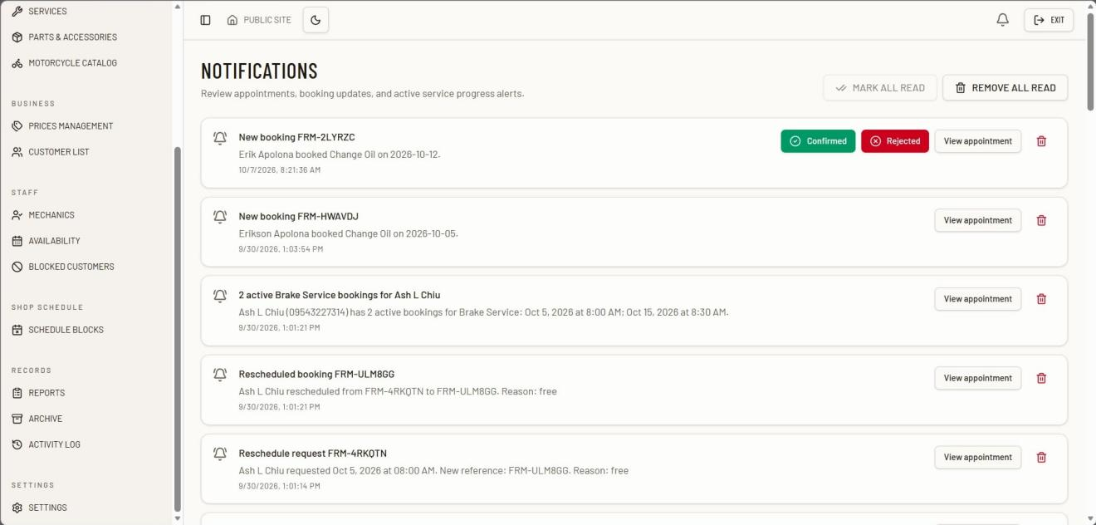
B. SCREEN LAYOUT

Preview 29: Notifications
Chapter 3
SUMMARY, CONCLUSION, AND RECOMMENDATIONS
A. Summary
This study aimed to design and develop a Web-Based Appointment Scheduling System for Fake Rider Motorparts to provide a more organized and efficient way of managing customer appointments, customer records, repair services, and schedules. The system was developed to address the limitations of the existing manual process, particularly the use of handwritten records, walk-in scheduling, and verbal communication.
The developed system provides customers with an online appointment booking process without requiring them to create an account or log in. Customers can enter their information, motorcycle details, select a service, choose an available schedule, and receive a unique booking reference number. The reference number can be used to check appointment details and repair status. For the administrator, the system provides functions for managing appointments, customer records, services, parts and accessories, mechanics, schedules, notifications, reports, and archived records.
The study also applied the Agile Software Development Life Cycle to guide the development of the system. Requirements were gathered through interviews, observations, and documentation review, while continuous testing and feedback were used to improve the system. The resulting system provides a centralized platform that supports appointment scheduling and repair service management at Fake Rider Motorparts.
B. Conclusion
The Web-Based Appointment Scheduling System for Fake Rider Motorparts provides a more organized and convenient approach to managing appointments and repair service information. By replacing manual appointment recording and scheduling with a web-based platform, the system helps reduce scheduling conflicts, improve record organization, and make service information easier to access.
The system also improves communication between the repair shop and its customers. Customers can schedule appointments online, check their booking information using a reference number, and receive updates regarding their appointment and repair status without creating an account. Meanwhile, the administrator can manage appointments, customer records, services, schedules, and other system information through a centralized platform.
Overall, the developed system addresses the identified problems of the existing manual process and provides a practical digital solution suited to the daily operations of Fake Rider Motorparts.
C. Recommendations
Based on the study, the following recommendations are proposed:
- Fake Rider Motorparts should continue using the system to improve the management of appointments, customer records, and repair service information.
- Proper orientation should be provided to the shop owner and staff to ensure that the system is used correctly and consistently.
- Regular maintenance and system updates should be conducted to address technical issues and improve system performance.
- Regular data backup should be performed to prevent the loss of customer, appointment, and service records.
- Future researchers may enhance the system by adding additional features such as online payment, advanced inventory management, and other functions that may support the future needs of the repair shop.

TECHNOLOGY ACTION PLAN

Fake Rider Motorparts
Rationale
The existing manual process at Fake Rider Motorparts requires customers and staff to rely on personal visits, phone calls, handwritten records, and manual scheduling. These methods may result in scheduling conflicts, delays, and difficulty in retrieving customer and service information. The proposed system provides a centralized platform that can improve appointment scheduling, record management, and communication between the repair shop and its customers.
Objectives
1. Implement the Web-Based Appointment Scheduling System for the daily appointment and service management of Fake Rider Motorparts.
2. Provide proper orientation and training to the shop owner and staff on the use of the system.
3. Maintain accurate and organized customer, appointment, and service records.
4. Improve the system based on user feedback and future operational needs.
Schedule of Implementation
The Web-Based Appointment Scheduling System for Fake Rider Motorparts will be implemented after thorough review, testing, and approval by the shop owner and authorized staff. The system must meet the operational requirements and user needs of the repair shop to ensure its effectiveness in managing appointments, customer records, and repair services. A pilot testing phase will also be conducted to verify the system’s functionality, usability, and reliability before its full implementation.
Mechanics of Implementation
The researchers will coordinate with the Fake Rider Motorparts management to present the system and demonstrate its major functions. Training sessions will be conducted for the shop owner and authorized staff to familiarize them with appointment management, customer record management, service management, schedule management, repair status updates, parts and accessories availability, notifications, and report generation. After the orientation and approval of management, the system will be introduced for operational use. Technical support, system monitoring, regular maintenance, and appropriate data backup procedures will also be provided to support continuous and reliable system operation. Necessary updates may be applied based on future operational requirements.
Benefits
The implementation of the Web-Based Appointment Scheduling System for Fake Rider Motorparts provides several operational benefits by reducing dependence on manual appointment recording and centralizing customer and repair service information within a single platform. It enables easier access to appointment schedules, customer records, service information, and repair status updates while allowing customers to conveniently book appointments and check their booking information. The system also supports schedule management, parts and accessories availability viewing, notifications, and report generation. These functions help the shop staff manage repair operations more systematically while providing customers with a more convenient and organized appointment and service experience.

References
Ampuan, J., & Delena, M. (2022). An implementation and evaluation of web-based appointment system for institutional scheduling. Mindanao State University.
Dela Fuente, J., et al. (2023). Project Clinik: A cross-platform scheduling and appointment reservation system. International Journal of Computing and Digital Systems.
Helo, P., & Thai, V. V. (2024). Digital tracking systems in logistics operations: Improving efficiency and visibility. International Journal of Logistics Management.
Luciano, R., et al. (2023). PARADAJuan: A web-based parking lot management system designed and developed using multi-paradigm programming languages. ResearchGate.
Nour, M. (2022). Information technology capability and service performance in logistics industries. Journal of Service Science and Management.
Patidar, A., Dosalwar, S., & Varshney, P. (2021). An effective garage management system web application for customer service. International Journal of Engineering Research & Technology.
Regla, J., & Dadiz, K. (2022). Online courier and service management system with text blast and QR code integration. Journal of Advanced Research in Computer Science.
Varshney, A., & Gupta, R. (2021). QR-code-based online appointment scheduling system for service management. International Journal of Innovative Technology and Exploring Engineering.

APPENDICES

APPENDIX A
LETTER OF INTENT

APPENDIX B
MODELING TOOLS

TERMINAL SYMBOL
● Indicates the origin of data and its predetermined end
● Describes external entities referred to as a person or a group of departments with which the system communicates.

PROCESS SYMBOL
● Symbol used for processing of data into useful information
● Describes a part of the system that transforms data inputs and outputs in the same way

DATA SYMBOL
● Indicates where data is stored.
● An opened-end rectangle used to present storage
● A symbol used to represent input or output choices in a process.

DECISION SYMBOL
● A decision or branching point. Lines representing different decisions emerge from different points of the diamond

DATA FLOW SYMBOL

● Represent by an arrow which shows the direction or movement of the flow of data into the system.

ON PAGE CONNECTOR SYMBOL

● Indicates that the flow continues where a matching symbol (containing the same letter inside the page) has been placed.

OUTPUT/DISPLAY SYMBOL

• Symbol used for displaying an output.
• It represents operations like displaying or information. printing

DATA INPUT SYMBOL

DATA INPUT SYMBOL

• Use for manual input.
• Use for form filling and submission.

APPENDIX C
INTERVIEW GUIDE / QUESTIONS
- Can you describe how you currently manage appointment scheduling, customer information, and repair service operations at Fake Rider Motorparts?
- What challenges do you encounter when recording appointments, organizing schedules, managing customer records, and preventing scheduling conflicts?
- How do you currently communicate appointment confirmations and repair service updates to customers, and what difficulties do you experience in providing timely information?
- How do you monitor the progress of motorcycle repair services and manage appointment schedules, and what problems do you encounter in coordinating these activities?
- How do you currently manage information about motorcycle parts, accessories, and repair services, and what difficulties do you experience when customers inquire about their availability and prices?
- What specific features or improvements would you like to see in the proposed Web-Based Appointment Scheduling System for Fake Rider Motorparts to improve appointment booking, repair service monitoring, customer record management, and overall shop operations?

APPENDIX D
User’s Guide
This guide explains how customers and administrators use the Fake Rider Motorparts Web-Based Appointment Scheduling System. Customers can book, view, cancel, or request to reschedule appointments without creating an account. Administrator-only functions require an authorized administrator account.

1. System Requirements
Before using the system, make sure that you have the following:
- A desktop computer, laptop, tablet, or smartphone.
- A stable internet connection through Wi-Fi, broadband, or mobile data.
- A current web browser, such as Google Chrome, Microsoft Edge, Mozilla Firefox, or Safari, with JavaScript enabled.
- The official Fake Rider Motorparts website address.
The system works on current versions of Windows, macOS, Linux, Android, and iOS that support a modern web browser. No software installation is required.

2. Accessing the System
- Connect your device to the internet.
- Open a supported web browser.
- Enter the official Fake Rider Motorparts website address.
- Wait for the home page to load.
- Select Book a Service or the appointment-booking option to begin.
Customers do not need to create an account or sign in to use the booking and appointment-management pages.

3. Customer Functions

3.1 Booking a Service Appointment
- Open the Book a Service page.
- Enter your personal information:
  - Last name and first name
  - Middle name, if applicable
  - Mobile number
  - Email address
- Select your motorcycle brand and model from the catalog, then enter its plate number.
- Select one or more services. Use the search box or category filter if needed.
- Choose whether you would like to add available products or parts, if that option is shown.
- Select an available appointment date and time. The system displays availability based on the selected services and motorcycle model.
- Enter additional notes when necessary.
- Review the appointment details, including the services, estimated amount, date, and time.
- Read and accept the Terms and Conditions.
- Submit the appointment request.
- Save the booking reference code shown after submission. You will need it to view or manage the appointment later.
New appointment requests are initially recorded as Pending until the shop reviews them.

3.2 Viewing an Appointment
- Open the My Appointment page.
- Enter the booking reference code.
- Select Search or the corresponding lookup button.
- Review the displayed customer, motorcycle, service, schedule, and appointment-status information.
If you cannot find the appointment, make sure that the reference code is correct and contains no extra spaces.

3.3 Recovering a Lost Reference Code
- On the My Appointment page, select Forgot your reference code?
- Enter the email address used when the appointment was booked.
- Select Send verification code.
- Enter the verification code sent to that email address.
- Select Email my reference code.
Use the recovered reference code to view the appointment.

3.4 Cancelling an Appointment
- Look up the appointment on the My Appointment page.
- Select Cancel Appointment when the option is available.
- Complete the email-verification step when prompted.
- Confirm the cancellation.
- Check that the appointment status changes to Cancelled.
Online cancellation is available only for appointments that are still eligible under the shop's cancellation policy. The system may prevent cancellation when the appointment status, notice period, or appointment history does not permit it.

3.5 Requesting a Reschedule
- Look up the appointment on the My Appointment page.
- Select Reschedule Appointment when the option is available.
- Complete the email-verification step when prompted.
- Choose a new available date and time.
- Enter the reason for the request.
- Read and accept the Terms and Conditions.
- Review and submit the reschedule request.
- Save the new reference code shown by the system.
The original appointment remains reserved while the shop reviews the reschedule request. The new schedule becomes active only after approval.

4. Administrator Functions
Only authorized administrators can access the administrative dashboard.

4.1 Signing In
- Open the Fake Rider Motorparts website.
- Open the administrator sign-in page.
- Enter the authorized administrator email address and password.
- Select Log In.
- After successful authentication, the administrator dashboard opens.

4.2 Using the Dashboard
The dashboard provides a summary of appointments, customers, service activity, and other operational information. Use the navigation menu to open the required management page.

4.3 Managing Appointments
- Open Appointments Management.
- Use the list, search field, filters, or date controls to locate an appointment.
- Open the appointment record to review its customer, motorcycle, service, schedule, product, and note details.
- Use the available actions to review, confirm, update, reschedule, start, complete, cancel, or otherwise manage the appointment when appropriate.
- Save or confirm the action, then verify that the updated status and details are correct.

4.4 Managing Services, Products, and Motorcycle Models
- Open Services, Parts & Accessories, or Motorcycle Catalog.
- Select the action you need, such as Add, Edit, Archive, or Restore.
- Enter or update the required details. Depending on the record, these may include the name, description, category, price, duration, stock quantity, image, motorcycle brand, or motorcycle model.
- Save the record.
- Confirm that active services, products, and motorcycle models appear correctly on the relevant customer-facing page.

4.5 Managing Prices
- Open Prices Management.
- Select the service or product that needs a price update.
- Enter the new price and save the change.
- Confirm that the displayed price is correct.
- Review the price history when it is available.

4.6 Managing Mechanics, Availability, and Schedule Blocks
- Open Mechanics to add, edit, archive, or review mechanic records.
- Open Availability to configure the dates and working hours of the mechanics or crew.
- Open Schedule Blocks to block dates or time ranges that should not be available for booking.
- When adding a schedule block, enter the date, time range, and reason as requested.
- Save the changes and check the booking schedule to confirm that availability is correct.

4.7 Managing Customers and Blocked Customers
- Open Customer List to search for customers by name or mobile number and review their appointment history.
- Open Blocked Customers to manage customer numbers that should not be allowed to submit new bookings.
- Confirm each action before saving changes to customer or blocking records.

4.8 Reviewing Notifications, Reports, Activity Logs, and Archives
- Open Notifications to review system alerts and pending actions, including applicable appointment or reschedule notifications.
- Open Reports to select a report and date range, then review or export the available report output.
- Open Activity Log to review recorded administrator and system activity. Use an available export option when an external copy is needed.
- Open Archive to review archived records and restore them when appropriate.
- Use permanent deletion only when it is necessary and permitted by the shop's record-retention policy.

4.9 Managing System Settings
- Open Settings.
- Update the available shop, booking, or system settings as needed.
- Save the changes.
- Review the affected booking or administrator page to confirm that the setting was applied correctly.

5. Troubleshooting

5.1 The Website Does Not Open
- Check your internet connection.
- Refresh the browser page.
- Confirm that the website address is correct.
- Try another supported browser or restart the device.

5.2 An Appointment Cannot Be Submitted
- Complete all required fields.
- Select a motorcycle, at least one service, an available date, and an available time.
- Review the validation messages beside the affected fields.
- Accept the Terms and Conditions before submitting.
- Wait for the current request to finish before selecting the submit button again.

5.3 No Appointment Time Is Available
- Choose another date.
- Try a different combination of services or a different available time.
- Check again after the shop updates its mechanics' availability or schedule blocks.
- Contact Fake Rider Motorparts if no suitable schedule is available.

5.4 A Reference Code Does Not Work
- Enter the code exactly as shown, without extra spaces.
- Use the Forgot your reference code? option to recover the code through the booking email address.
- Contact the shop if the appointment still cannot be located.

5.5 An Administrator Cannot Sign In
- Check the internet connection.
- Confirm that the administrator email address and password are correct.
- Check for typing errors or unintended spaces.
- Contact the person responsible for system administration if access remains unavailable.

5.6 Information Does Not Update
- Wait briefly, then refresh the page.
- Reopen the appointment or record to check its current state.
- Avoid submitting the same action repeatedly while a request is still processing.
- Contact the system administrator if the information remains unchanged.

6. Support
For help with booking, viewing, cancelling, or rescheduling an appointment, contact Fake Rider Motorparts using the shop's official contact information. For administrator-access or system-management concerns, contact the authorized system administrator.
Add the shop's verified phone number, email address, website address, and business hours before distributing this guide. Do not insert unverified contact details.

Running and Navigation of the System
This manual serves as a guide for users of Fake Rider Motorparts by providing step-by-step procedures for the major functions of the system. Visual illustrations are included to support each procedure.
Process Name: Home Page Navigation
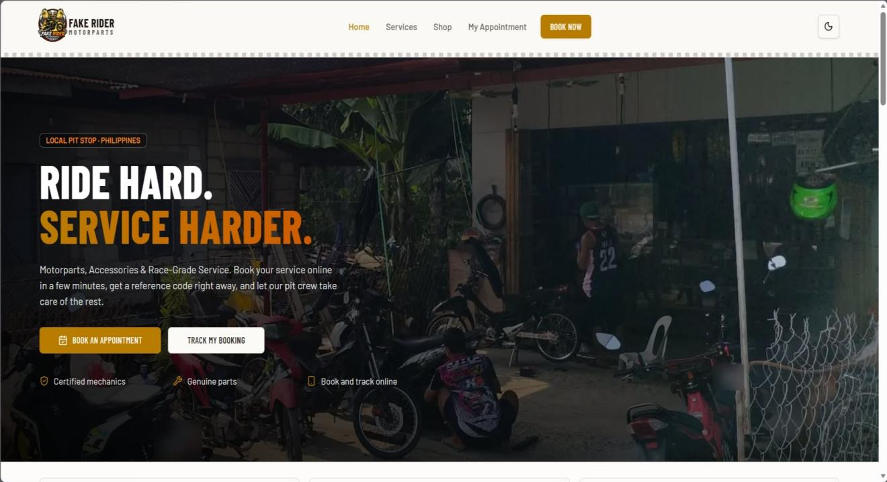
Description: Displays the main page where customers can access the system's features and services.

Procedure:
1. Open the Fake Rider Motorparts website.
2. View the homepage.
3. Navigate through the available menu options.
4. Click the desired menu or Book Now to access the selected function.

Process Name: Shop – Parts and Accessories
Description: Allows customers to browse, search, and reserve available motorcycle parts and accessories.
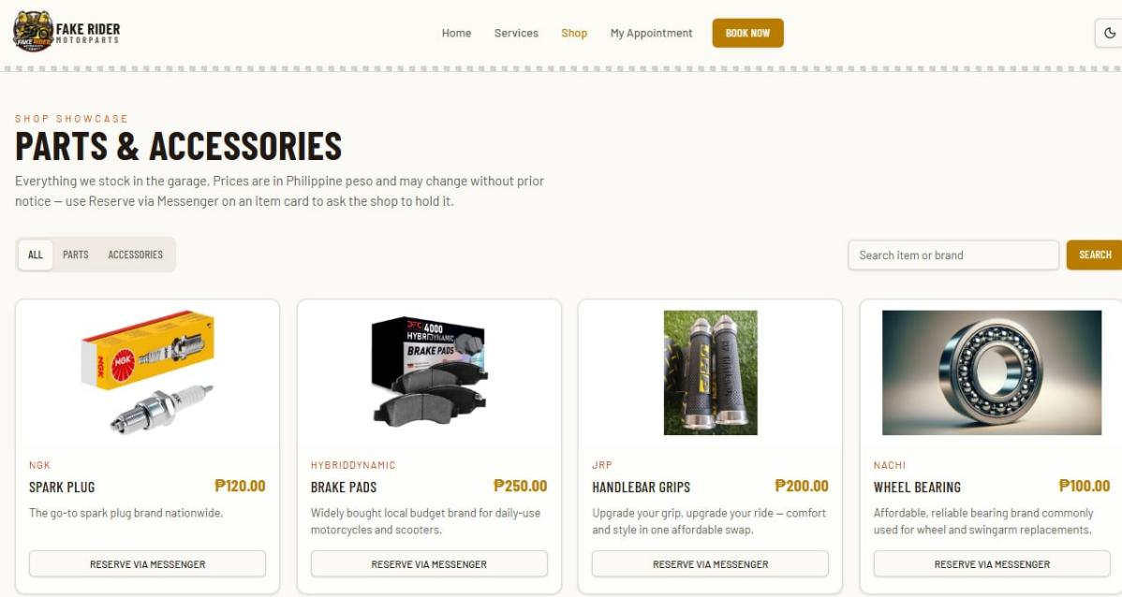

Procedure:
1. Open the Fake Rider Motorparts website.
2. Click Shop in the navigation menu.
3. Browse the available motorcycle parts and accessories.
4. Select All, Parts, or Accessories to filter the products.
5. Enter the item name or brand in the search bar.
6. Click Search to find the desired product.
7. Click Reserve via Messenger to inquire or reserve the selected item.

Process Name: Appointment Booking – Service Selection
Description: Allows customers to select the motorcycle repair and maintenance services they need.
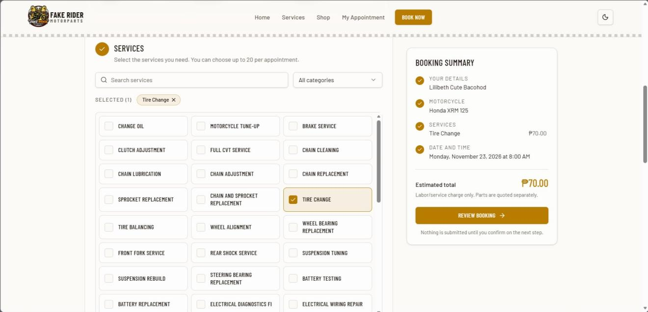
Procedure:
1. Open the Fake Rider Motorparts website.
2. Click Book Now.
3. Browse the available motorcycle services.
4. Select the desired services.
5. Review the selected services in the Booking Summary.
6. Check the estimated total service charge.
7. Click Review Booking to proceed.

Process Name: Appointment Booking – Personal and Motorcycle Details
Description: Allows customers to enter their personal information and motorcycle details for appointment booking.
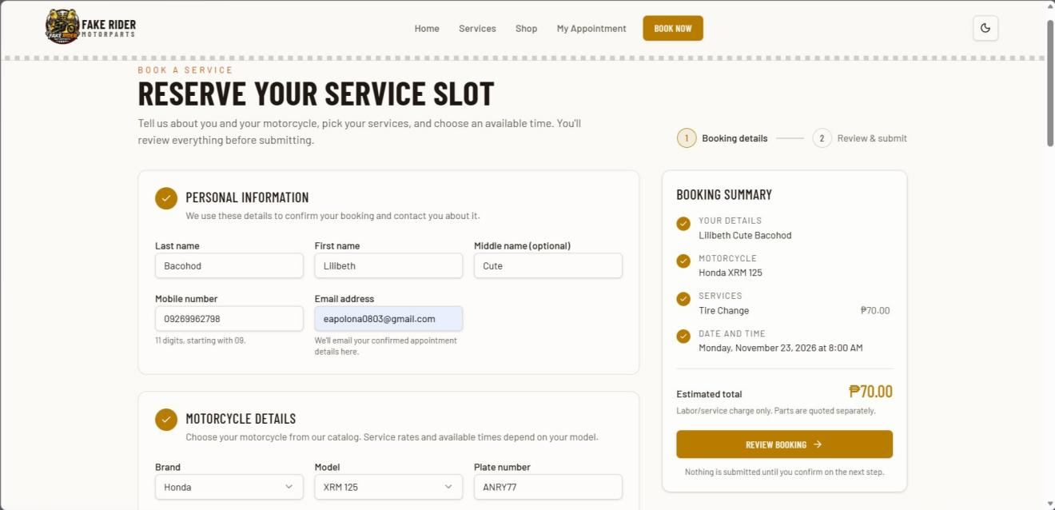
Procedure:
1. Open the Book Now page.
2. Enter the required personal information.
3. Provide the mobile number and email address.
4. Select the motorcycle brand.
5. Select the motorcycle model.
6. Enter the motorcycle plate number.
7. Review the information provided.

Process Name: Appointment Booking – Review and Submit
Description: Allows customers to review and submit their appointment request after verifying the booking details.
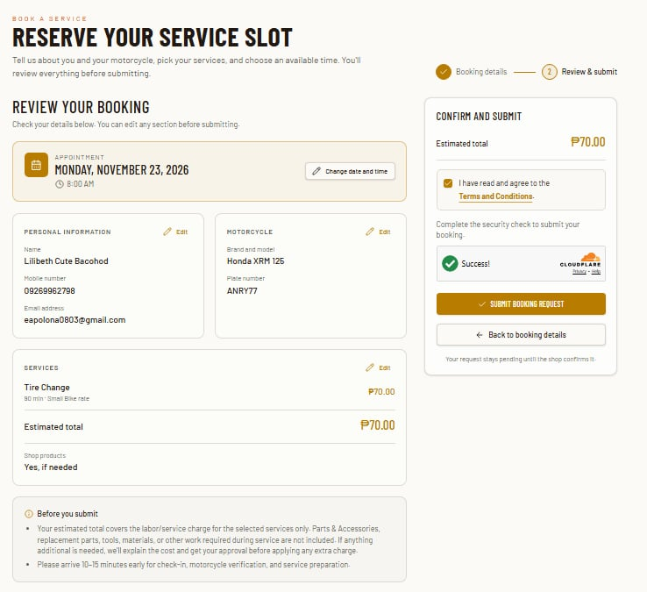
Procedure:
1. Review the selected appointment date and time.
2. Check the personal information.
3. Verify the motorcycle details.
4. Review the selected services and estimated total.
5. Edit any information if necessary.
6. Agree to the Terms and Conditions.
7. Complete the security check.
9. Click Submit Booking Request.
10. Wait for the shop to confirm the appointment.
Process Name: My Appointment – Appointment Tracking
Description: Allows customers to track their appointment status using a valid booking reference code.
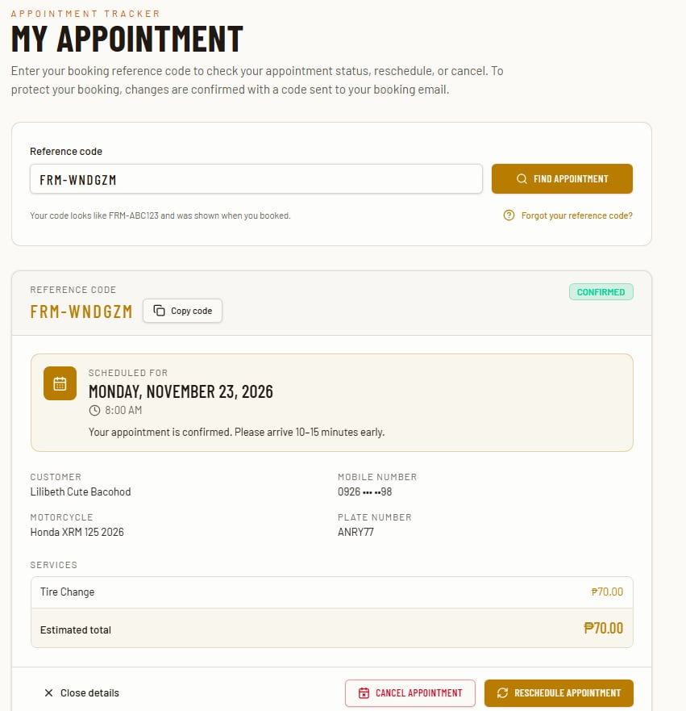
Procedure:
1. Open the Fake Rider Motorparts website.
2. Click My Appointment.
3. Enter the booking reference code.
4. Click Find Appointment.
5. View the appointment status and booking details.
6. Click Reschedule Appointment to change the schedule.
7. Cancel Appointment to cancel the booking if needed.
8. Complete the required email verification when making changes.

APPENDIX E
Source Code

Src/routes/book.tsx
Function emptyBookingForm() {
Return {
firstName: “”,
middleName: “”,
lastName: “”,
phone: “”,
email: “”,
motoBrand: “”,
motoModel: “”,
motoVariant: “”,

motoYear: String(new Date().getFullYear()),
plateNumber: “”,
notes: “”,
wantsProducts: null as boolean | null,
};
}
// …
Const BOOKING_PAGES = [
“Booking details”,
“Review & submit”,
] as const;
Export const Route = createFileRoute(“/book”)({
validateSearch: searchSchema,
head: () => ({
meta: [
{
Title: “Book a Service Appointment | Fake Rider Motorparts”,
},
{
Name: “description”,
Content:
“Reserve your motorcycle service slot online. Choose your services and schedule a convenient time, then save your reference code.”,
},
{
Property: “og:title”,
Content: “Book a Service Appointment | Fake Rider”,
},
{
Property: “og:description”,
Content:
“Reserve your motorcycle service slot online in a few minutes.”,
},
],
}),
Component: BookPage,
});
Type Errors = Partial<{
firstName: string;
middleName: string;
lastName: string;
phone: string;
email: string;
motoBrand: string;
motoModel: string;
plateNumber: string;
services: string;
wantsProducts: string;
date: string;
startTime: string;
schedule: string;
terms: string;
rescheduleReason: string;
}>;
// …
Const availability = useQuery<Availability>({
queryKey: [
“availability”,
serviceIds,
form.motoBrand,
form.motoModel,
isReschedule,
serviceIds.length > 1,
],
queryFn: () =>
availabilityFn({
data: {
days: 45,
serviceIds,

rescheduling: isReschedule,
allowMultiDayContinuation:
!isReschedule && serviceIds.length > 1,
Motorcycle: {
Brand: form.motoBrand,
Model: form.motoModel,
},
…(search.reschedule && search.phone
? {
rescheduleReference: search.reschedule,
reschedulePhone: normalizePhilippineMobile(
search.phone,
)!,
}
: {}),
},
}),
Enabled: serviceIds.length > 0 && motorcycleSelectionReady,
});
Const dates = useMemo(
() =>
Availability.data

? computeAvailableDates(availability.data)
: [],
[availability.data],
);
Const slots = useMemo(
() =>
Availability.data && date
? computeAvailableSlots(availability.data, date)
: [],
[availability.data, date],
);
// …
Const mutation = useMutation({
mutationFn: async () => {
if (form.wantsProducts === null) {
throw new Error(
“Choose whether you would like to avail shop products.”,
);
}
Const submittedSchedule = {

Date,
startTime,
};
Const res = await book({
Data: {
firstName: form.firstName.trim(),
middleName: form.middleName.trim(),
lastName: form.lastName.trim(),
phone: normalizePhilippineMobile(form.phone)!,
email: form.email.trim().toLowerCase(),
motoBrand: form.motoBrand.trim(),
motoModel: form.motoModel.trim(),
motoVariant: form.motoVariant.trim(),
motoYear: Number(form.motoYear),
plateNumber: form.plateNumber.trim(),
serviceIds,
date,
startTime,
notes: form.notes.trim(),
wantsProducts: form.wantsProducts,
turnstileToken,
idempotencyKey: bookingRequestId,
termsAccepted: true as const,

multiDayContinuationAccepted,
…(isReschedule
? { rescheduleReference: search.reschedule }
: {}),
…(isReschedule

? { rescheduleReason: rescheduleReason.trim() }
: {}),
},
});
return {
res,
submittedSchedule,
};
},
onSuccess: ({ res, submittedSchedule }) => {
if (!res.ok) {
if (
!isReschedule &&
isDuplicateBookingMessage(res.error)
) {
setDuplicateBookingMessage(res.error);
setErrors(({ schedule: _, ...current }) => current);
setDate("");
setStartTime("");
setTurnstileToken("");
setBookingRequestId(randomId());
availability.refetch();
return;
}
setErrors((current) => ({
...current,
schedule: res.error,
}));
setTurnstileToken("");
setBookingRequestId(randomId());
availability.refetch();
return;
}
clearBookingDraft();
setResult(
"continuationSegments" in res
? {
reference: res.reference,
total: res.total,
date: submittedSchedule.date,
startTime: submittedSchedule.startTime,
continuationSegments: res.continuationSegments,
}
: {
reference: res.reference,
total: res.total,
date: submittedSchedule.date,
startTime: submittedSchedule.startTime,
},
);
window.scrollTo({
top: 0,
behavior: "smooth",
});
},
onError: (err: Error) => {
if (
!isReschedule &&
isDuplicateBookingMessage(err.message)
) {
setDuplicateBookingMessage(err.message);
setErrors(({ schedule: _, ...current }) => current);
setDate("");
setStartTime("");
return;
}
const msg = err.message.toLowerCase();
let scheduleError: string;
if (
msg.includes("network") ||
msg.includes("fetch") ||
msg.includes("connect")
) {
scheduleError =
"Network error. Please check your connection and try again.";
} else if (msg.includes("timeout")) {
scheduleError = "The request timed out. Please try again.";
} else if (
msg.includes("validation") ||
msg.includes("invalid")
) {
scheduleError =
"Some fields have invalid values. Please review the form.";
} else {
scheduleError =
"We could not submit your booking. Please review your details and try again.";
}
setErrors((current) => ({
...current,
schedule: scheduleError,
}));
availability.refetch();
},
});

function validationErrors(steps: number[]) {
const e: Errors = {};
if (isReschedule && !rescheduleReady) {
e.schedule =
rescheduleError ??
"Loading the original appointment details.";
return e;
}
if (steps.includes(1)) {
if (form.lastName.trim().length < 2)
e.lastName = "Enter your last name.";
if (form.firstName.trim().length < 2)
e.firstName = "Enter your first name.";
if (!normalizePhilippineMobile(form.phone))
e.phone = PHONE_VALIDATION_MESSAGE;
if (
!isReschedule &&
!/^\S+@\S+\.\S+$/.test(form.email.trim())
) {
e.email = "Enter a valid email address.";
}
}
if (steps.includes(2)) {
if (!form.motoBrand.trim()) e.motoBrand = "Required";
if (!form.motoModel.trim()) e.motoModel = "Required";
if (!isReschedule && catalogUnavailable) {
e.motoBrand =
“The motorcycle catalog is unavailable. Please try again shortly.”;
}
If (
!isReschedule &&
!catalogUnavailable &&
Form.motoBrand &&
!brands.includes(form.motoBrand)
) {

e.motoBrand =
“Select a brand from the motorcycle catalog.”;
}
If (
!isReschedule &&
!catalogUnavailable &&
Form.motoModel &&
!modelsForBrand.some(
(model) => model.value === form.motoModel,
)
) {
e.motoModel =
“Select a model from the motorcycle catalog.”;
}
If (form.plateNumber.trim().length < 2)
e.plateNumber = “Required”;
}
If (steps.includes(3) && serviceIds.length === 0)
e.services = “Select at least one service.”;
if (
steps.includes(3) &&
serviceIds.length > MAX_BOOKING_SERVICE_SELECTIONS
) {

e.services = `Select up to ${MAX_BOOKING_SERVICE_SELECTIONS} services per appointment.`;
}
if (steps.includes(4) && !date)
e.date = “Select your preferred date.”;
if (steps.includes(4) && date && !startTime)
e.startTime = “Select your preferred time.”;
if (steps.includes(3) && form.wantsProducts === null) {
e.wantsProducts = “Choose Yes or No for shop products.”;
}
If (steps.includes(4) && availabilityLoading) {
e.schedule =
“Availability is still loading. Please wait a moment.”;
}
If (
Steps.includes(4) &&
(availability.isError || availabilityError)
) {
e.schedule =
availabilityError ??
“We could not verify availability. Please try again.”;
}
If (
Steps.includes(4) &&

isReschedule &&
!rescheduleReason.trim()
) {
e.rescheduleReason =
“Tell us why you need to reschedule.”;
}
If (steps.includes(5) && !terms)
e.terms = “You must accept the terms and conditions.”;
return e;
}
function validateBooking() {
const e = validationErrors([1, 2, 3, 4, 5]);
return showValidationErrors(e);
}

function showValidationErrors(e: Errors) {
setErrors(e);
const firstInvalidField = validationFieldOrder.find(
(field) => e[field],
);
if (!firstInvalidField) return true;
setBookingPage(
firstInvalidField === "terms" ? "review" : "details",
);
setFocusRequest(firstInvalidField);
return false;
}

function continueToReview() {
const e = validationErrors([1, 2, 3, 4]);
if (!showValidationErrors(e)) return;
const requiresMultiDayConfirmation =
needsServiceStepMultiDayConfirmation ||
needsMultiDayContinuationConfirmation;
if (
requiresMultiDayConfirmation &&
!multiDayContinuationAccepted
) {
setMultiDayContinuationOpen(true);
return;
}
setBookingPage("review");
window.scrollTo({
top: 0,
behavior: "smooth",
});
}

function continueWithMultiDayBooking() {
setMultiDayContinuationAccepted(true);
setMultiDayContinuationOpen(false);
setBookingPage("review");
window.scrollTo({
top: 0,
behavior: "smooth",
});
}

function returnToBookingDetails() {
setErrors({});
setBookingPage("details");
window.scrollTo({
top: 0,
behavior: "smooth",
});
}

function submitBooking() {
if (!rescheduleReady || !validateBooking()) return;
mutation.mutate();
}

// ...

